A history of Indigenous languages
-- and how to revitalize them

Keyword: Culture, Education, History, Language, Indigenous Peoples

Video: Lindsay Morcom, ‘A history of Indigenous languages-- and how to revitalize them’
https://www.ted.com/talks/lindsay_morcom_a_history_of_indigenous_languages_and_how_to_revitalize_them
Read and answer (1)-(3) questions before watching the video!

[ 1 ] Introduction

The speaker, Lindsay Morcom, is of Anishinaabe heritage and a member of Ardoch Algonquin First Nation.
She researches education, Aboriginal languages, language revitalization and linguistics.
In this video, she talks about the importance of having own culture, especially language, and how can we revitalize cultures that is on the verge of being lost.

Lindsay Morcom

[ 2 ] Why did I choose it?
I am studying Indigenous people in Australia at this university and I have learned that many indigenous cultures around the world have been persecuted and threatened with extinction. I think what the speaker is describing here applies to indigenous peoples in Japan as well.

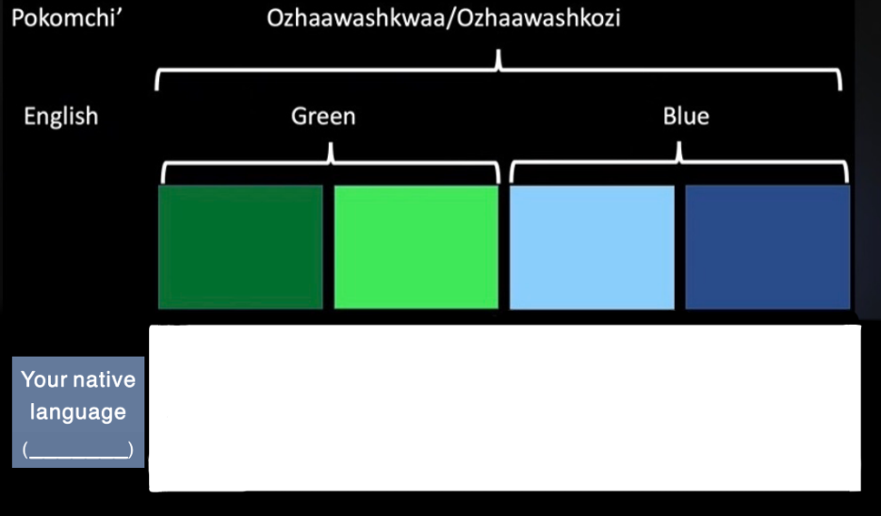
[ 3 ] Warming up activity
As in the example in Pokomchi’ and English, consider the case of your native language and write the following things in image 1.
(1) distinguish the colors.
(2) write the names of the colors.

Image1 : quoted from Lindsay Morcom (2020), edited by Yamamoto.

Watch the video and answer the following questions!
[ 4 ] Questions
Answer the following questions.
[ Part1 ] 0:00~3:10

(1) What Dene Elder Paul Disain said?
Our language and culture is ______________________________________________________.

(2) What is the characteristic of anisinabe? (2:40~)
It can mark all words as either _______________ or _______________ in the language.
[ part2 ] 3:11~8:22

Words | Meaning |  | example
(1) immemorial | (a) starting longer ago than people can remember, or than written history shows. |  | (あ)From time immemorial, it seems, pitching signs have been standard.
(2) endangered | (b) to put someone or something in danger of being hurt, damaged, or destroyed. |  | (い) The lizards are classed as an endangered species.
(3) atrocity | (c) an extremely cruel and violent action, especially during a war. |  | (う) Now senior officers fear the organisation is limbering up for a wave of further atrocities.
(4) tuberculosis | (d) a serious infectious disease that affects many parts of your body, especially your lungs. |  | (え) All children brought to the clinic were automatically vaccinated against tuberculosis.
(5) cemetery | (e) a piece of land, usually not belonging to a church, in which dead people are buried |  | (お) He was caught in the end, trying to bury one of the bodies in the cemetery, in a fresh grave.
(6) reconciliation | (f) the process of finding a way that two beliefs, facts etc that are opposed to each other can both be true or successful. |  | (か) In almost all relationship conflicts, reconciliation depends upon the creation of a more satisfactory reward system.
(7) dire | (g) extremely serious or terrible. |  | (き) The overwhelming impression left by the survey is one of dire poverty.
(8) revitalization | (h) to put new strength or power into something. |  | (く) Authorities claim that a short nap can reduce tension and revitalize you.
(9) assimilation | (i) the process of becoming an accepted part of a country or group. |  | (け) Sometimes the difference caused by assimilation is very noticeable, and sometimes it is very slight.
[ part2 ] 3:11~8:22
(3) What did TRC state about ‘cultural genocide’ ?
“Cultural genocide is ____________________________________________________________________ as a group.”

(4) Which four countries opposed the ‘United Nations Declaration on the Right of Indigenous people Article in 2007?
( ) ( ) ( ) ( )
[ part3 ] 8:23~
(5) Which languages were mentioned as having been successfully restored?
( )

(6) What does the speaker state is a "settlement" without the maintenance of indigenous languages and cultures?
( )

[ 5 ] Vocabularies
Following the example of (h)-(2)-(お), connect the appropriate word definitions and example sentences with a line.
All of the meaning and examples are quoted from ‘Longman Dictionary of Contemporary English Online’. ( https://www.ldoceonline.com/ )

Meaning |  | Word |  | example
(a) a piece of land, usually not belonging to a church, in which dead people are buried |  | (1) immemorial |  | (あ) All children brought to the clinic were automatically vaccinated against ( ).
(b) the process of finding a way that two beliefs, facts etc that are opposed to each other can both be true or successful. |  | (2) endangered |  | (い) Now senior officers fear the organisation is limbering up for a wave of further ( ).
(c) the process of becoming an accepted part of a country or group. |  | (3) atrocity |  | (う) In almost all relationship conflicts, ( )  depends upon the creation of a more satisfactory reward system.
(d) starting longer ago than people can remember, or than written history shows. |  | (4) tuberculosis |  | (え) Sometimes the difference caused by ( ) is very noticeable, and sometimes it is very slight.
(e) an extremely cruel and violent action, especially during a war. |  | (5) cemetery |  | (お) The lizards are classed as an ( ) species.
(f) to put new strength or power into something. |  | (6) reconciliation |  | (か) From time ( ), it seems, pitching signs have been standard.
(g) a serious infectious disease that affects many parts of your body, especially your lungs. |  | (7) dire |  | (き) He was caught in the end, trying to bury one of the bodies in the ( ), in a fresh grave.
(h) to put someone or something in danger of being hurt, damaged, or destroyed. |  | (8) revitalize |  | (く) Authorities claim that a short nap can reduce tension and ( ) you.
(i) extremely serious or terrible. |  | (9) assimilation |  | (け) The overwhelming impression left by the survey is one of ( ) poverty.
[ 6 ] Answers
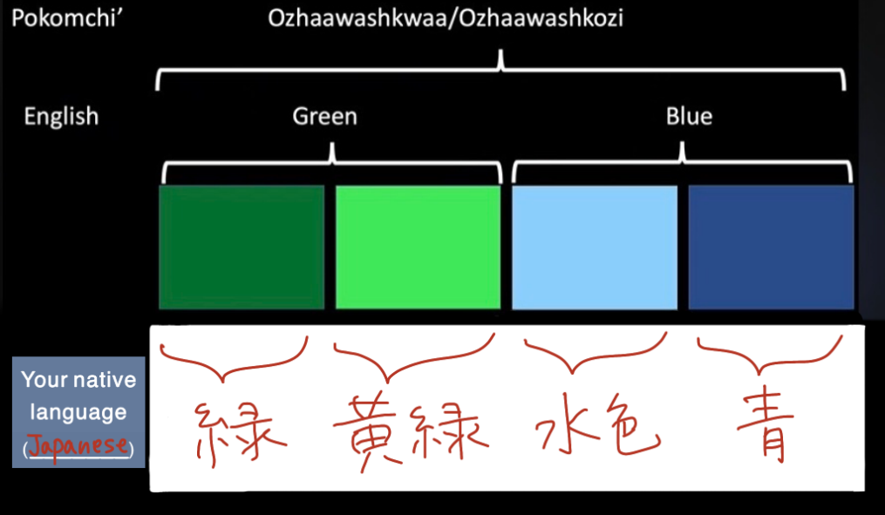
Example of [ 3 ]

Answer of questions [ 4 ]
(1) the window through which we see the world
(2) animate / inanimate
(3) the destruction of those structures and practices that allow the group to continue
(4) United States, New Zealand, Australia, Canada
(5) Mi’kmaq
(6) assimilation

Answers of questions [ 5 ]
(a)-(5)-(き)
(b)-(6)-(う)
(c)-(9)-(え)
(d)-(1)-(か)
(e)-(3)-(い)
(f)-(8)-(く)
(g)-(4)-(あ)
(h)-(2)-(お)
(i)-(7)-(け)

-References-
Lindsay Morcom (2020) ‘A history of Indigenous languages - and how to revitalize them’
TED Ideas worth spreading,
https://www.ted.com/talks/lindsay_morcom_a_history_of_indigenous_languages_and_how_to_revitalize_them
Longman Dictionary of Contemporary English Online, https://www.ldoceonline.com/

