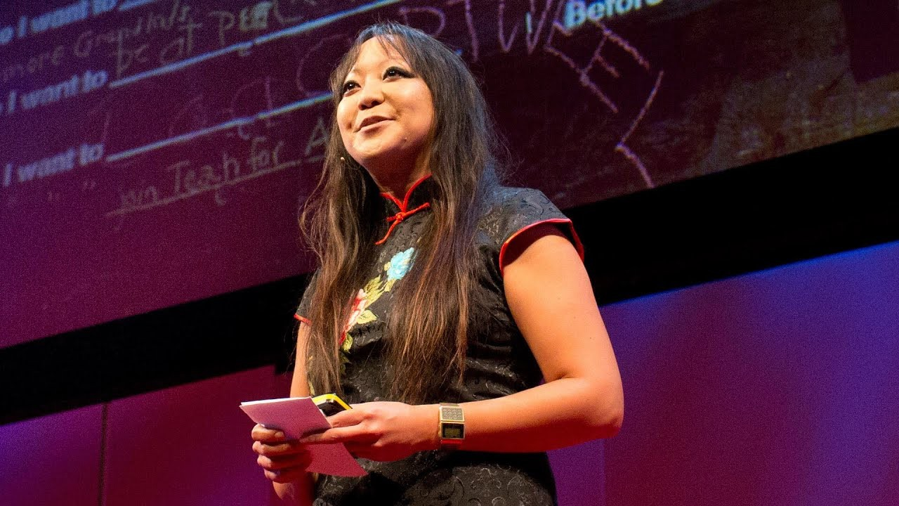

Before I die, I want to …

Access to the Talk
by Candy chang

https://www.ted.com/talks/candy_chang_before_i_die_i_want_to/transcript?langu age=en

About This TED Talk & Reason to Choose
Have you ever recognized the fact that you will be dead in some day? Death is what we are often discouraged to think about. Watching Candy Chang’s TED talk, you can consider values and possibilities of your own life as a reflection of recognizing your death. “Thinking about death clarifies your life,” as Candy Chang strongly claims. That is why I would like to share this TED talk.

About This TED Talk & Reason to Choose
- Have you ever thought about “death” of yourself or of someone else who is close and important to you? If you have, please write down your thought as so far as you can.
- Guess what Candy Chang’s occupation is from the talk’s thumbnail.

Vocabulary & Grammar Development
These sentences below are from Chang’s talk. Fill in the blanks in each sentence. The meaning of the words or phrases in parenthesis.
(Definitions of words come from Oxford Advanced Learner Dictionaries.)

I trust a city that always for music. I feel like every time someone sneezes, New Orleans has a parade.
(to allow somebody/something to pass; to allow somebody/something to take the place of somebody/something)

So anyone walking by can pick up a piece of chalk, reflect on their life, and share their personal in public space.
(a strong desire to have or do something)

Before I die, I want to be tried for .

(the crime of attacking ships at sea in order to steal from them)

Before I die, I want to live .

(not using the public supplies of electricity, gas, water, etc.)

Thinking about death your life.

(to make something clearer or easier to understand)

Engaging Questions
Answer questions below to understand this talk more deeply.

- Before Chang starting #beforeidie project, how had she tried to share more with her neighbors in public space? That project is supposed to be a prototype of #beforeidie project.

- In her talk, what does she mention as something that changed her life forever.

- She claims that a neglected space became a constructive one through asking the #beforeidie question. What does “neglected space” suggest?
- What do you want to do before you die? Please answer the question by filling the blacks below.
Before I die, I want to .

Fun activity
Before you die, what do you want to do? Share your dreams in each age.

In your … | Dreams
20s | I want to …
30s
40s
50s
60s
70s and more

Example:
In my … | Dreams
20s | I want to be a PhD candidate in the University of Oxford.
30s | I want to be a researcher in Europe.
40s | I want to realize my parents’ dream to migrate in Spain  after their retirement.
50s | I want to learn Portuguese and read Fernando Pessoa’s  poetry in his language.
60s | I want to migrate to the beach in Thailand and open my  own atelier.
70s and more | I want to publish my own novel.

Answers
Vocabulary & Grammar Development
- I trust a city that always makes way for music. I feel like every time someone sneezes, New Orleans has a parade.
- So anyone walking by can pick up a piece of chalk, reflect on their life, and share their personal aspirations in public space.
- Before I die, I want to be tried for piracy.
- Before I die, I want to live off the grid.
- Thinking about death clarifies your life.
Engaging Questions

- She shared ordinary questions by using simple tools like stickers, stencils and chalk with her neighbors.
- Sudden and Unexpected death of Joan, who is a mother to her.
- A side of an abandoned house near Chang’s house in New Orleans.
- N/A

