


Build the Tower, Build the Team


https://www.ted.com/talks/tom_wujec_build_a_tower_build_a_team

The reason I chose the one as topic

When I was a high school student, I tried the challenge showed in this talk. The
story and the conclusion is very simple,
but it includes the very important thing for us to collaborate with a team. I just want
you to try this challenge and also think
about the how to work better as a team.



Before listening to the TED talk...


Have you ever faced the difficulty working as a team?
Please share your own experience.

Vocabulary
check


buckle collaborate geometrical gingerly iterative lame
- bend something out of its original shape
- doing something again and again; especially in order to improve
- the pattern made with a simple shape such as triangles or squares
- unable to walk without difficulties
because of the weakness
- work with somebody for a some purposes
- doing something very carefully, with a cautious manner




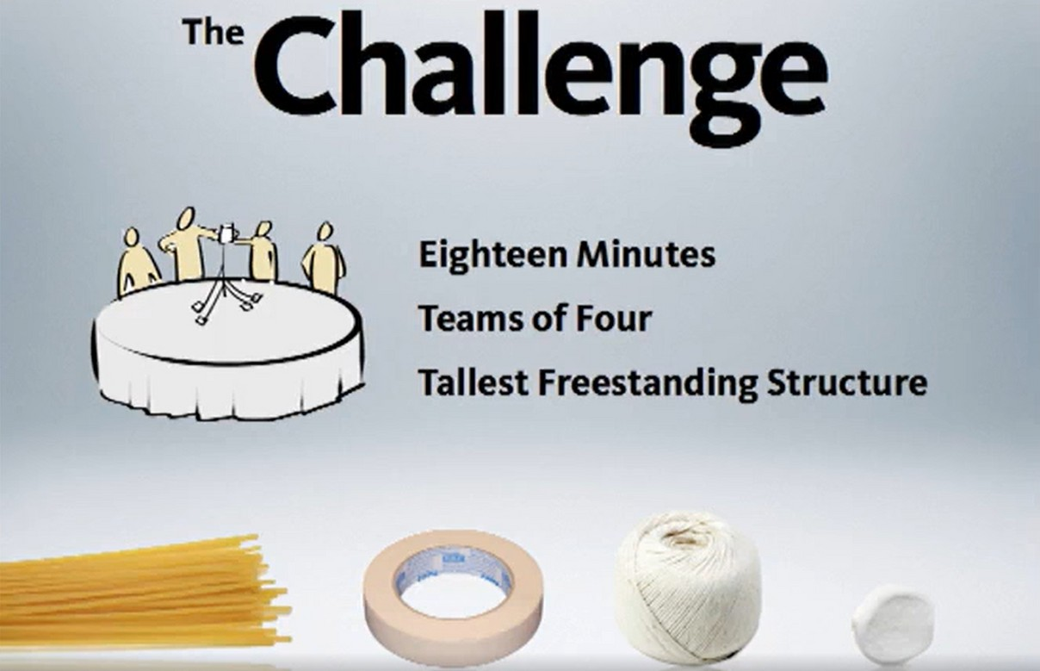
Marshmallow Challenge
1yard of tape (90cm) 1yard of string(90cm) 20 sticks of spaghettis 1 marshmallow
(has to be on the top)



You can try your own 5min mashmallow challenge!


Please place them in a order; who can build a higher structure?

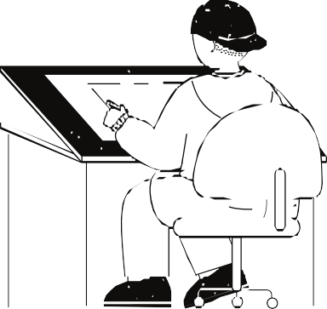

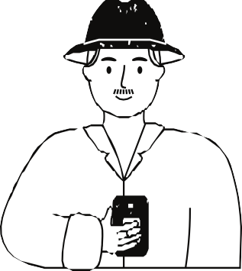
Architects & Engineers

Lawyers

CEOs




Business school Students

Kindergatners

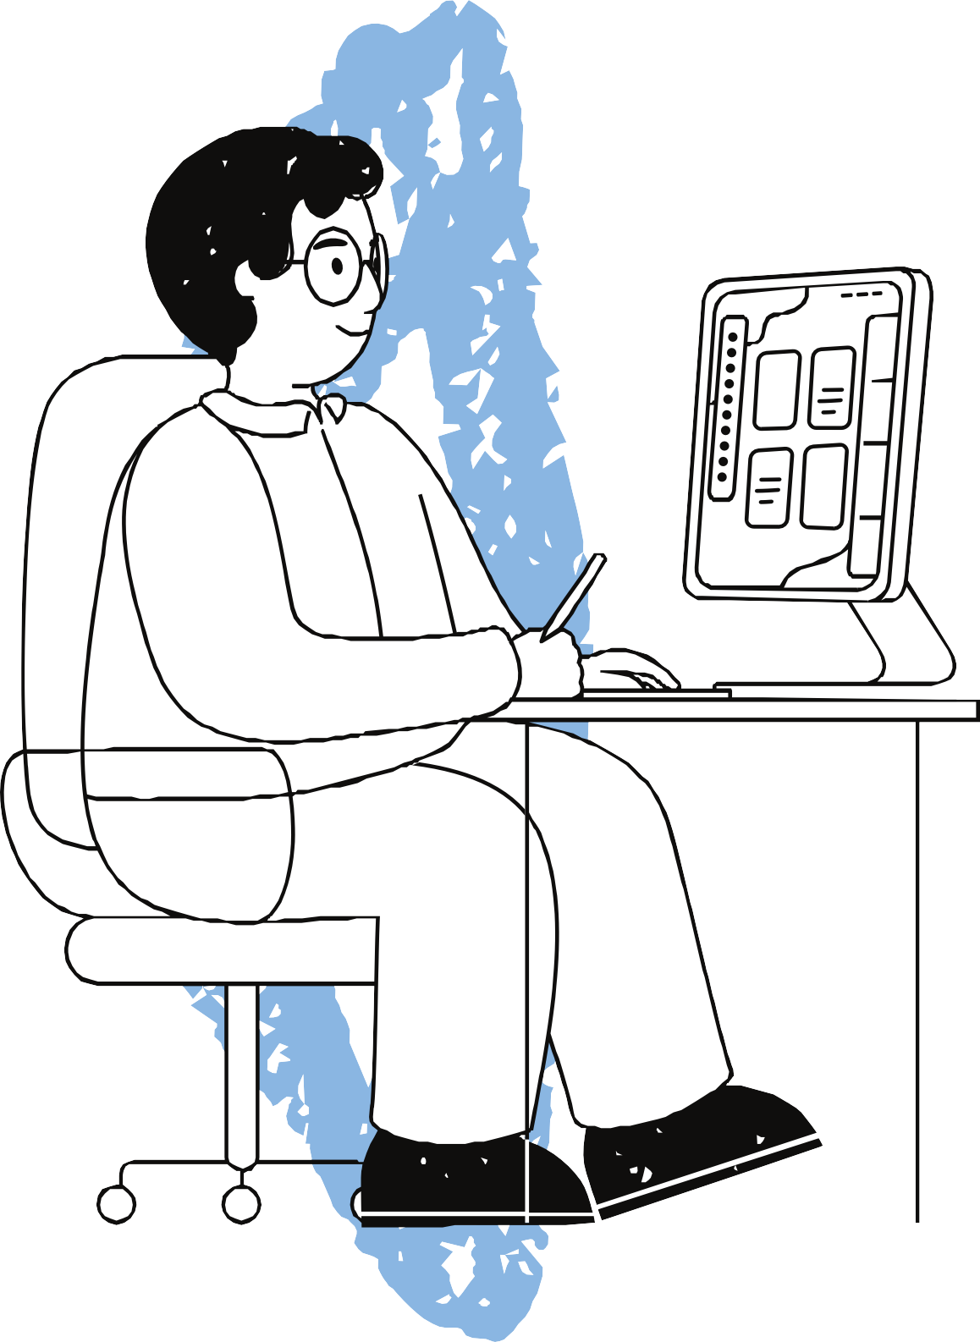
Listen to the TED TALK!
Now

and answer the following question as much as possible
https://www.ted.com/talks/tom_wujec_build_a_tower_build_a_team

- Why business students end with the challenge crises?


- What the iterative process for designers comprises with?

- What is the key point for architecture to stand stably?

- How the incentives affects for us to success?

- In this presentation, what the marshmallow represents?

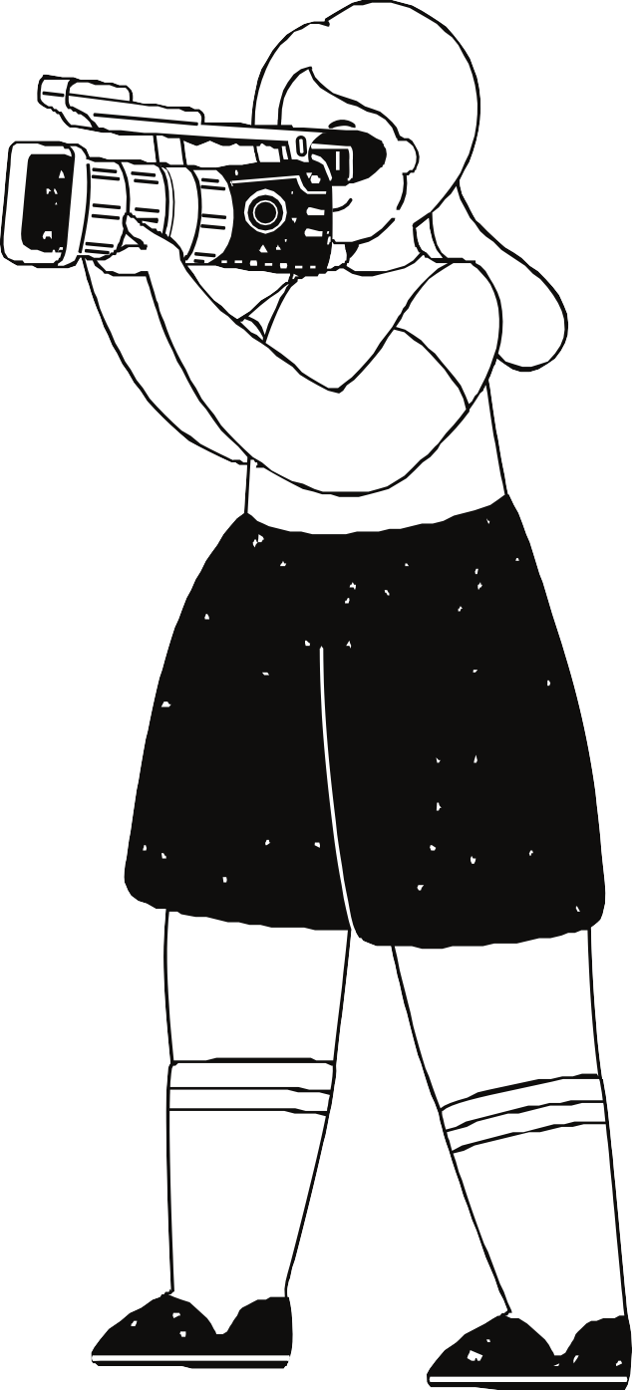
Now let’s discuss the following questions with your mate!

Why do you think business person tend to focus on one right answer?
What kind of education makes them to
think as such?






Why do you think the facilitation skills leads the challenge success more than the one without facilitator?

Can you come up with the point that can affects people strongly except incentives?

After this presentation, has your way of thinking toward success changed?
Please share your own
thinking toward success.


Thank you very much!
https://www.ted.com/talks/tom_wujec_ build_a_tower_build_a_team/transcript

Please place them in a order; who can build a larger structure?


Architects & Engineers

Lawyers

CEOs



Business school Students

Kindergatners

Vocabulary
check

buckle collaborate geometrical gingerly iterative lame
- bend something out of its original shape
- work with somebody for a some purposes
- the pattern made with a simple shape such as triangles or squares
- doing something very carefully, with a cautious manner
- doing something again and again; especially in order to improve
- unable to walk without difficulties because of the weakness

- Why business students end with the challenge crises?
-they are trained to find one right plan and run out time with only one plans
- What the iterative process for designers comprises with?
-create the prototypes and refine it
- What is the key point for architecture to stand stably
-triangles and self-reinforcing geometrical patterns
How the incentives affects for us to success?
- -just with the incentives, people are less likely to success. When they are trained(have higher skill), they are likely to success
- In this presentation, what the marshmallow represents?
-the biggest difficulty or the wall we have to overcome on the project

