



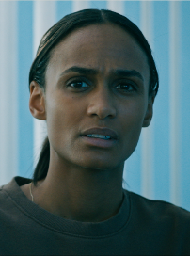

Juliane : AJ, when can you be sure there are no further security issues?

A・J : 24 hours.

Juliane : Good.

Thea : What’s line with Hanna until then?

Noah : We should keep this under wraps until we know what we’re dealing with. We still need to run the expansion announcement test tonight.

Isabelle : And what do we tell the people here?

A・J : Why do we have to tell them anything?

Isabelle : Because the system which is supposed to be keeping them safe, isn’t it?

A・J : It will after we complete our review.

Isabelle : And if they find out before that?

A・J : That’s not going to happen.

Noah : The road maps the same as with Hanna. Once we find out who’s behind the breach will tell the residents what we’ve learned, and that it’s fixed.

Juliane : A・J, my tell is to you should get started.

Power Point C:\Users\rika0\OneDrive - 東京外国語大学\提出予定課題2\8123103 Rika Narikiyo GLIP AL2 .pptx

