Answer of the Gapfill!
[Verse 1]
The warden threw a party in the county jail.
The prison band was there and they began to wail.
The band was jumpin' and the joint began to swing.
You should've heard those knocked out jailbirds sing.
[Chorus]
Let's rock, everybody, let's rock.
Everybody in the whole cell block
was dancin' to the Jailhouse Rock.

warden : The guard of the facility (like dormitory, nursing home, prison)
wail : Crying, shouting
swing : shaking, moving
Jailhouse : prison (Institution to detain persons who committed a crime)
↓
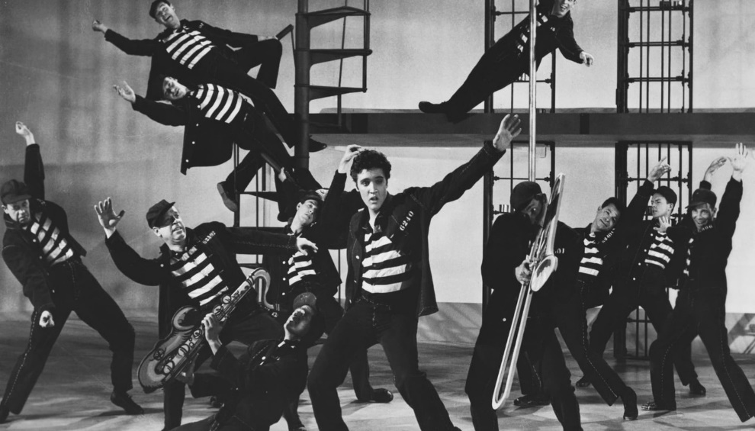

[Verse 2]
Spider Murphy played the tenor saxophone,
Little Joe was blowin‘ on the slide trombone.
The drummer boy from Illinois went crash, boom, bang,
The whole rhythm section was the Purple Gang.

Purple gang : the name of the gang in about 1920, in Detroit
[Chorus]
[Verse 3]
Number forty-seven said to number three:
'You're the cutest jailbird I ever did see.
I sure would be delighted with your company,
come on and do the Jailhouse Rock with me.

Jailbird : prisoner
[Chorus]
[Verse 4]
The sad sack was a sittin' on a block of stone
way over in the corner weepin' all alone.
The warden said, 'Hey, buddy, don't you be no square.
If you can't find a partner use a wooden chair.

Weeping : crying, teering
Square : In this song, it means serious, not interesting person
[Chorus]
[Verse 5]
Shifty Henry said to Bugs, ‘For Heaven’s sake,
no one‘s lookin, now’s our chance to make a break.
Bugsy turned to Shifty and he said, Nix nix,
I wanna stick around a while and get my kicks.

Shifty : not serious
Stick around : wondering around the neighborhood
[Chorus]

