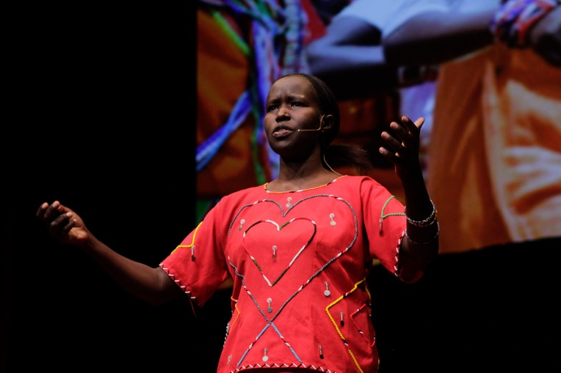

Do you know how girls spend their lives in Kenya? Do you know the school for girls and their future in Kenya? The speaker is Kakenya Ntaiya. She grew up in a village of Kenya, Enoosaen. She thought she had to do something for her community, and she built a school for girls! She shares the importance of the education for the empowerment.

https://www.ted.com/talks/kakenya_ntaiya_empower_a_girl_transform_a_community?language=en

Listening

- How did Kakenya Ntaiya spend her childhood?

- What problems were in Kakenya Ntaiya’s village when she came back there?

3. How many girls were enrolled at the first year of the school? Choose the one of the below.
A.10
B. 30
C.100

4. In her community, how grandmothers are seen?

5. What made her to decide to start to work with boys?

6. What problems did she refer to child marriage?

Dictation

1. Some had been ______, others were ________, and some came from families that are very traditional, that had never sent any girl to school.
2. So before a girl could learn math or history, she needed to feel safe, she needed to be ＿＿_ and be _________.
3. Together they talked about a Kenya _______________________________, where Linet is a leader and where communities like Enoosaen are _______ because its members -- all its members -- have opportunities.

Discussion

- Do you know about the situation of the education in the area / country you major in?
- What do you think about the empowerment of women? What does need for that?
- Do you have any idea about the relationship between tradition and education?
- What opinions do you have about child marriage?
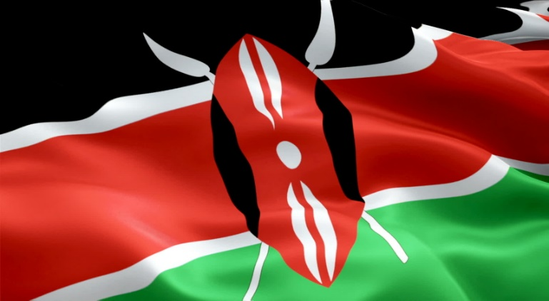

Answer
Listening
- She spent her childhood helping her mother cook, clean, farm and take care of her siblings.
- There some problems related to girls like going through FGM, still leaving school, still getting married to men older than their fathers and still having children when they're teenagers.
- B
- Grandmothers are seen as the proud keepers of their stories and cultures.
- Because she did not want the boys to grow up with the same mindset as their fathers before them.
- She referred to the economic problems. Child marriage is expected to cost trillions of dollars next 15 years and it will cost their village because those girls can be a doctor or a teacher and that will be loss for their village.
Dictation
- abused, orphans
- rested, well-nourished
- where all girls have the same opportunities, thriving

TRANscript
To empower girls, you need to educate them. That was my dream. And so I built a school, and in the process, I learned something much bigger. When you empower a girl, you transform a community. School is just a start.

I grew up in rural Kenya in a small village called Enoosaen. I was the first of eight children, and I spent my childhood helping my mother cook, clean, farm and take care of my siblings. Like other Maasai girls, I was engaged from a very young age to be married. But as I reached puberty, I underwent female genital mutilation, known as FGM. This picture shows some of the tools that are used to perform FGM on girls. FGM was supposed to mark the end of my childhood and, by extension, my education. But I negotiated with my father in order to stay in school -- even after going through FGM.

Years later I went to university. And in order to get my community's support, I promised to come back one day to repay that support. But years later, when I went back to my village, not much had changed. Girls were still going through FGM, still leaving school, still getting married to men older than their fathers and still having children when they're teenagers. I did not want to see any more girls go through that. That's when I knew what I needed to do to give back to my community.

I built a school just for girls so that they can be free from FGM and early marriage. At my first enrollment –
At my first enrollment, I had hoped for 10 girls. 100 came.
I started to realize just how big this dream was, and soon I learned that my school could be the foundation -- but it wasn't going to be enough.

So that first year, I enrolled these 30 girls. Some had been abused, others were orphans, and some came from families that are very traditional, that had never sent any girl to school. So school started. Though the girls seemed excited to be there, they were having difficulty staying awake. What was going on? They had a teacher, they had books, there was a new classroom on the way, but ... They were determined to be there, but they had no energy. Then I realized they were hungry, so I quickly found a cook and food. Soon thereafter, I learned that a classroom was not enough. I needed a boarding school. Not only were the girls tired and hungry from chores and long walks to school and back home, they were also not safe. It's a sad truth, but girls are often assaulted, raped and even kidnapped on their way to school. So before a girl could learn math or history, she needed to feel safe, she needed to be rested and be well-nourished.

So let me tell you about some of my girls. This is Faith. Faith comes from a very traditional family in the community. Her older sister had already gone through FGM and already married, but Faith was so determined. She really loved learning, and she wanted to come to my school when she heard about it. So she asked her father, her mother -- anyone to bring her to my school. They all refused. Faith did something very brave. She stole an egg from her mother's house, went to the market, sold the egg and bought a single pencil. Then she walked five miles, clenching that pencil, trying to enroll. She arrived --

She arrived tired and hungry, but determined. I listened to her story, and we enrolled her in my school. But getting into my school was only just the start. Faith needed food, she needed medicine, she needed counseling -- all of which we provided. And she also met adults who already believed in her. Supported by this community, Faith was ready to learn.

This is Faith. Six months of schooling, now she's a happy sixth grader who dreams of becoming a pilot someday, and her family now supports her, and best of all, her younger sisters will follow in her footsteps.

Child marriage is expected to cost the global economy trillions of dollars over the next 15 years. We can talk numbers, but in a real lifetime, what child marriage will cost my village is the doctor, the teacher, the entrepreneur, the true partner our men will need in the future ... real ways women can help us lift out of poverty.

So I came to realize once again, as I did when I needed help to go to university, that while I could dream or have a dream, I could not make it come true all by myself. So I went back to the elders who helped me more than a decade ago. I needed their support once again if I was going to be successful. So I formed a community board with religious leaders, parents and some teachers from other schools. I needed allies in the government and in the community to help advance my goal. I needed especially the support of the chief to help me enforce the no-FGM policy in my school. At first he was resistant, but I persisted --

I also needed the fathers. That brings me to Linet. Linet's father, Momposhi, did not believe in the education of girls. In fact, he himself never went to school. But Linet's mother believed in Linet and brought her to enroll in my school, and I knew she belonged with us. I just had to find a way to get Momposhi to believe in Linet, too. So I used the pretense of revealing Linet's grade to get Momposhi to come. He came, and he started noticing his daughter being promising as a student. With each visit, he built a strong relationship with his daughter -- noticing not just her grades but also accepting her as someone with full potential. So when Linet was accepted in one of the top national high schools after eighth grade, Momposhi was bursting with pride and went around the village telling everyone how proud and how smart his daughter was.

Can you imagine? He brought Linet to the new school himself. It was the first time either of them had ever been to Nairobi. Today Linet is studying at university in Australia –
and Momposhi is our greatest advocate in the community.

I also brought mothers to the table, including my own. That's my mother in one of our training programs. And our mothers are involved in the education of their own children. I also brought grandmothers into the mix.

In my community, grandmothers are the proud keepers of our stories and cultures, and I wanted my girls to learn and embrace our rich Maasai culture. Today, grandmothers do story time with the girls, and it's a beautiful way our community remains connected.
I also ... started working with the boys!

What would happen if the boys grew up with the same mindset as their fathers before them? I'll tell you, not much will change. So I enlisted support from an organization called I'm Worth Defending: a group of young, progressive leaders led by Alfred and George. Together we created a training program for boys and girls who could not attend my school, sharing vital information about gender equality, health and human rights. Today we have reached over 10,000 boys and girls and counting.
It turns out it truly does take a village to make this kind of a dream come true.

That's what you're seeing today, where nearly 400 girls have not gone through FGM in my village, in a region where nearly 80 percent of women have been cut. Believe me, these girls, they are sharing their experiences with their sisters, their cousins and their friends. They're so interested. Over time, this is becoming the new normal and it's being embraced by the same, same community -- my community.

So what does transforming communities mean to Kenya? President Obama visited Kenya in 2015, and he met with representatives from organizations trying to help improve communities. Guess what? He met Linet!

Together they talked about a Kenya where all girls have the same opportunities, where Linet is a leader and where communities like Enoosaen are thriving because its members -- all its members -- have opportunities. Helping the communities see that each daughter is a treasure, every sister is full of potential, and helping every single girl see that value in herself. There is no limit to what that future will cost.

Not every girl who comes to my school will be a PhD, but every single one of them will achieve her full potential and will become an advocate for her children and her grandchildren for years to come.
Today my dreams are informed by what I learned from them and what I've learned from you. My journey led me out of Enoosaen and back again. And in the process, I was embraced by the world, and you have become my village. So I make a new promise to you, my elders, my sisters and my friends, that I am going to keep dreaming and keep going until girls like Linet and Faith achieve their dreams and I see mine: that all communities give every single woman and every single girl their dreams come true.

Thank you.
Thank you, thank you.

