
The MBTI


Have you ever heard or tried the MBTI test? MBTI is the abbreviation for Myers-Briggs Type Indication, and it classifies people’s personalities into 16 types. Today, the MBTI is one of the most widely used personality tests.


But do you think it is possible to divide people’s personalities into 16 types? How much can we believe the MBTI? I want to think about these questions with you guys and that’s why I chose this topic.


A. Check the vocabulary.
metric introversion/extroversion intention favorable subconsciously
tempt nuance innate malleable mould upbringing
B. Watch the video and take notes.
(video> https://www.ted.com/talks/merve_emre_how_do_personality_tests_work )
・MBTI is…

・Problems of personality tests
1 the metrics

→ the results of tests can be inconsistent.

2 the definition of personality traits

Ex) the definition of introvert and extrovert have shifted like…

3 personality does change


・How a personality test is used is important

C. Let’s try the MBTI test!
Actually, MBTI test has many questions and takes 10-15minutes, but this time, let’s try easy version. (So be sure this is not accurate.)

Q1. What do you do when you have a problem？Circle the alphabet you think is closer to you.
1. E (Be talkative) or I (Think a lot)
2. S (Just accept) or N (How can it be?)
3. F (Hard to understand, but feel empathy) or T (Not acceptable, then no empathy)
4. J (Have to do, I do) or P (What should I do first?)

Q2. Combine the alphabets you chose. Then, that is your MBTI. (ex. INFP)


*Each alphabet has meaning. E(Extroverts)/I(Introverts), S(Sensors)/N(iNtuitives), T(Thinkers)/F(Feelers), J(Judgers)/P(Perceivers).

*Try the real one If you want to. >無料性格診断テスト | 16Personalities

D. Consider the accuracy of MBTI.
Q1. Google your MBTI and read the explanation. Does your MBTI describe you well? Rate the accuracy and explain why you rate so.

%

Q2. After understanding the problems personality tests have and considering the accuracy of your own MBTI, do you think MBTI is worth believing? Do you think people’s personality can be classified? (Of course, the answer could be ‘yes’. Write Freely.)

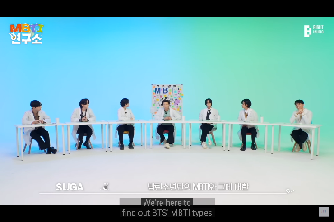
Column: MBTI meets KPOP
In these few years, MBTI is wide spreading in KPOP, as well as in Korea. There are so many KPOP YouTube contents related to MBTI.
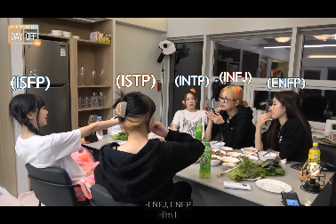
If you see these contents, you will see how MBTI has penetrated in Korean society and how fun talking about MBTI is. Though MBTI test has some negative sides, just talking with your friends will be fun. Try it!

