How great leaders inspire action
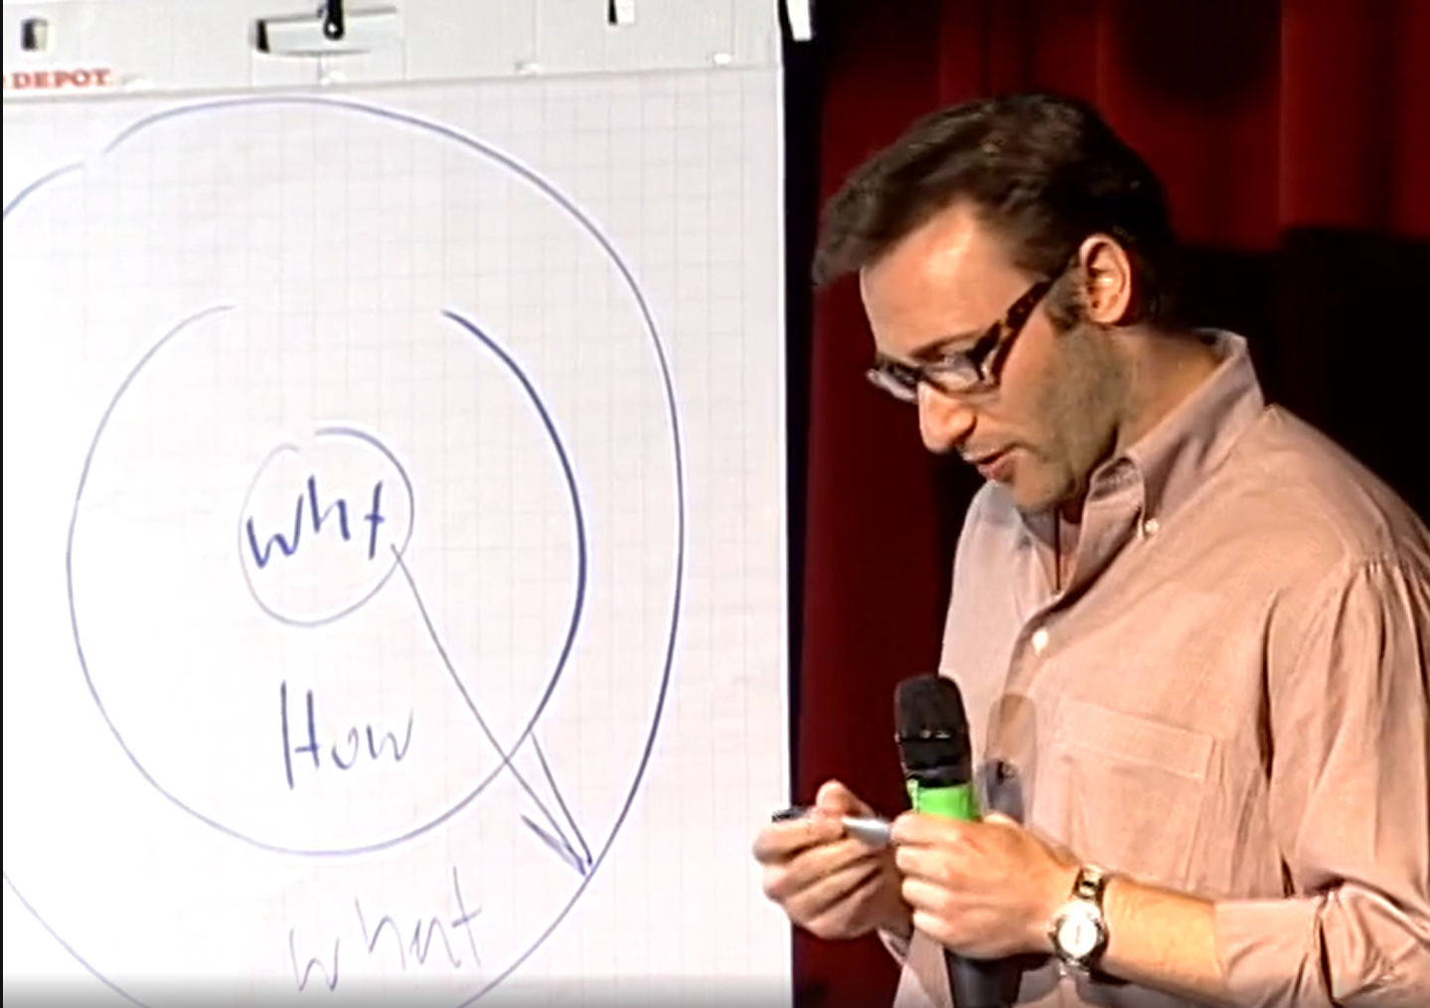
Simon Sinek has a simple but powerful model for inspirational leadership － starting with a
golden circle and the question: "Why?"
His examples include Apple, Martin Luther
King Jr. and the Wright brothers …
https://www.ted.com/talks/simon_sinek_how_great_leaders_inspire_action?

Why I chose this TED talk
It teaches us the importance of telling why. This why-first mindset would be necessary for us when we think about our future.

Questions
- What makes Apple different from other computer companies?

① Its prominent technology
② Its vision
③ Its perfectly designed products

- What is in the center of the“golden circle”?

True or False (3-5)
- “to make a profit”can be WHY.
- The Wright brothers had a college education to realize the first manpower
fright.
- A single part of the brain controls both decision-making and language.
- 250,000 people who heard Dr.King's speech showed up for Dr.King.

Listening
- Whether they're individuals or organizations, we follow those who ( a ), not because we have to, but because we want to. We follow those who( a ), not for them, but for ( b ). And it's those who start with "( c )" that have the ability to ( d ) those around them or find others who ( d )them.

Discussion Topics
・Have you ever been inspired by a vision when you buy a product?
・What kind of vision do you feel sympathy for?

References
Apple — September Event 2014
https://www.youtube.com/watch?v=38IqQpwPe7s
The opening movie clearly shows its vision and tries to share its value.
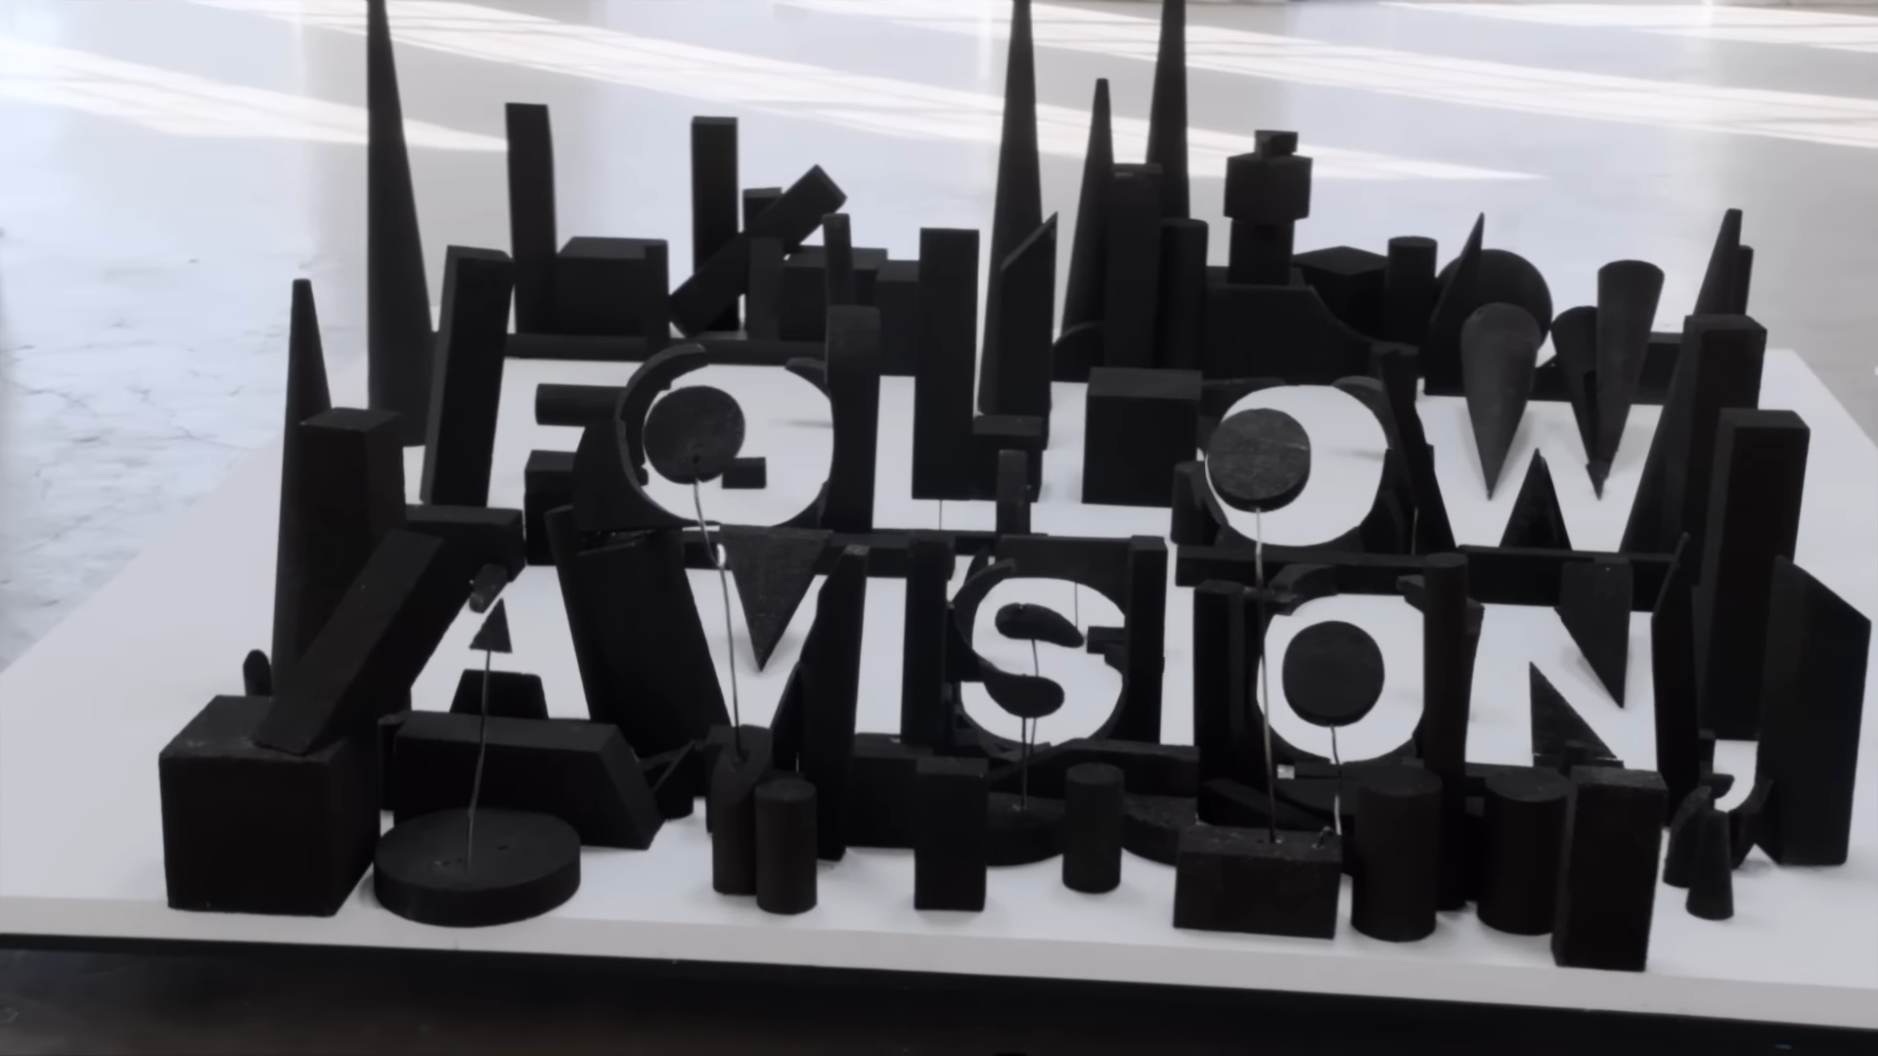

Answers
1. ②
2. Why
3. False
4. False
5. True
6. False (for themselves)
7. a. lead b. ourselves c. why d. inspire (17:00～)

