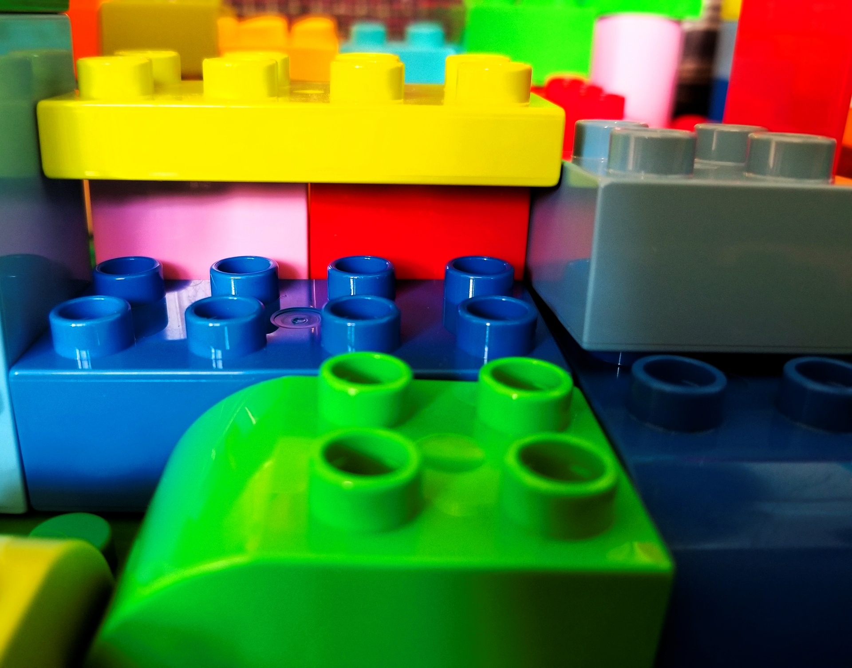
How I'm using LEGO to teach Arabic

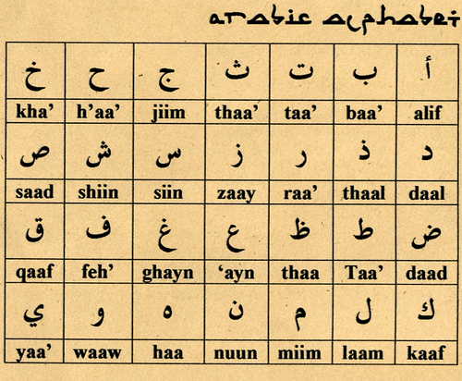
The speaker of this Ted, Ghada Wali is a graphic designer. She was born in Egypt and has designed fonts or design-driven art projects. When she studied in Italy, she went to a library, and she noticed there were only books about ISIS, terrorism or destruction and were not any of literature or poetry at the place of the category of “Arabic/Middle Eastern books”. So, she started to think about combining innocence and Arabic identify.

https://www.ted.com/talks/ghada_wali_how_i_m_using_lego_to_teach_arabic/transcript?subtitle=ja

Questions

- Why Ghada Wali thinks that graphic design can change the world?

2. According to her, what is the road to more tolerant communities?

3.What are the difference between Arabic and Latin?

4. What information are written for each letter in the book?

5. What contents are in her pocketbook for Arabic?

Dictations
1. Visual communication was the medium that spoke far louder than words when _____________________________________________ were suppressed for almost 30 years.

- It was precisely this political and social suppression, ___________________________________________________that slowly eroded the significance of the Arabic script in the region.

3. It's because we are _______________________, is that I can see a future ________________________ all come tumbling down.

1.Do you know any writers or poets of Arabic or Middle Eastern?
2.Have you ever tried to learn Arabic? Or do you want to do so?

Answers
- Because it helped overthrow two separate dictators in her own city of Cairo.
- Effective communication and education are.
- Different baselines, connectivity, punctuation and diacritics. And Arabic does not have capital letters but has 4 different letter forms.
- the letter is explained in form, sound and examples of words in function, in addition to the equivalent in Latin.
- It has 29 Arabic letters and the 4 different forms, plus a 400-word dictionary.

- the population of over 90 million voices
- coupled with decades of colonialism and miseducation
- all made of the same building unit
where the barriers between people

