

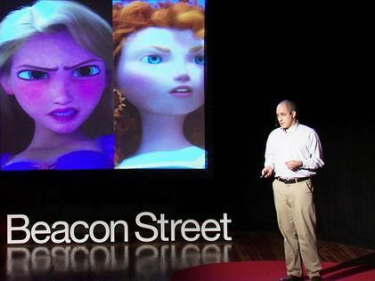

Active Learning Assignment 1

TED Video: How Movies Teach Manhood
Colin Stokes: How movies teach manhood | TED Talk

Why I Chose This Presentation
This presentation points out the effect movies can have on the audience without them realizing it. Children movies are thought that they are peaceful, happy-ending, and full of hope. However, they often depict characters that fit and strengthen gender roles influencing children to learn what it is to be a “man” or a “woman”. This talk makes us rethink and revalue the movies we watched as a child. At the same time, it helps us look into the social structure or events that regenerate gender norms.


Vocabulary & Grammar Practice
Read the sentences mentioned during the presentation. Write the words in bold next to their definitions.
- The wizard would say, "Dorothy, you are the savior of Oz that the prophecy foretold.
- Provide the adequate context that I could have used in navigating the adult world that is co-ed.
- It's almost as though if you're a boy, you are a dopey animal,
- It has not yet caught on and caught fire, but maybe today we will start a movement.
- It pretty much flunks the Bechdel test.
- We've got quite a few scenes of the men having deep, angst-ridden conversations
- Are we soaking up that story?
- We have tools at our disposal like "girl power," and we hope that that will help
- I want fewer quests where my son is told, "Go out and fight it alone,"

- To start burning > To gain popularity
- Available to be used by ourselves
- Something someone says about what will happen in the future
- Having feelings of angst
- Wanting to sleep, because or as if you have taken a drug
- To enjoy the effects or experience of something as much as possible/ To understand and remember information well
- To fail an exam or course of study
- A long search for something that is difficult to find, or an attempt to achieve something difficult
- With both male and female students
from Cambridge Learner’s Dictionary and Oxford Learner’s Dictionary

Questions for You to Think
  - What is the Bechdel test?

  - What movie did you like when you were a child? What characters are in that movie?

  - Related to the above question, are there any messages that the audience might receive from that movie?

  - What kind of gender stereotypes can you find in entertainment works such as films, dramas, and music videos?


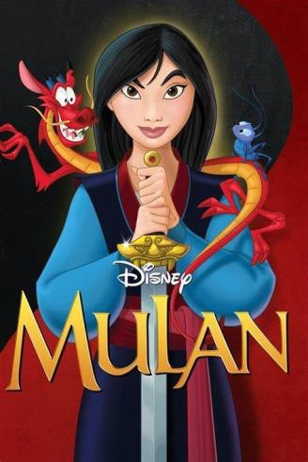

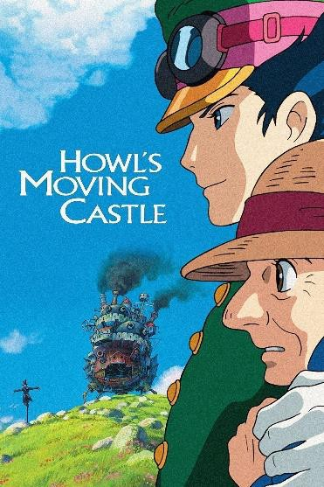
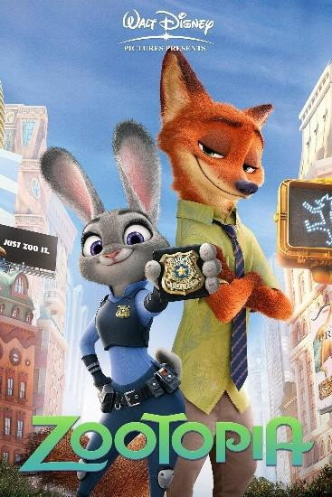
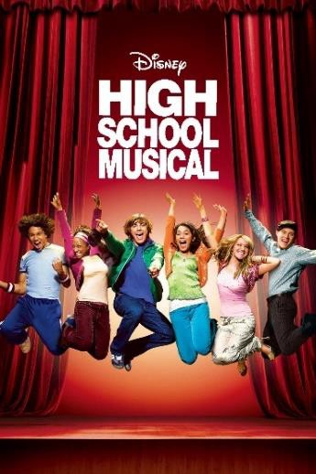

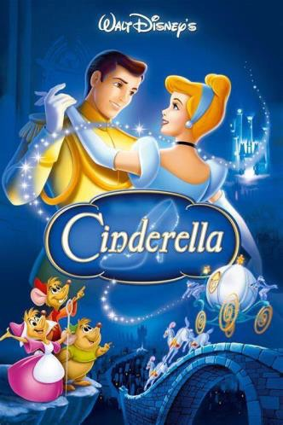

  - How should society deal with the problem of children being influenced by the entertainment industry?

  - In addition to movies, social media is within the reach of children today. How are they affected?

Activity
Sorting Games: How can we sort these movies out? What effect may these films have on the
audience? (Choose one or more movies below. If you have never seen any of the movies, you can imagine from the poster)
>After doing it alone, discuss your answers with other people

Answers

Vocabulary & Grammar Practice
- caught fire (catch fire)
- at our disposal
- prophecy
- angst-ridden
- dopey
- soaking up (soak up)
- flunks (flunk)
- quests (quest)
- co-ed

Questions
  - What is the Bechdel test?
The Bechdel test is a test composed of three questions. The three questions are “Is there more than
one character in the movie that is female who has lines?”, “Do these women talk to each other at any point in the movie?”, and “Is their conversation about something other than the guy that they both like?” This test was made by a comic book artist named Alison Bechdel. This test can play a part in measuring the representation in a movie.

  - What movie did you like when you were a child? What characters are in that movie?
Example: I liked “The Little Mermaid” from Disney. The main characters were Ariel, a princess in the ocean, Flounder, a friend fish of Ariel, Sebastian, a crab that watches over Ariel, Ursula, a villain,
Prince Eric, and so on. The female characters above are Ariel and Ursula, and the male characters are Flounder, Sebastian, and the Prince.

  - Related to the above question, are there any messages that the audience might receive from that movie?
Example: Kissing a Prince is happily ever after. Boy can be one of your best friends. Ideal woman is pretty and young.

  - What kind of gender stereotypes can you find in entertainment works such as films, dramas, and music videos?
Example: Women are often depicted as rather extremely strong or gentle. In Japanese romance films and dramas, the woman is preferred to be kind, gentle, and quiet. Strong women are often not

married. As for men, dangerous or mysterious types are depicted as someone attractive in
entertainment content for teenagers. Loving sports and being in good shape are connected with masculinity.

  - How should society deal with the problem of children being influenced by media and entertainment?
Example: Increasing the variety of content for children, for example, not only cartoons but also
documentaries targeting children. Regularly check each company’s work and announce how much it achieves in terms of diversity and inclusion.

  - In addition to movies, social media is within the reach of children today. How are they affected by this new technology?
Example: Children are more likely to be exposed to inappropriate content such as hate speech or pornography. It’s more difficult for parents or other adults to keep an eye on or to have control over what children are watching.

Activity
Example answers:
Movies can be divided into “Japanese movies or foreign movies”, “Movies that set the main target to children or those that are mainly targeted to adults”, “Movies with women as main characters or
those that do not female leading characters” etc.
(Messages which Justice League might send) Women should wear clothes that show more skin. Woman is a peacemaker, a person who stops the fight in a group. Women should be strong but not big size. Men should fight hiding their dark side or weakness.
(Messages which High School Musical might send) High School Musical shows that girls tend to be indoors doing things like studying, and boys are good at sports. Ideal high school life is composed of friendship and love. Boys are the ones who take initiative in relationships.

