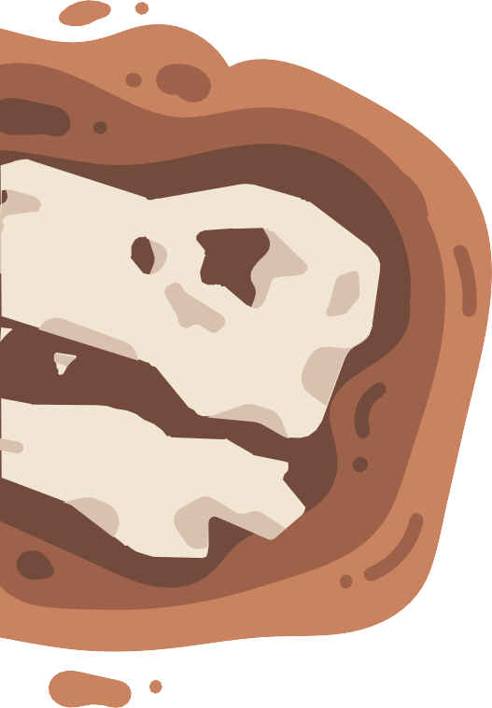
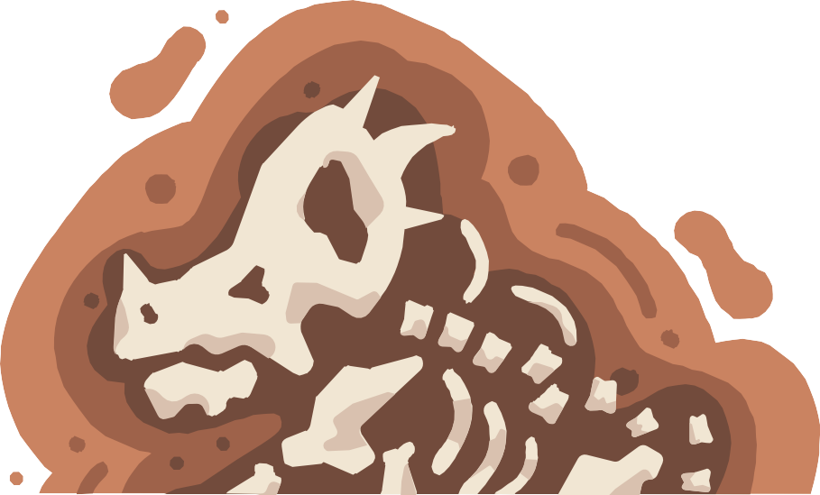
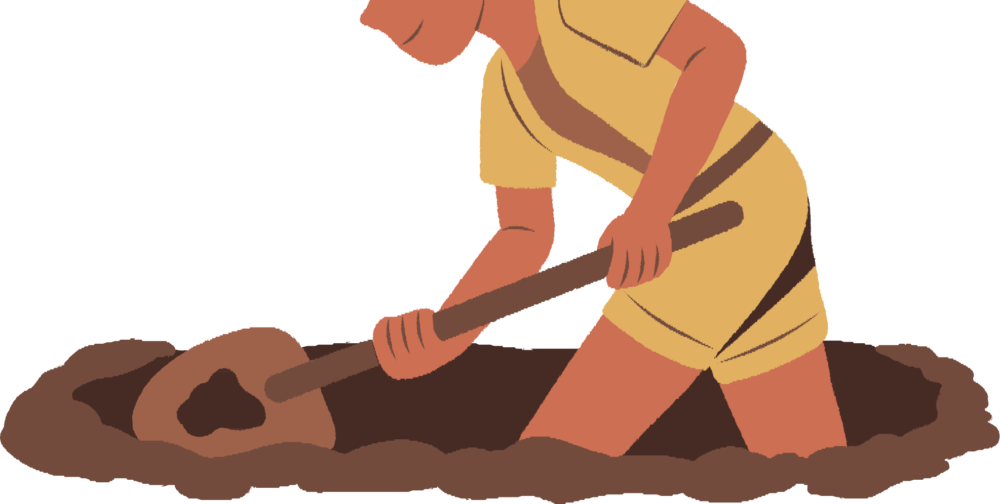
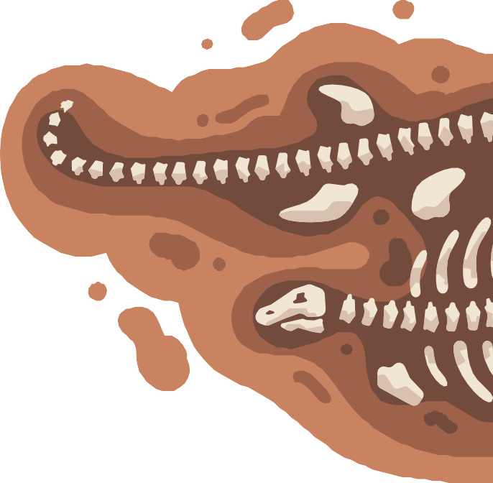
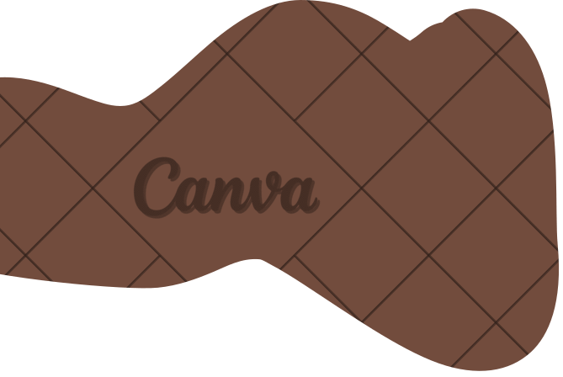
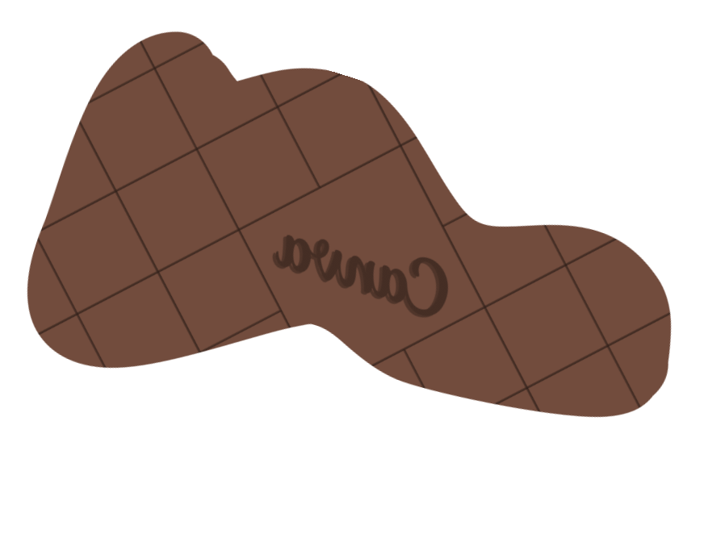
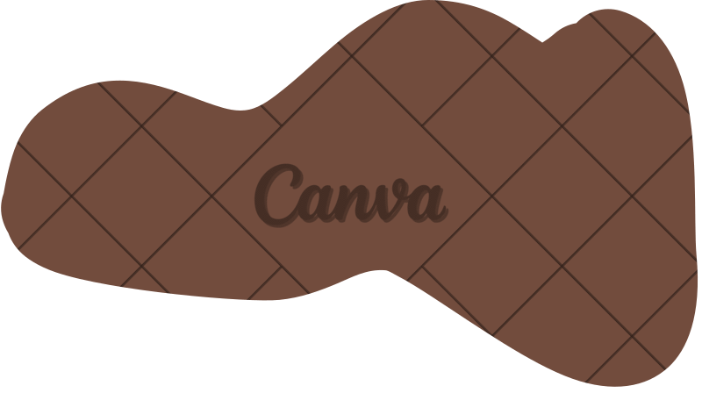
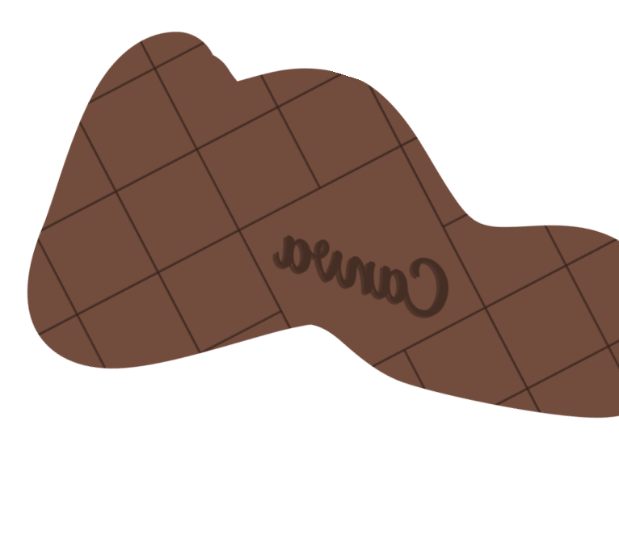

HOW TO FOSSIILIIZE......
YOURSELF

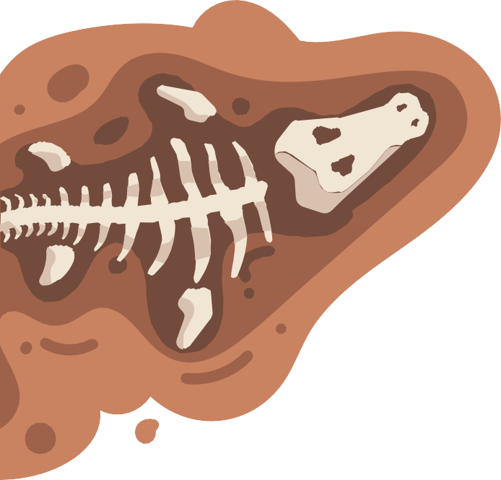
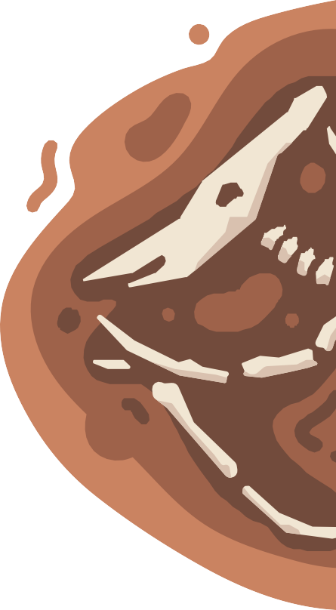
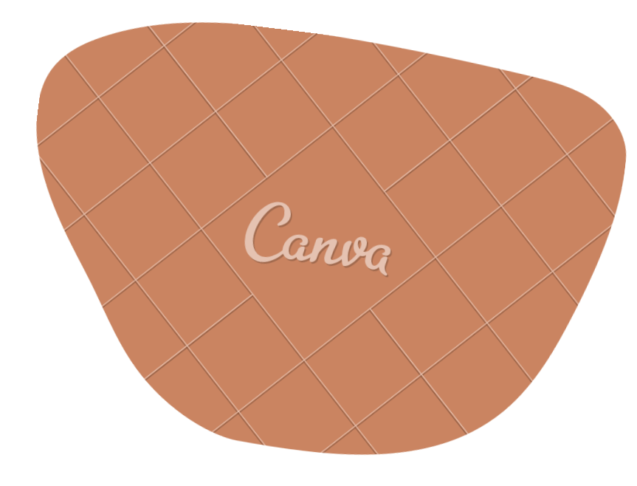
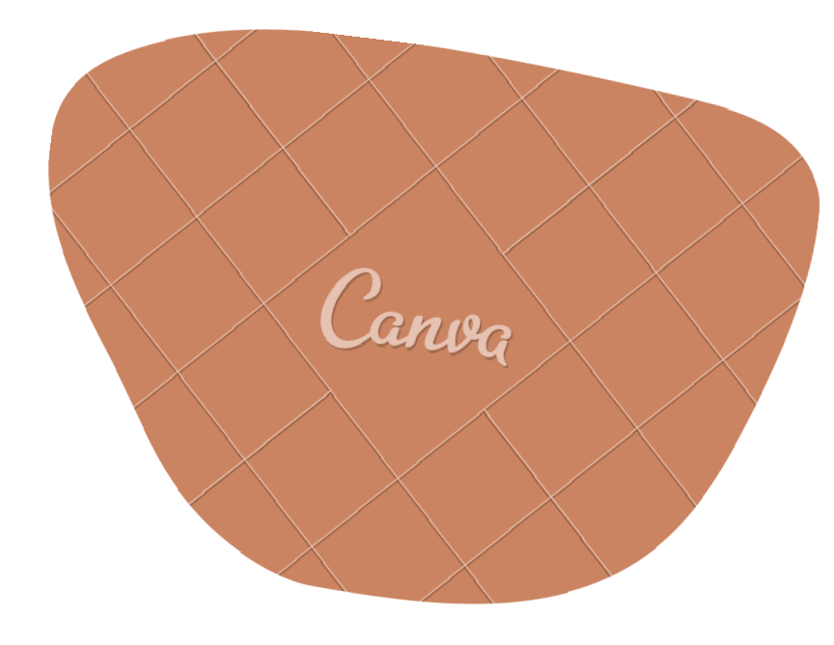
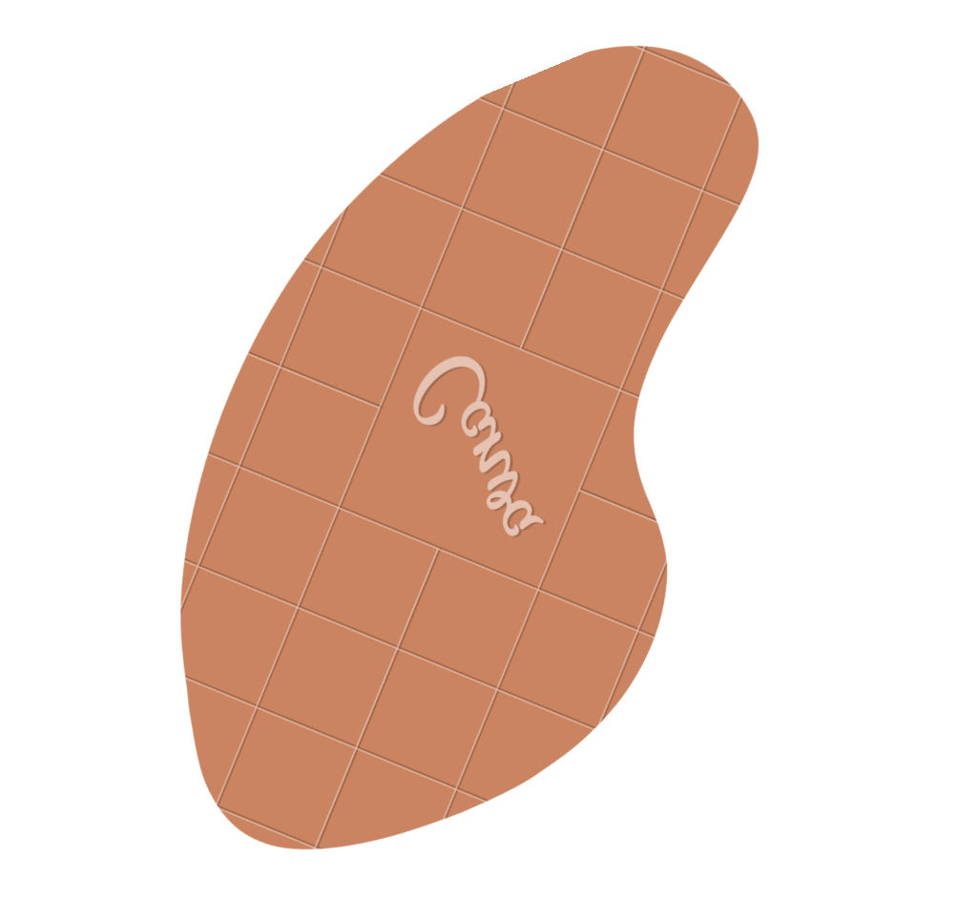
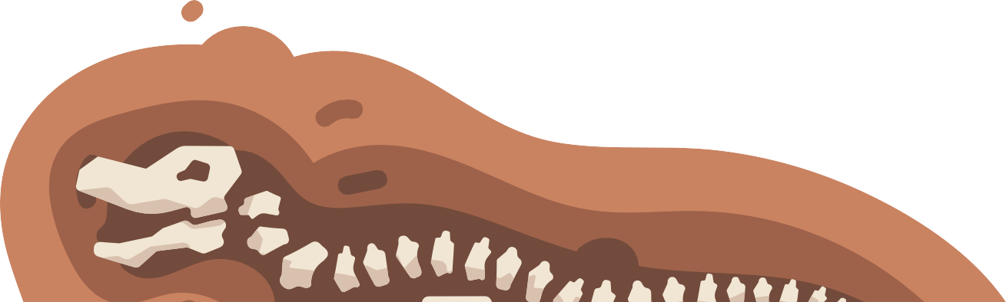
THE VIIDEO
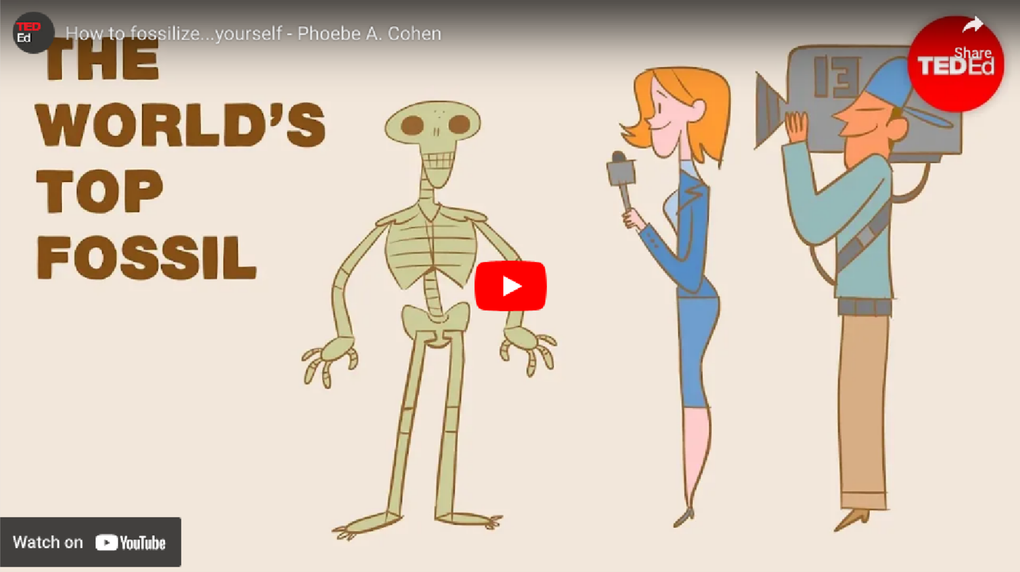
Presented by Phoebe A. Cohen


HOW MUCH DO YOU
KNOW ABOUT FOSSIILS?

Fossils are important proof that life and the environment have changed over time.
Thanks to geologists’ and archeologists’ work, their effort, and their contributions to the knowledge of science and history, many facts have been revealed for a long time.
But, in the first place, how are fossils formed?
In this video, you can learn the process of fossil formation and know how to fossilize yourself!

WHY II CHOSE THIIS VIIDEO?

At first, the title of this video caught my eye. Then, I thought “Is it possible to fossilize myself?”. I had never wanted to do so, but the idea sounded interesting to me. If I can fossilize myself, I can get people’s attention forever just because I’m a fossil. That means that even if I accomplish nothing, I can be treated preciously. I thought it was worth doing. Moreover, if my descendants exhibit me as a fossil, they may have a chance to get money.
For these reasons, I was curious about the way of fossilization.

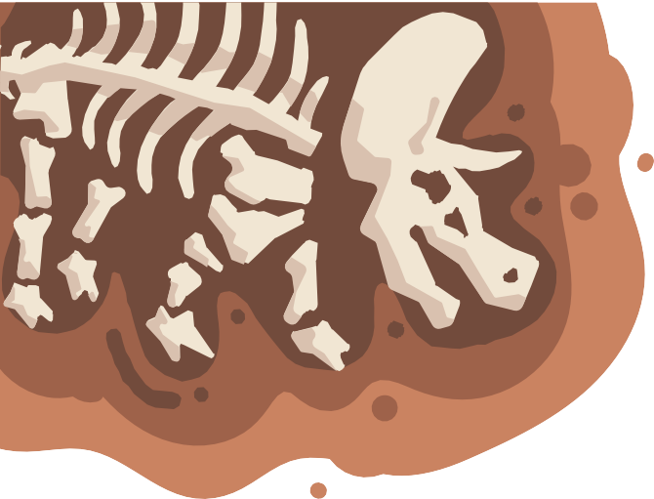
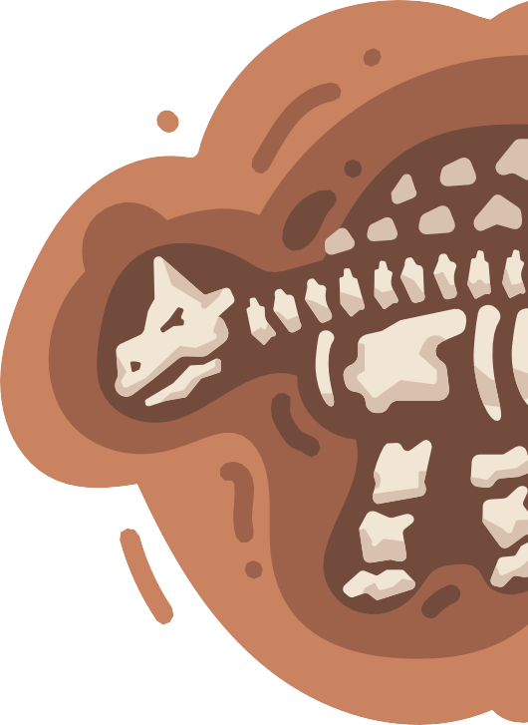
BEFORE WATCHIING THE VIIDEO
 corpse a dead body
paleontologist a person who studies or is an expert in the branch of
science concerned with fossil animals and plants
sap the liquid in a plant or tree that carries food to all its parts.
amber a hard, transparent, yellowish-brown substance that was formed in ancient times from sap
intact not damaged or impaired in any way; complete
precipitate cause (a substance) to be deposited in solid form from a solution
lithify transform (a sediment or other material) into stone
subduct to draw or turn downwards

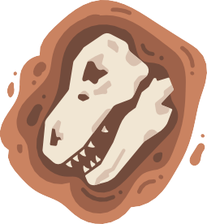
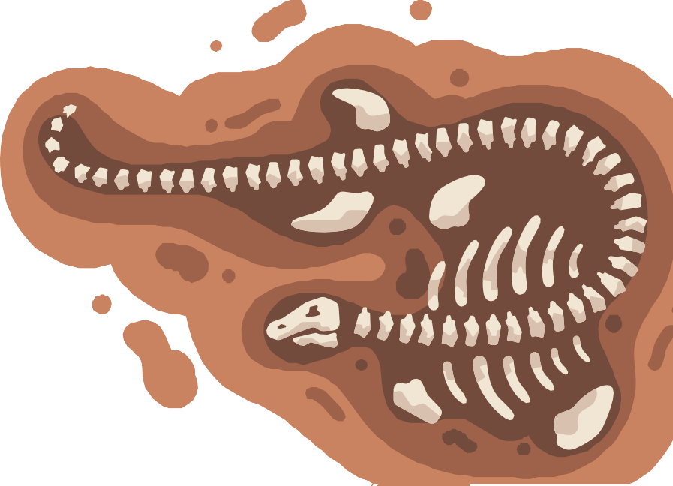
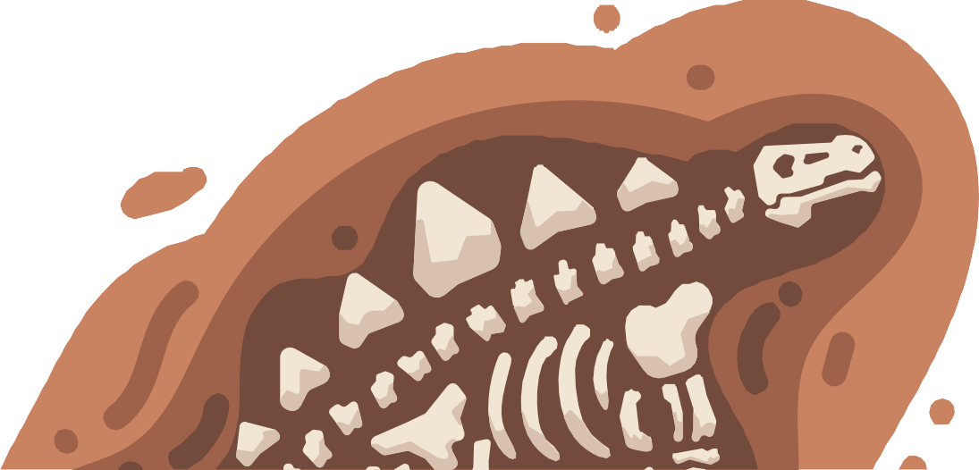
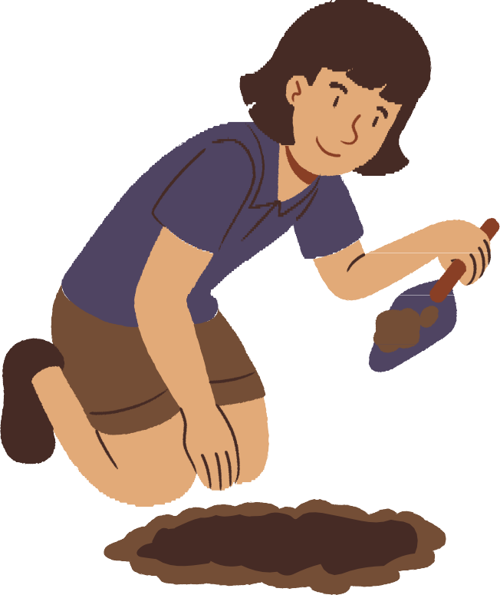
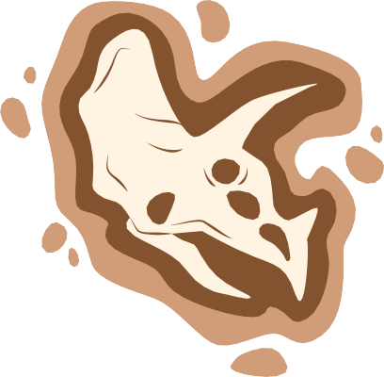
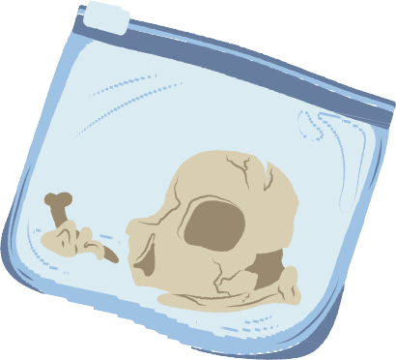
QUESTIIONS

Chose the correct answer for each question!

①THE BEST PLACE TO DIIE IIF YOU WIISH TO BECOME A FOSSIIL IIS::

- A mountain top

- A pine forest

- A shallow ocean

- A prairie

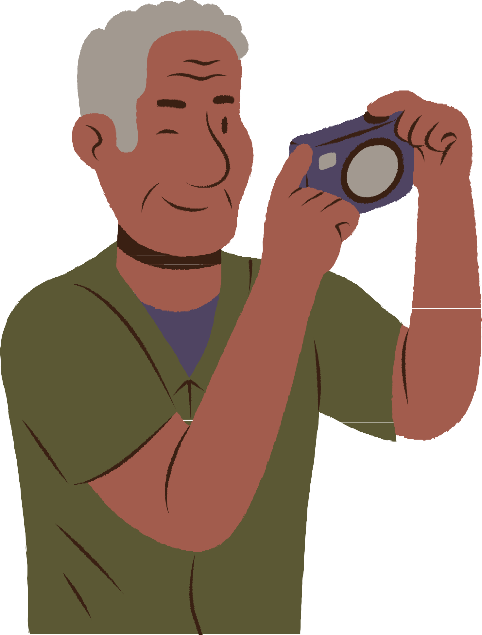
②WHIICH OF THE FOLLOWIING FOSSIILS AN EXAMPLE OF
PERMIINERALIIZATIION?
- A fossilized dinosaur bone

- An insect trapped in amber

- A frozen wooly mammoth

- A dinosaur footprint


③WHIICH OF THE FOLLOWIING PROCESS ARE NOT LIIKELY TO RUIIN YOUR CHANCES OF BECOMIING A FOSSIIL?
  - Erosion

  - Scavenging

  - Sedimentation

  - Plate tectonics



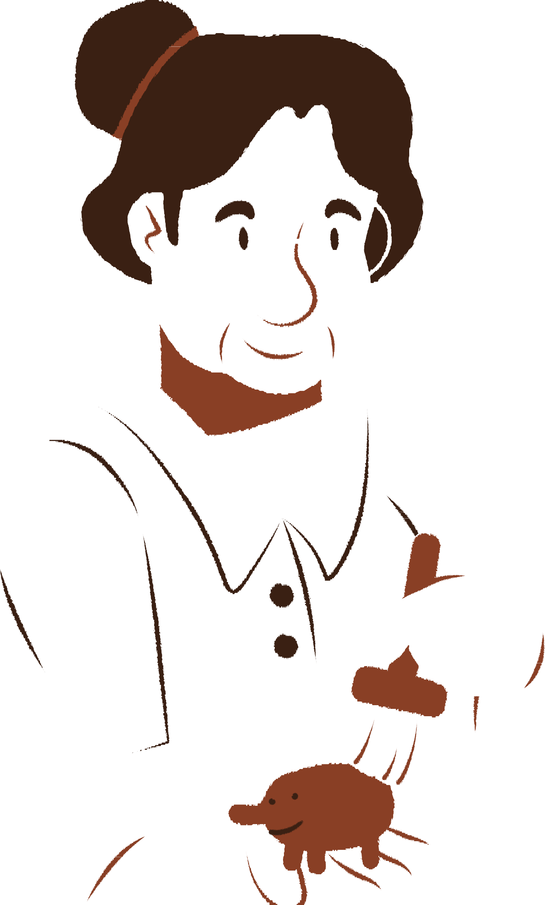
④WHIICH OF THE FOLLOWIING IIS LEAST LIIKELY TO BECOMIING A FOSSIIL?

    - A clam shell

    - A slug

    - An elephant

    - A pine tree

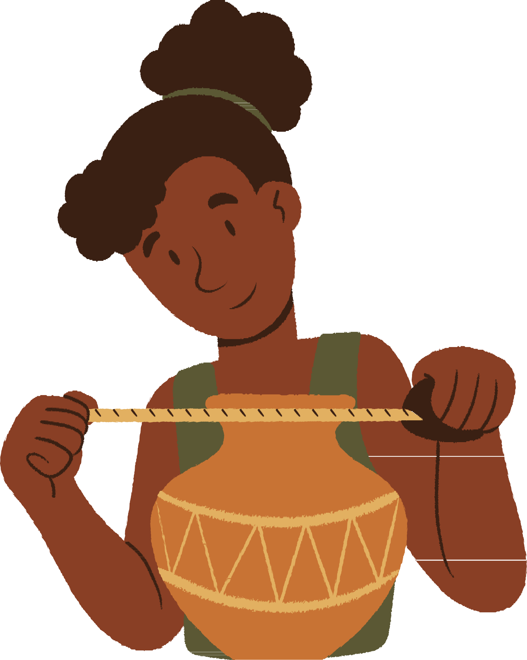
⑤WOULD A DRY CAVE BE A GOOD PLACE FOR PERMIINERALIIZATIION TO OCCUR?
- No, because permineralization requires amber from trees to occur

- Yes, because permineralization requires a dry environment

- No, because permineralization requires flowing water

- Yes, because permineralization requires a dark environment

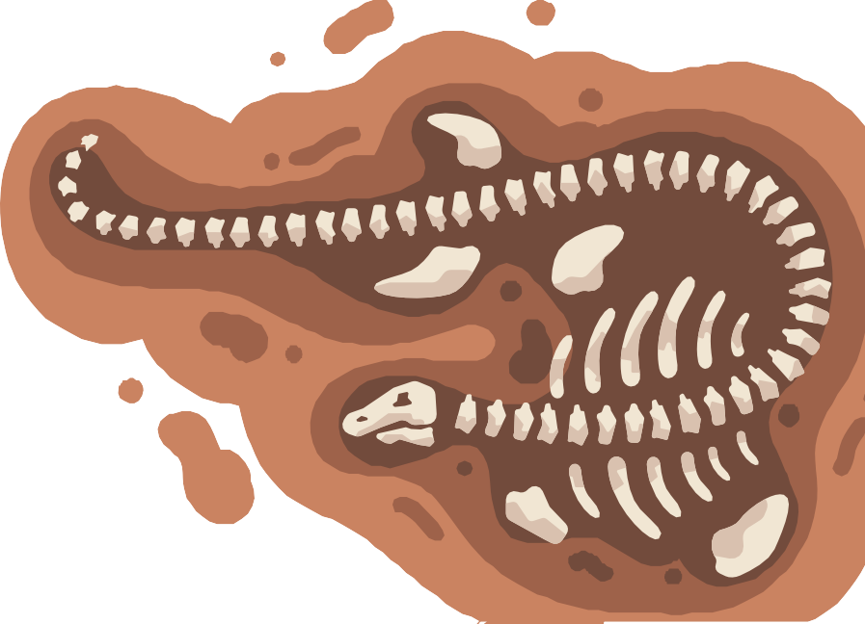
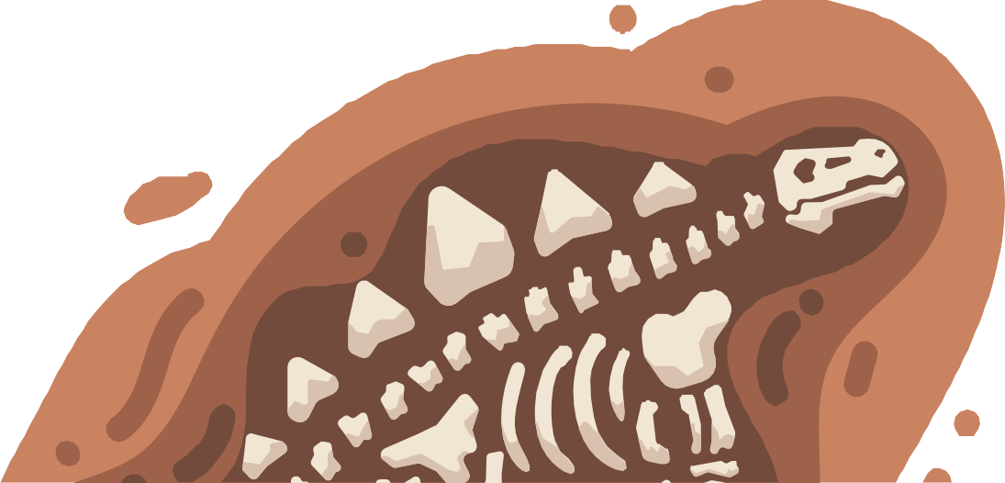
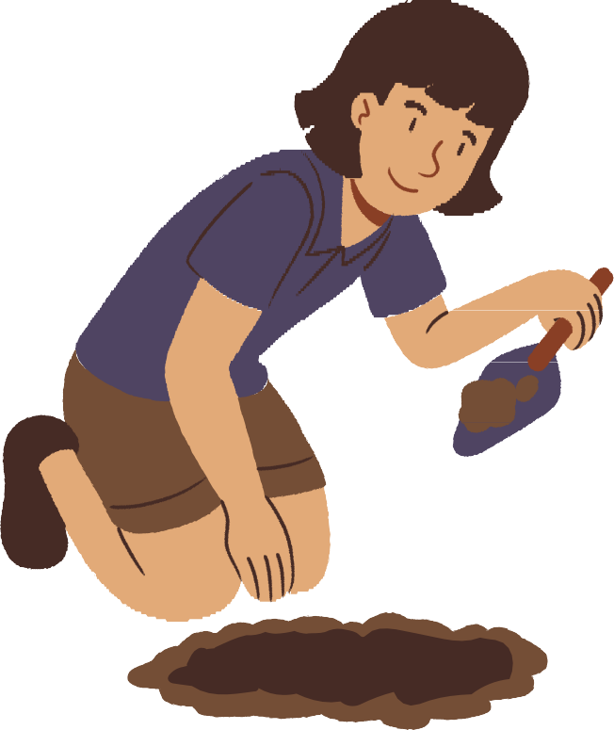
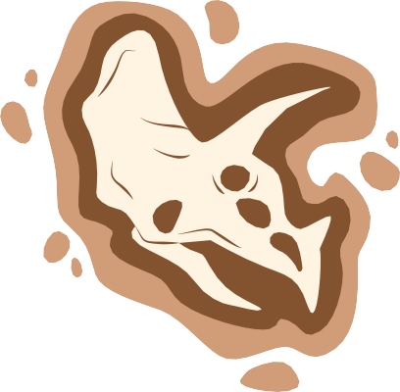
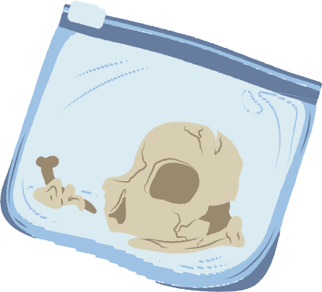
DEEPER
QUESTIIONS

Answer freely in sentences!

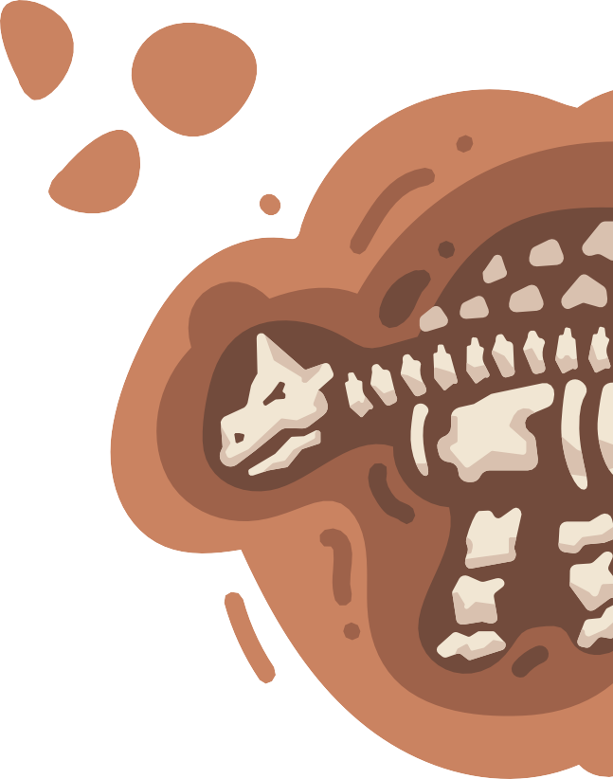
DEEPER QUESTIIONS
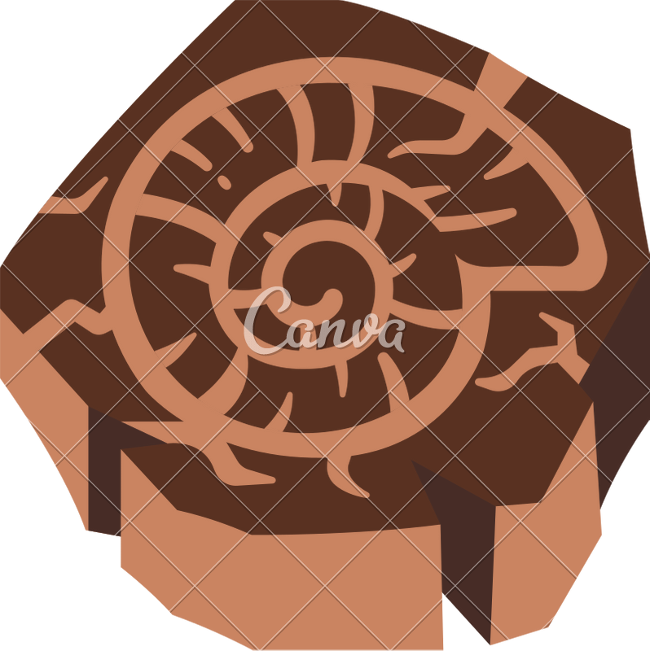
- Do you want to fossilize yourself? Why?/Why not?

- Do you like going to museums?/Do you want to go to museums? Why?/Why not?
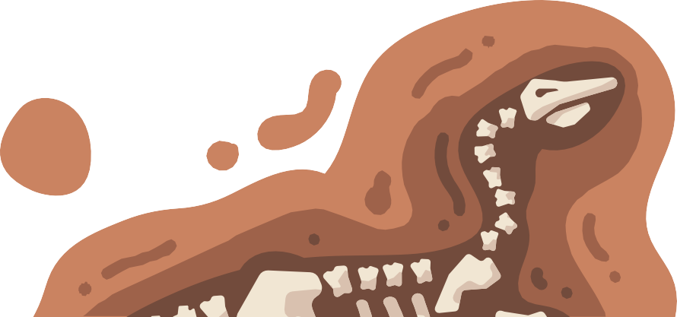
- If you can bring extinct animals back to life (like Jurassic Park), do you want to do so?

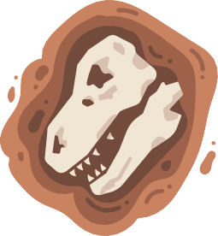
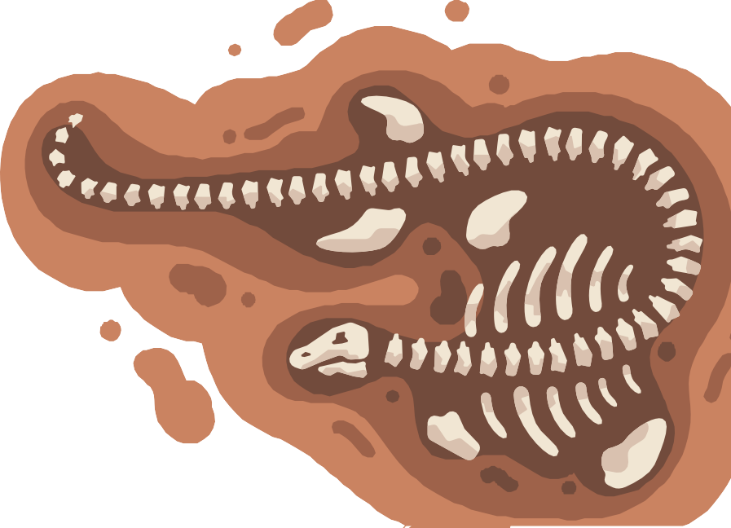
FUN QUIIZZES

Is this a fossil or not?
Answer ○ or ✕.

FOSSIILS OR NOT

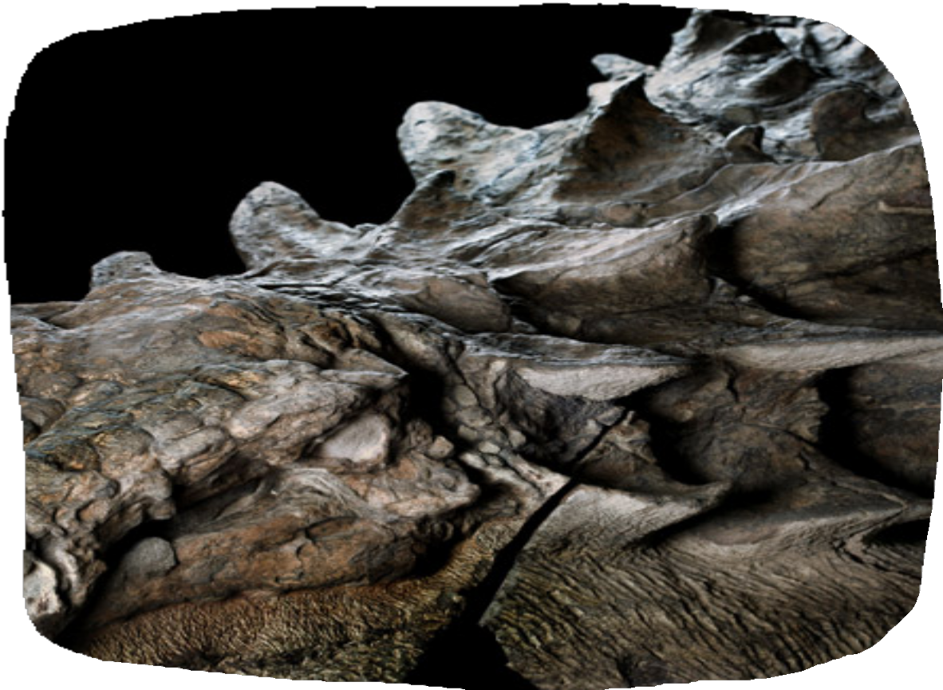
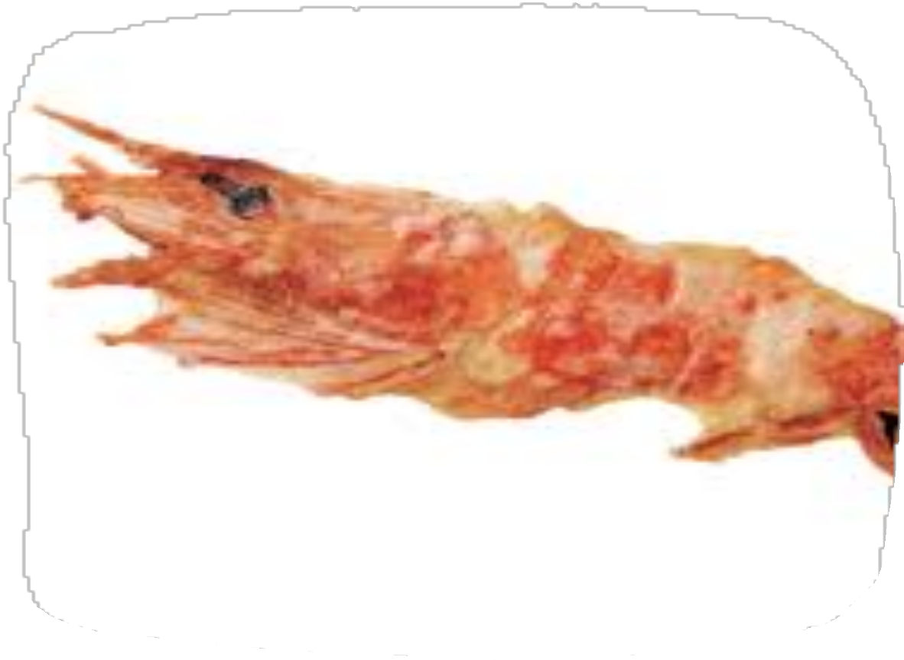
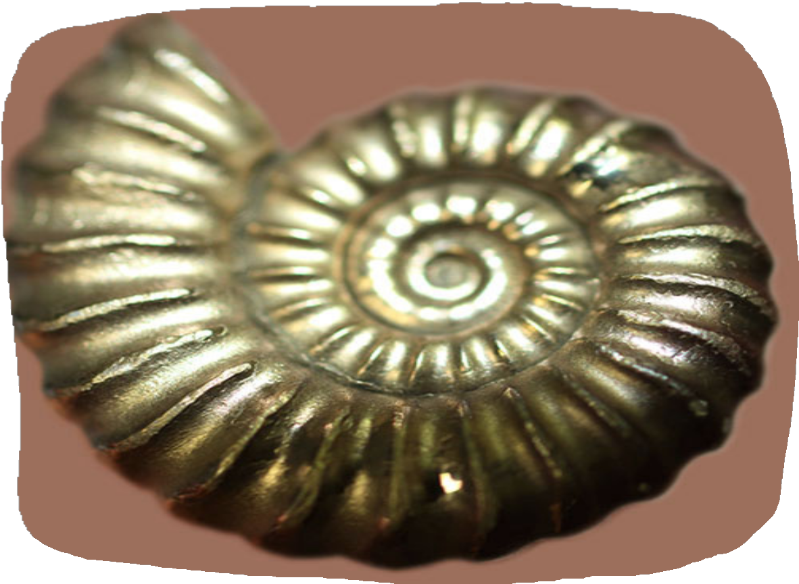
① ② ③

FOSSIILS OR NOT

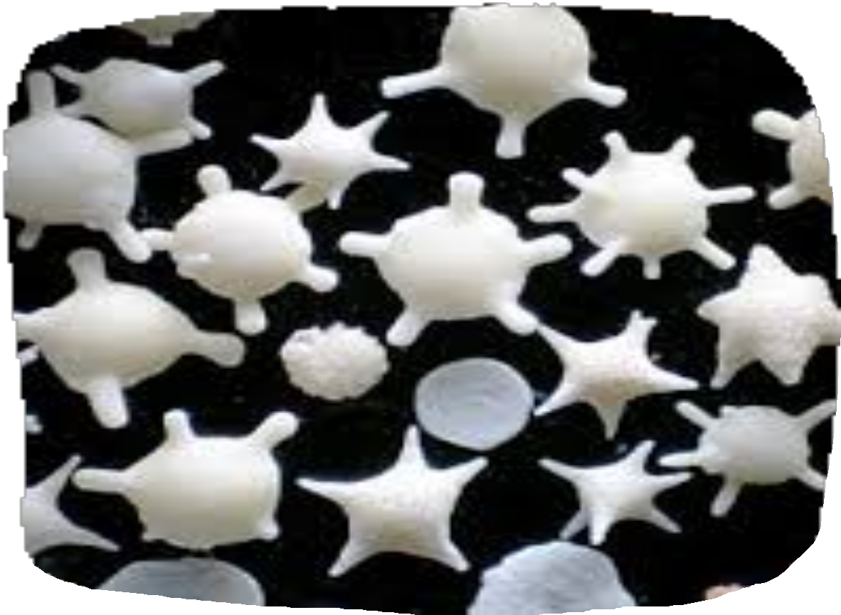
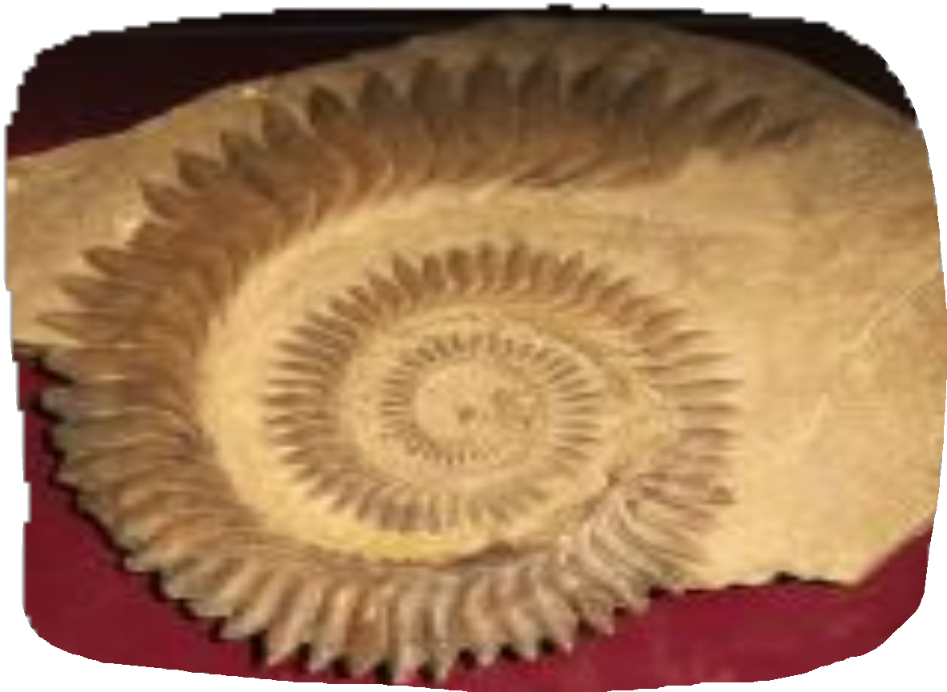
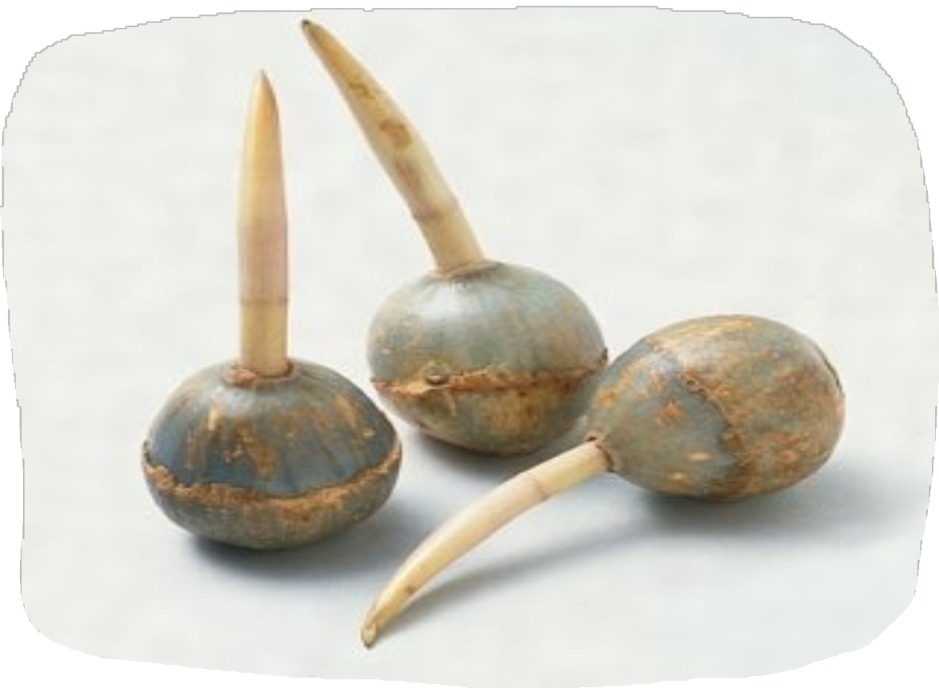
④ ⑤ ⑥

Questions
ANSWERS

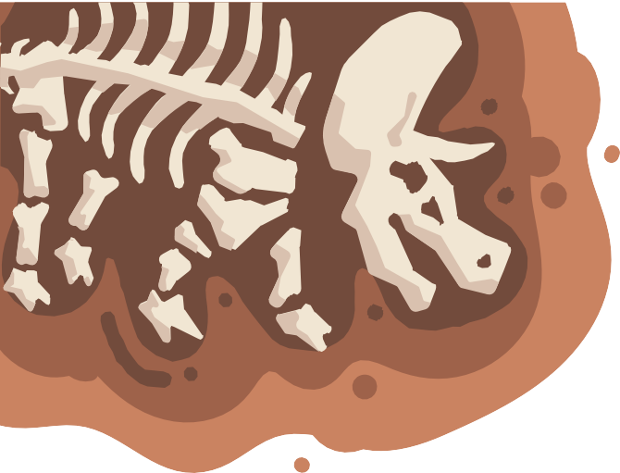
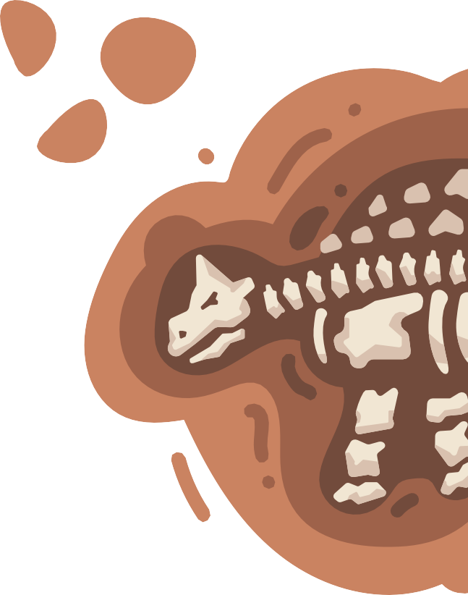
①C ②A ③C ④B ⑤ C
Fun Quizzes
① ○ ② ✕ ③ ○ ④ ✕ ⑤ ○ ⑥ ○

① A fossil of nodosauridae in good condition
② A senbei of shrimp
③ A fossil of ammonite whose only component has been replaced with pyrite
④ Dead foraminifera, a protozoan with a calcium carbonate shell. Commonly known as "star sand".
Not fossilized.
⑤ Shark with rounded lower jaw, Helicoprion fossil
⑥ The combination of a fossil of scaphopoda and a concretion which is formed when the carbon
inside reacts with the calcium in the ground

