

Active Learning 1


Topic
“How to live to be 100+” - Dan Buettner

Reference : https://www.ted.com/talks/dan_buettner
_how_to_live_to_be_100

The reasons why I chose this topic
- I would like to tell what I learn from the lecture to my grandparents who are in their 80s.
- I am interested in health and longevity.
- I found it interesting that Okinawa was introduced as one of the regions of longevity.

  - longevity - living for a long time
  - debunk - to show that something is less important, less good, or less true than it has been made to appear
  - cartilage - a type of strong tissue found in humans in the joints
  - artery - one of the thick tubes that carry blood from the heart to other parts of the body
  - clog - to (cause something to) become blocked or filled so that movement or activity is difficult

  - exponentially - in a way that becomes quicker and quicker as something that increases becomes larger
  - diabetes - a disease in which the body cannot control the level of sugar in the blood
  - centenarian - someone who is 100 years old or more
  - archipelago - a group of small islands
  - heterogeneous - consisting of parts or things that are very different from each other

- According to the Danish Twin Study, what percentage of life expectancy is determined by genetics?
- What determines most of our lifespan?
- How many cells do our bodies have?
- According to the lecturer, how many times faster is a 65- year-old aging than a 12-year-old?
- How many years of age is it described that a person could live to if they could maximize their human capacity?

- In the Sardinian society, how are older people treated?
- What is the way of eating called, which is to stop eating when you are 80 percent full?
- In Okinawa, there is a system where you automatically have friends. What is it called?
- “The reason for which you wake up in the morning” is said to be related to longevity. In the lecture, how is it explained in Japanese?
- What type of diet is common between Sardinia and Okinawa?

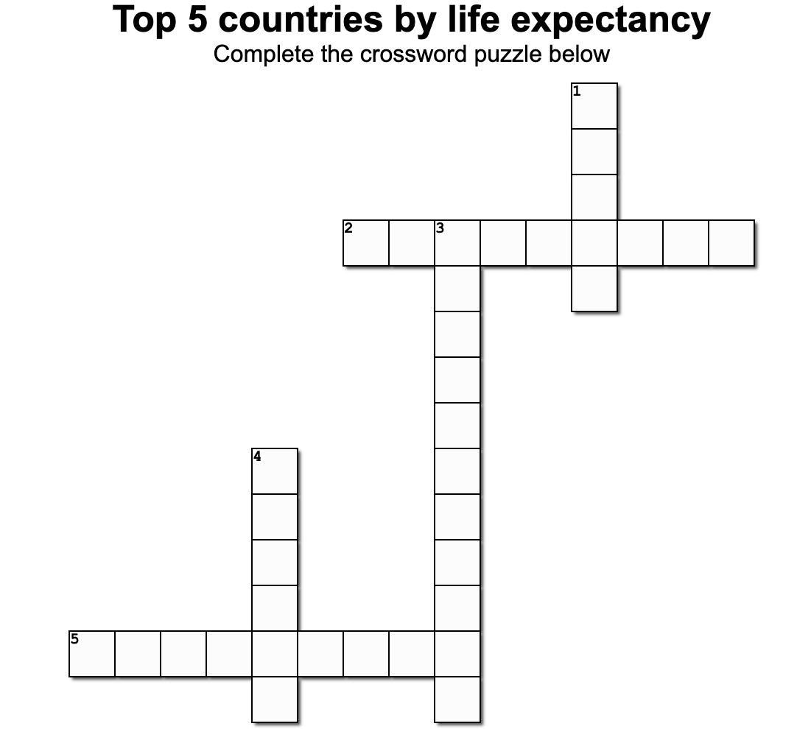
Fun activity

Across
2. The capital city is Canberra
5. Merlion is a symbol of this country

Down
1. The capital city is Tokyo
3. The capital city is Seoul
4. The capital city is Oslo

8

- About 10%
- Our lifestyle
- 35 trillion cells
- About 125 times faster
- 90 years

- They are treated equitably.
- Hara, Hachi, Bu diet
- A Moai
- ‘Ikigai’
- Plant-based diet

The answers to the fun activity

- Japan
- Singapore
- South Korea
- Norway
- Australia

