TED TALKS: How we can make the world a better place by 2030

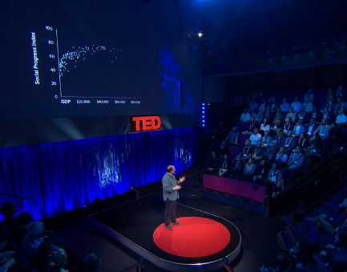
Can we end hunger and poverty, halt climate change and achieve gender equality in the next 15 years? The governments of the world think we can. Meeting at the UN in September 2015, they agreed to a new set of Global Goals for the development of the world to 2030. Social progress expert Michael Green invites us to imagine how these goals and their vision for a better world can be achieved.

https://www.ted.com/talks/michael_green_how_we_can_make_the_world_a_better_place_by_2030?language=en

1. Why chose it
Recently in Japan, people keep saying that it is important to achieve Global Goals such as SDGs.
However, I only know the word and do not know about it well. Therefore, I chose this video so that we can learn the importance of to achieve a new set of Global Goals.

2. Before watching the video
◦run the numbers: to estimate, calculate
(Ex. We’ve run the numbers, and the answer.)

◦flagship(adjective): most important, primary, major
(Ex. the flagship target)

◦doomsayer: people who predict that bad things will happen
(Ex. Doomsayers who say that the world can’t get better are simply wrong.)

◦flood tide of: numerous, large number of
(Ex. Even a flood tide of economic growth is not going to get us there,)

◦hold someone to account: hold someone responsible for his or her mistakes and failures
(Ex. We can hold our leaders to account to achieve this target.)

3. Fill in the blanks while watching the video
１. The target was to take from a baseline of , when percent of the world’s population lived in poverty, to get to percent poverty this year.

２. The Social Progress index all this together using indicators to create an aggregate score a scale of 0 to 100.

３. And what this us is that as we get , social progress does tend to . However, as we get richer, each dollar of GDP is buying us
and social progress.

4. Think and answer the questions

Q1. He claimed that we must become rich in order to get to the Global Goals. ___C・W

Q2. The goal of halving the percentage of the poor by 2015 was not achieved. ___C・W
→What was the final result?
Q3. Please list what you can do in order to achieve the Global Goals (even if it is a small thing.)
・

Q4. In the region you major, how do people think about to achieve the Global Goals?

