How Webtoons Are Changing Movies and TV

Have you ever read comic books on the Internet? “Webtoons” have been one of the most popular ways of killing time on the train, I think. Actually, I am a reader of webtoons, so I was surprised at the fact that webtoons have had an influence on many things and people.
What did webtoons change? What benefit can we get from the spread of webtoons? Watch the video and find the answers.

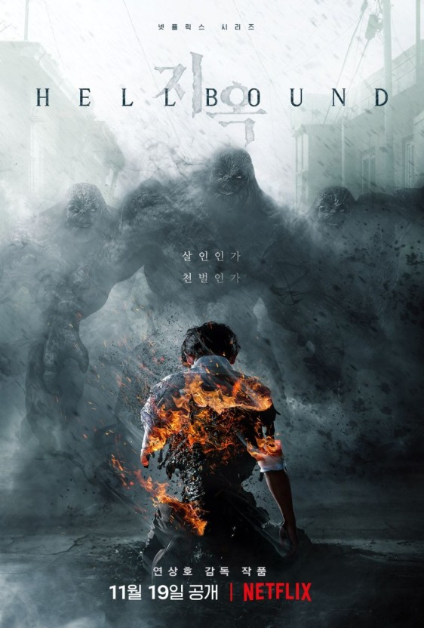
Words
Vocabulary Help
- unheard: not previously known of or done
- blockbuster: a book or movie that is very successful
- cliché: a phrase or opinion that is overused and betrays a lack of original thought

Synonymous; think of the synonymous of the following words
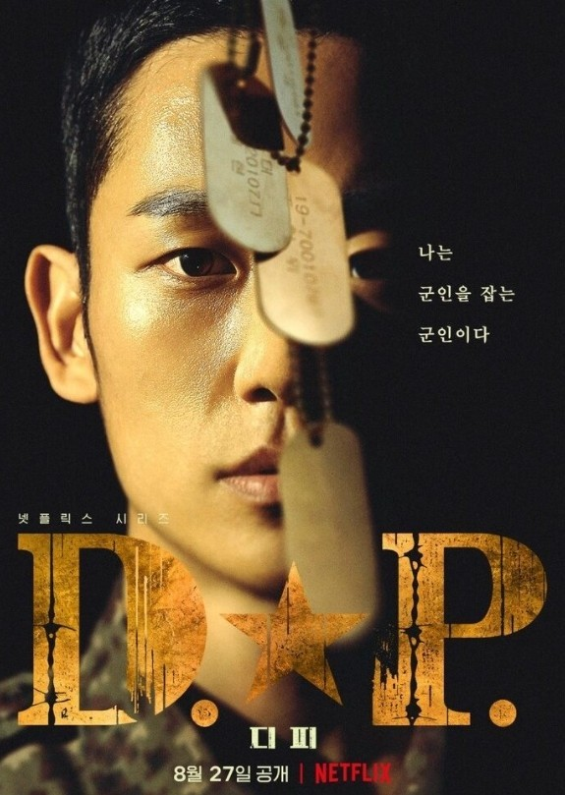
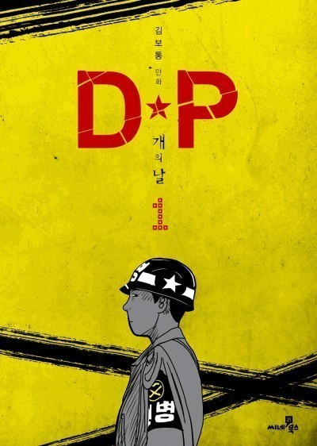
①bizarre
②unheard
③blockbuster
④cliché
⑤fabulous
⑥mythology

Comprehension Check
- What is webtoons?
- What is one of the major webtoon platforms in the U.S?
- What types of executives has she met?
- What is the benefit for writers of webtoons?
- What impact did True Beauty’s author have on Korean society?

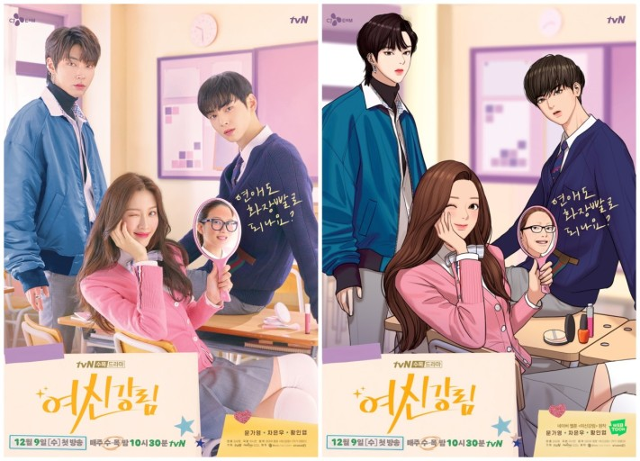
Discussion on The Topic
These days, more and more people prefer to use digital books. What are the reasons for this? Which do you prefer, digital books or printed books? Why?

Answers
Synonymous
①unusual, strange
②unprecedented
③megahit
④platitude
⑤very good, excellent
⑥folklore

Comprehension Check
- It is comic-like illustrations published in short segments once a week and meant to be read on a smartphone in five to ten minutes.
- Naver webtoon
- Those who start to realize the webtoon universe is a treasure trove of new and fabulous stories just waiting to be made into movies or TV series, and those who cannot fully capitalize on this phenomenon as well until they notice the worth.
- Web story authors get real-time feedback from the audience who reads each episode so that the writers get better faster.
- The author, who is a single mother, created a positive influence which made single-parent society much more public than before in Korea.

