TED Talks: How women wage conflict without violence

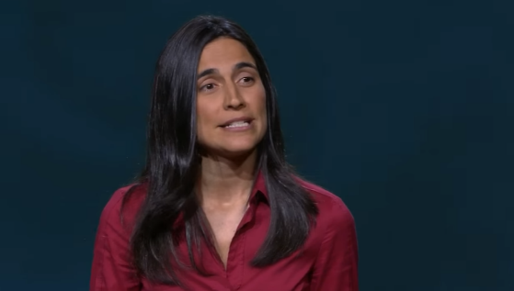
Julia Bacha explains the reason why nonviolent resistance is more effective than violent resistance. To adopt nonviolence resistance, the role of women in public life is important. She cites examples where this approach has been successful.

The reason why I chose this presentation
Discrimination against women in Afghanistan is frequently reported. Women are not able to receive education. This is why I am interested in women's rights. I thought this presentation would be useful in raising the status of women, as it stated that women play an important role in asserting their rights.

Before watching presentation

Q1 What do you consider important in order to wage constructive conflict? State briefly.

Watch the following video and answer the questions.
Julia Bacha: How women wage conflict without violence | TED Talk
Q2 According to the Victor Asal’s research, the greatest factor of a movement’s decision to adopt nonviolence is…
① Political perspectives (right-wing or left-wing)
② Repression
③ Ideology about the role of women in public life.
④ Religious beliefs

Q3. What is ‘a secret weapon’(4:08)？State briefly.

Q4 Understanding details Fill the blanks.

The first one is that I don’t believe women are inherently or ( ) more peaceful than men. But I do believe that in today’s world, women ( ) ( ) differently. Having had to ( ) being in the less powerful position in ( ) aspects of their lives, women are often more ( ) at how to surreptitiously ( ) for change against large, powerful actors.
Q5 In the middle east, cameras (the international community) are largely focused on the men because…

Q6 During the First Intifada, which activity happened more frequently?
A. Violent activity
B. Unviolent activity

Q7 True or False.
‘During the Intifada, many women were active at that time, and their achievements are well known around the world.’

Q8 In order to offer up role models to future generations, what we should do?
A. We should compare failed and successful political conflict.
B. We should lift up the women who played important roles in struggles.
C. Not given

Q9. What is her attitude toward women’s rights?
Words | Answers
1.tactic
2.pursue
3.colleague
4.adopt
5.cemetery
6.launch
7.multiple
8.inherently
A. Women will take up their rightful space in public life.
B. It will not change.
C. Not given

Q10 Match the following words with their meanings.

a. To begin something such as a plan or introduce something new
b. Very many of the same type, or of different type
c. A planned was of doing something.
d. An area of ground in which dead bodies are buried.
e. To follow someone or something, usually to try to catch him, her, or it.
f. To choose someone or something.
g. One of a group of people who work together.
h. in a way that exists as a natural or basic part of something.
Answers
Q1 Communication, Cooperation, Nonviolence, etc.. (Sample answers)
Q2 ③
Q3 For encouraged women to participate in public life. (Sample answer)
Q4 essentially, experience, power, navigate, multiple, adept, pressure
Q5 Men often end up involved in the more confrontational scenes which our international community find so irresistible in the news.
Q6 B
Q7 False
Q8 B
Q9 A
Words | Answers
1.tactic | c
2.pursue | e
3.colleague | g
4.adopt | f
5.cemetery | d
6.launch | a
7.multiple | b
8.inherently | h
Q10

