Is it possible to lose weight fast?
By Hei Man Chan (2022)


I have gained 20 kilograms in the last 6 months. This was a perfect topic for me, as I have had difficulty losing weight. The "ideal body shape" has put a sort of curse on people today, sometimes causing people to be unhealthy. I think this TED Talk would be useful for students who may suffer from that curse.

BEFORE YOU WATCH

VOCABULARY
Match the following words with their meanings.
a) bizarre - a small drop of a liquid

b) intake - to eat less food or only food of a particular type in order to
lose weight

c) droplet - a set of rules about food and exercise or medical treatment
that you follow in order to stay healthy or to improve your self

d) deficit - the amount of food, drink, etc. that you take into your body

e) replenish - very strange or unusual

f) deplete - to reduce sth by a large amount so that there is not enough
left

g) regimen - to make sth full again by replacing what has been used

h) dietary - the amount by which sth, especially an amount of money,
is too small or smaller than sth else

i) promise - to make sth seem likely to happen; to show signs of sth
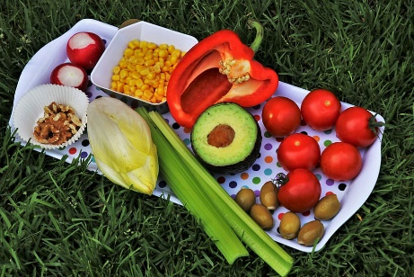
WATCH https://onl.la/Dr144PB
WATCH FOR MAIN IDEAS
Watch the TED Talk Is it possible to lose
weight fast? by Hei Man Chan and answer
the questions below.

- What were the dangerous diets popular in Victorian England at the time?
- What were Sam and Felix’s plan to lose weight?
c) What does speaker thinks would happen after Felix thought his diet was working?

AFTER YOU WATCH
One of your friend excessively reduces her caloric intake in an attempt to
lose weight.
Watch the TED Talk again and give her an appropriate advice.

Your friend

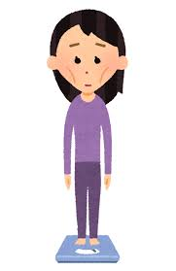


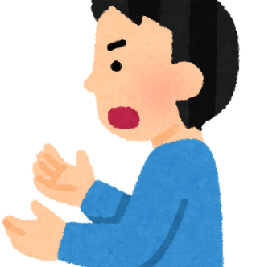
You

ANSWER

BEFORE YOU WATCH
a) bizarre - very strange or unusual

b) intake - the amount of food, drink, etc. that you take into your body

c) droplet - a small drop of a liquid

d) deficit - the amount by which sth, especially an amount of money,
is too small or smaller than sth else

e) replenish - to make sth full again by replacing what has been used

f) deplete - to reduce sth by a large amount so that there is not enough
left

g) regimen - a set of rules about food and exercise or medical treatment
that you follow in order to stay healthy or to improve your self

h) dietary - to eat less food or only food of a particular type in order to
lose weight

i) promise - to make sth seem likely to happen; to show signs of sth

WATCH
a) What were the dangerous diets popular in Victorian England at the time?
Dieters swallowed an unhatched tapeworm and let it grow inside them by consuming undigested meals.
b) What was Sam's plan to lose weight?
His plan was to gradually decrease his calorie intake and increase his regular exercise.
c) What did speaker say would happen after Felix thought his diet was working?
As soon as he stopped starving himself, his body would replenish its glycogen store and regain that weight.

AFTER YOU WATCH
Example
The diet you're on is actually very dangerous! If you eat very little, you'll get less exercise, lose muscle mass, and burn fewer calories. Then when you start eating again, you will gain weight quickly.
The key is to eat a diet based on what nutrients you need and exercise!

