Another Day Of Sun

La La Land

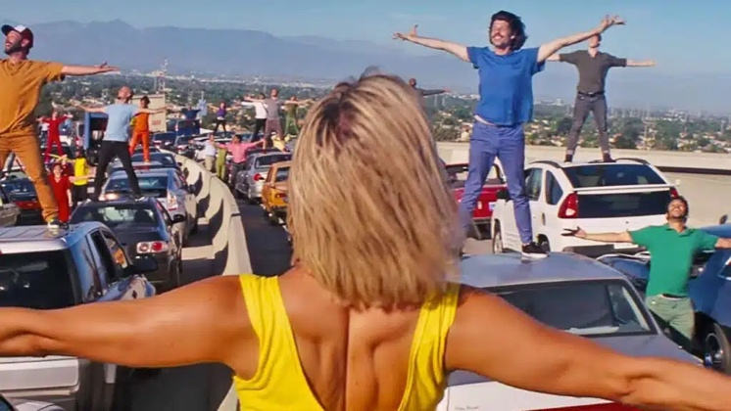

Verse
I think about that day
I left him at a Greyhound station, west of Santa Fé
We were 17, but he was sweet and it was true
Still I did what I had to do
′Cause I just knew
Summer Sunday nights
We'd sink into our seats
Right as they dimmed out all the lights
A Technicolor world made out of music and machine
It called me to be on that screen
And live inside each scene
Without a nickel to my name
Hopped a bus, here I came
Could be brave or just insane
We′ll have to see
'Cause maybe in that sleepy town
He'll sit one day, the lights are down
He′ll see my face and think of how he used to know me

Chorus
Behind these hills I′m reaching for the heights
And chasing all the lights that shine
And when they let you down (it's another day)
You′ll get up off the ground (it's another day)
′Cause morning rolls around and it's another day of sun

Verse
I hear ′em everyday
The rhythms in the canyons that'll never fade away
The ballads in the barrooms left by those who came before
They say, "You gotta want it more"
So I bang on every door
And even when the answer's "No"
Or when my money′s running low
The dusty mic and neon glow
Are all I need
And someday as I sing a song
A small-town kid′ll come along
That'll be the thing to push him on and go go

Chorus
Behind these hills I′m reaching for the heights
And chasing all the lights that shine
And when they let you down (it's another day)
You′ll get up off the ground (it's another day)
′Cause morning rolls around and it's another day of sun

Verse
And when they let you down
The morning rolls around
It's another day of sun
It′s another day of sun
It′s another day of sun (sun, sun, sun)
It's another day of sun
Just another day of sun
It′s another day of sun
The day has just begun
It's another day of sun

Outro
It′s another day of sun
