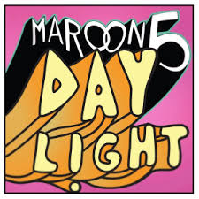
DAYLIGHT- Maroon5
Verse 1
Here I am ______ I’ll have to ______ soon
Why am I ______ on? We knew this day would ______

We knew it all ______ How did it come so ______?
Pre-Chorus
This is our last ______, but it’s late
And I’m trying not to ______
’Cause I know when I ______ I will have to ______ away
Chorus
And when the ______ comes I’ll have to go
But tonight, I’m gonna ______ you so close
‘Cause in the ______ we’ll be on our own
But tonight, I need to ______ you so close
Verse 2
Here I am ______ At your ______
In my arms, so ______
The sky is getting ______
The stars are ______ out Somebody ______ it down
Bridge
I never want it to ______
Because I don’t wanna start all ______, start all ______
I was afraid of the ______
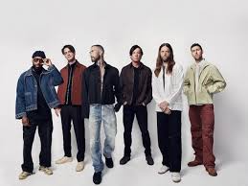
But now it’s all that I ______, all that I ______, all that I ______

