A whole new world 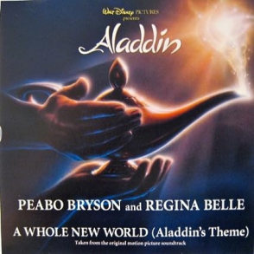
https://youtu.be/EXTLJmYsaUQ?si=EY6Ze2vMOuQ8oOPy

I can show you the world Shining, ( ), ( )
Tell me, princess, now when did You last let your heart decide?
I can open your eyes Take you ( )
Over, sideways and under On a magic carpet ride
A whole new world A new fantastic point of view
No one to tell us no Or where to go Or say we're only dreaming
A whole new world A ( ) place I never knew
But when I'm way up here It's ( ) clear
That now I'm in a whole new world with you
Now I'm in a whole new world with you
Unbelievable sights Indescribable feeling ( , , )
Through an endless diamond sky
A whole new world
Don't you dare close your eyes A hundred thousand things to see
Hold your breath - it gets better I'm like a shooting star
I've come so far I can't go back to where I used to be
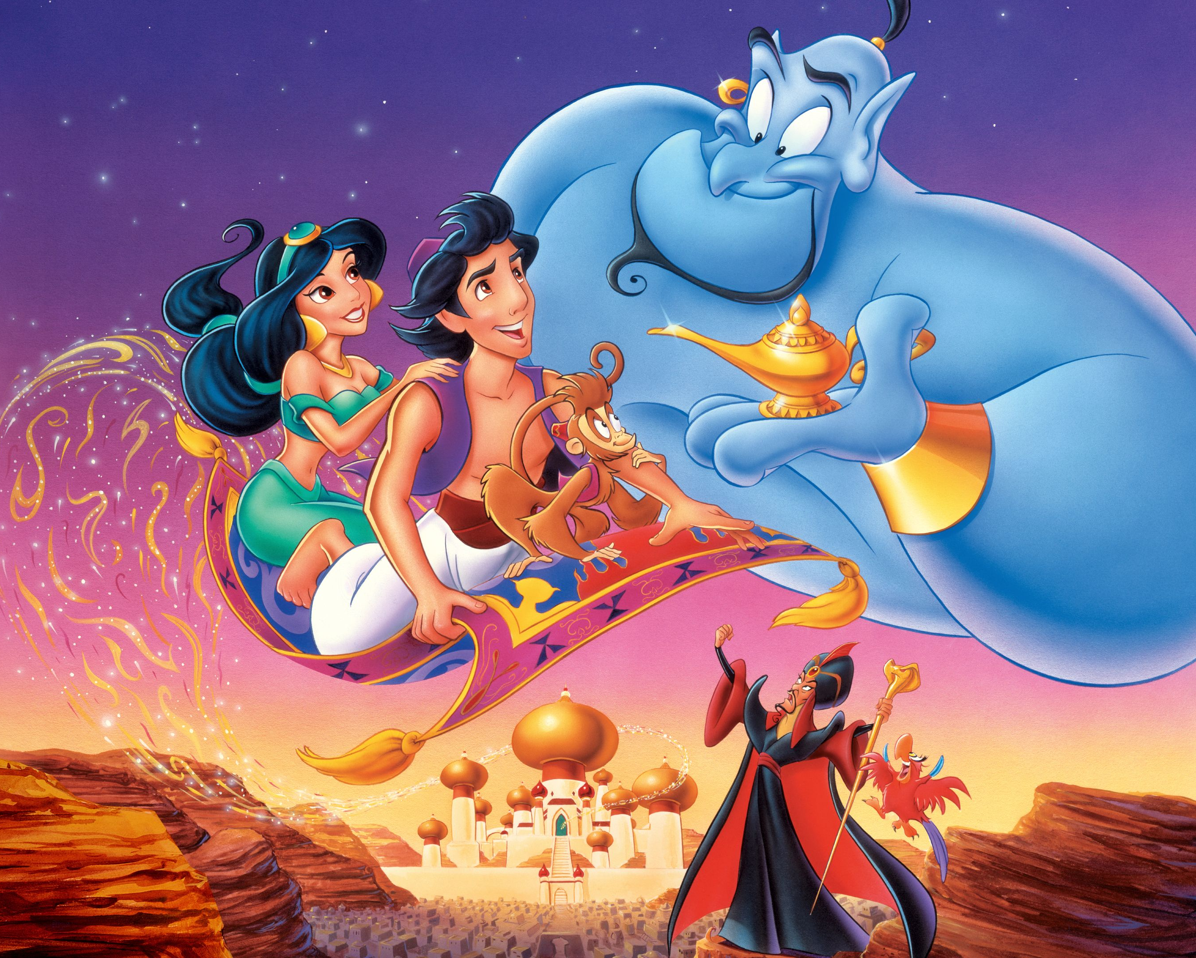
A whole new world Every turn a surprise
With new horizons to pursue Every moment ( )
I'll chase them anywhere There's time to spare
Let me share this whole new world with you
A whole new world That's where we'll be
A thrilling chase
A wondrous place
For you and me

