Ted talk
MY 12 PAIRS OF LEGS

WHY I CHOSE IT

・I saw it 5 years ago, and I still remember this story so I wanted to share with everyone.

・It challenges the perceptions of disability and explores the concept of human potential and augmentation.

・Through this talk, I realized that each of us has many things we cannot do, weaknesses, and areas where we fall short. Instead of perceiving them negatively, if we can embrace them positively and transform them into our strengths, our lives will shine even brighter.

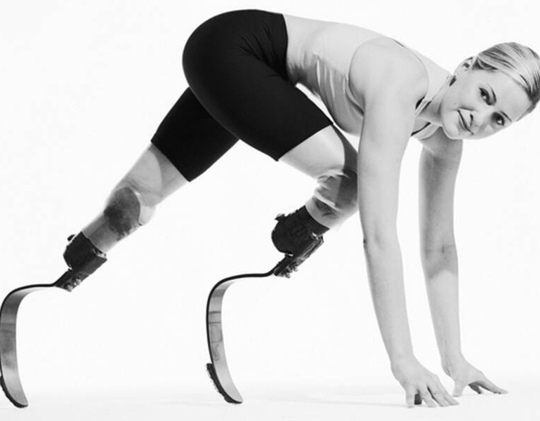
AIMEE MULLINS

link for the ted talk ::: https://www.ted.com/talks/aimee_mullins_my_12
_pairs_of_legs?language=ja&subtitle=en

Aimee Mullins is an athlete, model, and motivational speaker. Despite having both legs amputated, she excelled as a Paralympic athlete, set world records, and became a trailblazing model challenging beauty norms. Through her inspiring talks, Mullins encourages others to embrace their uniqueness and overcome obstacles.

Descend ::: move or fall downwards. "the aircraft began to descend"

VOCABULARY DEVELOPMENT

Prodding ::: poke with a finger, foot, or pointed object.
"he prodded her in the ribs"

Wiggling ::: move or cause to move up and down or from side to side with small rapid movements.
"Vi wiggled her toes"

Launch pad ::: something that sets a particular activity, enterprise, etc. in motion.
"it's one of those shows that has been the launch pad for many great careers"

Groundbreaking ::: innovative; pioneering. "groundbreaking research into fertility problems"

Prosthetic ::: denoting an artificial body part, such as a limb, a heart, or a breast implant.
"she has learnt to walk again using prosthetic legs"

Sprinting ::: the competitive athletic sport of running distances of 400 metres or less.
"the year turned out to be a great one for British sprinting"

VOCABULARY DEVELOPMENT

Benal ::: so lacking in originality as to be obvious and boring.
"songs with banal, repeated words"

Whimsy ::: playfully quaint or fanciful behaviour or humour.
"the film is an awkward blend of whimsy and moralizing"

Augmentation ::: the action or process of making or becoming greater in size or amount.
"the augmentation of the curriculum with new subjects"

Collective ::: done by people acting as a group. "a collective protest"

GRAMMAR
DEVELOPMENT

"So I made a deal with the adults that the kids could come in without any adults for two minutes on their own."

The infinitive phrase "to come in without any adults" expresses the purpose or intention behind the deal made with the adults.

ENGAGING QUESTIONS
If you see people who without legs or hands, or blind or deaf, or having any disabilities,what do you think ?

How we can the shift from focusing on overcoming deficiencies to embracing augmentation and potential impact ?
01
02

How can we embracing and celebrating differences to contribute to a more inclusive and diverse society?
03

04

ENGAGING QUESTIONS
What are some common stereotypes you think people may have about individuals who have disabilities ?

05 06 07

Have you ever seen someone who has leveraged what seemed to be their weaknesses or shortcomings? (It can be your own example as well.)
How can we promote equal opportunities and accessibility for individuals with disabilities in education, employment, and other areas of life?
Do you have weaknesses or shortcomings? What are they? How do you feel about them?

FUN ACTIVITY

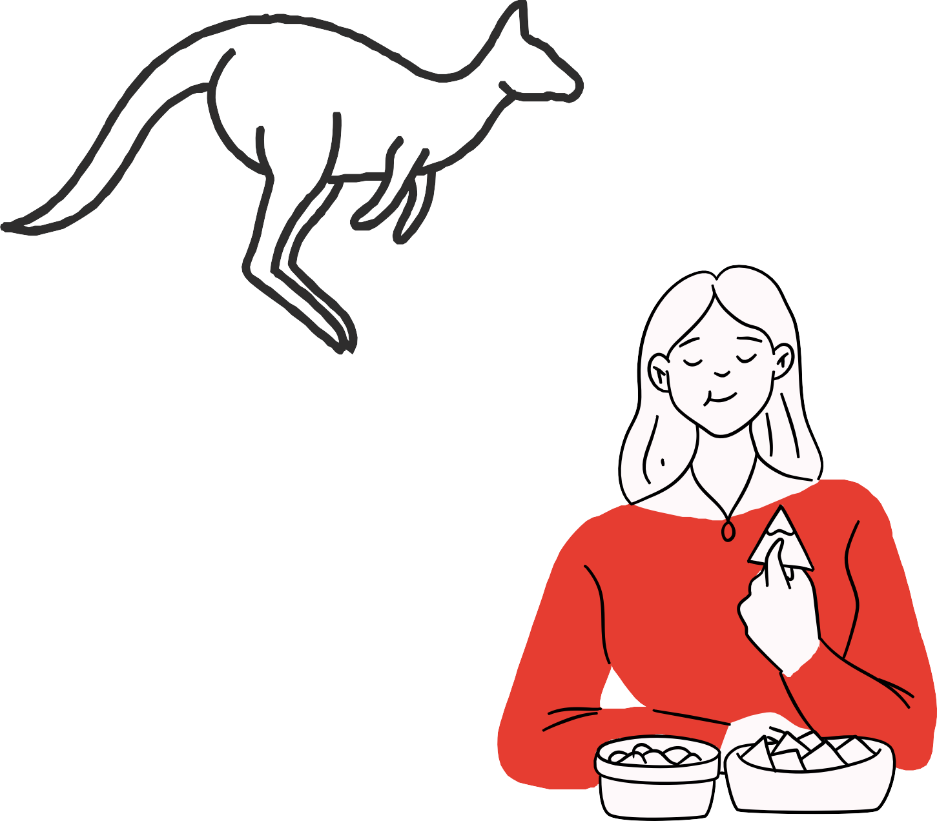
Practice of transforming disabilities or weaknesses into positives.

1.
If you will be able to replace any legs, what legs do you want to have?
ex) kangaroo leg , fast run leg

2.
Let's try to eat someting without seeting anything.
- What is the good point of that?

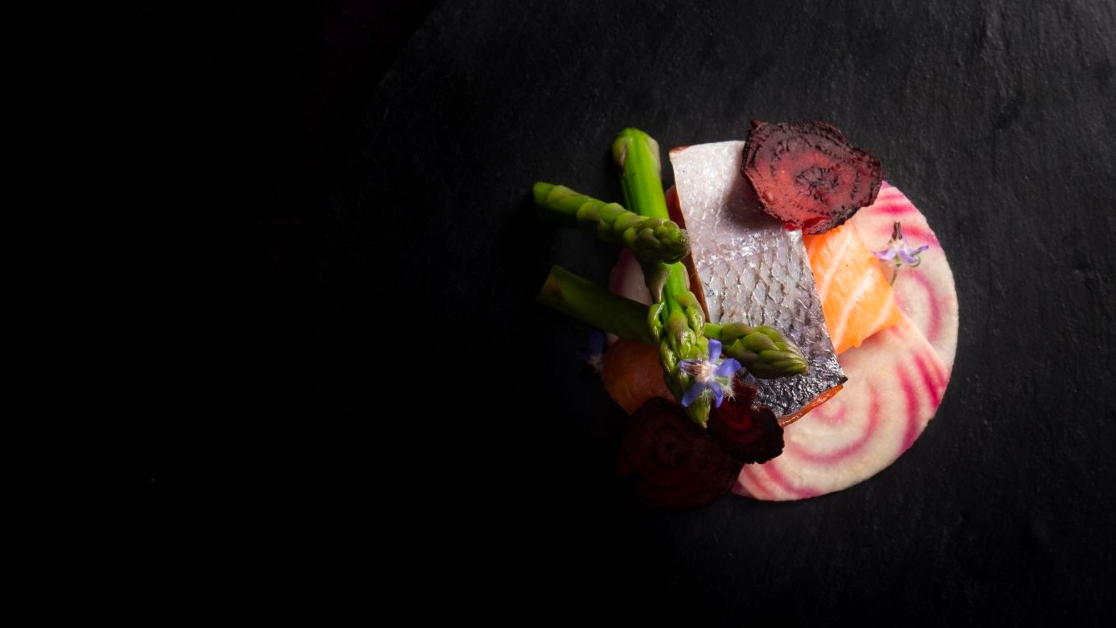
FUN ACTIVITY
Dans Le Noir?

Dans Le Noir? is a unique restaurant where diners experience dining in complete darkness, served by blind or visually impaired waitstaff. It aims to enhance sensory perception, promote empathy, and create a memorable dining experience beyond sight.

Let's find other example of enjoying challenges.

ANSWERS FOR THE QUESTIONS

If you see people who without legs or hands, or blind or deaf, or having any disabilities,what do you think ?
01

When I see blind or legless individuals, I used to feel pity, fear for myself, or wonder how I could help them. However, at some point, I started feeling guilty for having such emotions and began to question how I should truly perceive and approach these situations.

How we can the shift from focusing on overcoming deficiencies to embracing augmentation and potential impact ?
02

Emphasize capabilities is important. Shift the "narrative" from what individuals with disabilities cannot do to what we can do. Highlight our unique talents, skills, and perspectives, and showcase success stories of individuals who have achieved remarkable things despite their disabilities.

How can we embracing and celebrating differences to contribute to a more inclusive and diverse society?
03

In my view, everyone has flaws, weaknesses, and aspects that make them different from others. Some may have visible differences, while others may have hidden ones. Understanding about this is important for diverse society.

What are some common stereotypes you think people may have about individuals who have disabilities ?
04

Common stereotypes about individuals with disabilities include perceptions of helplessness, pity, incompetence etc. It is important to challenge these stereotypes and recognize the diverse abilities, strengths, and potential of individuals with disabilities as unique individuals.

How can we promote equal opportunities and accessibility for individuals with disabilities in education, employment, and other areas of life?
06
This includes providing accommodations in education, ensuring accessible facilities and technologies, promoting inclusive method in employment, and raising awareness and understanding of disability issues.
For example, there are times when you might come across someone loudly berating others on a train or in public. Knowing whether it's from illness can greatly affect how we treat. In schools and workplaces, it is important to prioritize what individuals can do rather than what they cannot. For instance, my brother has a cognitive impairment but excels in immersing himself in a single task.
Have you ever seen someone who has leveraged what seemed to be their weaknesses or shortcomings? (It can be your own example as well.)

artist Frida Kahlo, who suffered from chronic pain and physical disabilities due to a bus accident, channeled her experiences into her artwork and became an influential figure in the art world. These individuals serve as inspiring examples of leveraging challenges to fuel for personal and professional growth.
05
07

Do you have weaknesses or shortcomings? What are they? How do you feel about them?

I 'm not good at speak with more than 3 person at once. I'm also not good at waking up early, and I feel like that's my shortcomings.

I felt that I have to improve better, but recently I think this is my characteristic and don't have to remove. I want to explore ways to leverage this and incorporate it into my daily life.

