Try everything https://youtu.be/jpqV3dzYOgk?si=QlU24RgtB528oium
Lyrics
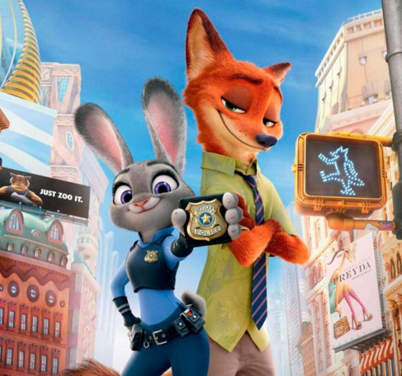
[Refrain]
Oh oh oh oh oh ooh...
Oh oh oh oh oh ooh...
Oh oh oh oh oh ooh...
Oh oh oh oh oh ooh...

[verse1]

I tonight, I lost another
I still mess up, but I'll just start again
I keep , I keep on
But I always get up now to see what's next

[Prechorus]
Birds don't just they fall down and
Nobody learns without

[Chorus] ×２
I won't give up, no, I won't give in
Till I reach the end and then I'll start again
No, I won't leave, I wanna try everything
I wanna try even though I could fail

Oh oh oh oh oh ooh...(try everything...)
Oh oh oh oh oh ooh...(try everything...)
Oh oh oh oh oh ooh...(try everything...)
Oh oh oh oh oh ooh...

[verse2]

Look how far you've come, you filled your heart with love
Baby, you've done enough, take a deep breath
Don't beat yourself up, don't need to run so fast
Sometimes we come last, but we did our best

[Chorus]

[Bridge]
I'll keep on making those new mistakes
I'll keep on making them every day
Those new mistakes

[Refrain]

[Outro]
Try everything

