I See The Light
(Mandy Moore , Zachary Levi )
https://share.google/oW3xTVB6i1qV7305G

All those days watching from①（ ）
All those years outside looking in
All that time never even knowing
Just how②（ ）I’ve been
Now I’m here, blinking ③（ ）
Now I’m here, suddenly I see
Standing here, it’s all so④ （ ）
I’m where I’m meant to be

And⑤（ ）I see the light
And it’s like the sky is new
And at last I see the light
And it’s like the sky is new
And it’s warm and real and bright
And the world has somehow shifted
All at once everything looks different
Now that I see you
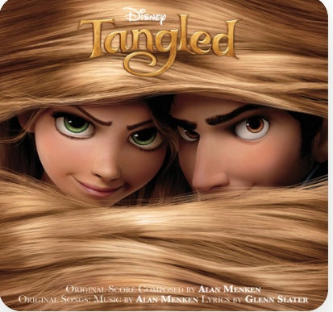
Eugene (Flynn):
All those days chasing down a daydream
All those years living⑥（ ）
All that time never truly seeing
Things , the way they were
Now she’s here shining in the starlight
Now she’s here, suddenly I know
If she’s here it’s⑦ （ ）
I’m where I’m meant to go

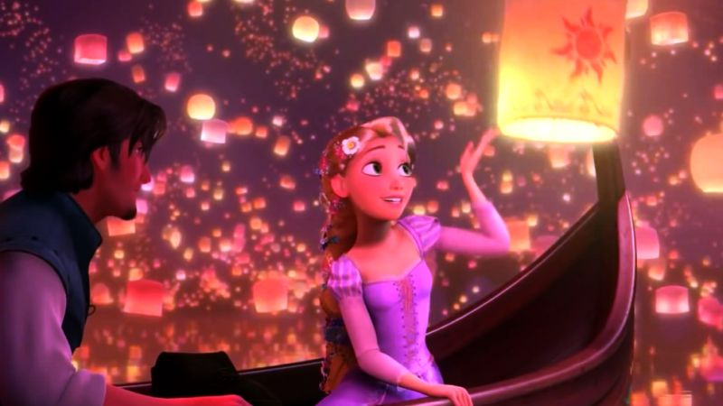
Rapunzel & Eugene (Flynn):
And at last I see the light

Eugene (Flynn):
And it’s like the fog is ⑧（ ）

Rapunzel & Eugene (Flynn):
And at last I see the light

Rapunzel:
And it’s like the sky is new

Rapunzel & Eugene (Flynn):
And it’s ⑨（ ）and⑩（ ）and⑪（ ）
And the world has somehow shifted
All at once , everything is different

