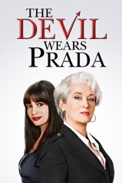
Job Interview
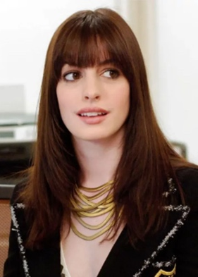
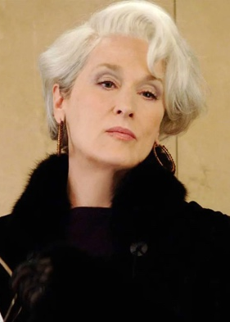

L1: Miranda : Who are you?
L2: Andy : Uh, my name is Andy Sachs. I recently graduated from Northwestern University.
L3: Miranda : And what are you doing here?
L4: Andy : Well, I think I could do a good job as your assistant. And, um— Yeah, I came to New York to be a journalist and sent letters out everywhere...and then finally got a call from Elias-Clarke...and met with Sherry up at Human Resources. Basically, it's this or Auto Universe.
L5: Miranda : So you don't read Runway?
L6: Andy : Uh, no.
L7: Miranda : And before today, you had never heard of me.
L8: Andy : No.
L9: Miranda : And you have no style or sense of fashion.
L10: Andy : Well, um, I think that depends on what you're—
L11: Miranda : No, no. That wasn't a question.
L12: Andy : Um, I was editor in chief of the Daily Northwestern. I also, um, won a national competition for college journalists...with my series on the janitors' union, which exposed the exploitation—
L13: Miranda : That's all.
L14: Andy : Yeah. You know, okay. You're right. I don't fit in here. I am not skinny or glamorous...and I don't know that much about fashion. But I'm smart. I learn fast and I will work very hard.
L15: Nigel : I got the exclusive on the Cavalli for Gwyneth...but the problem is, with that huge feathered headdress that she's wearing...she looks like she's working the main stage at the Golden Nugget.
L16: Andy : Thank you for your time.
L17: Nigel : Who is that sad little person? Are we doing a before-and-after piece I don't know about?

