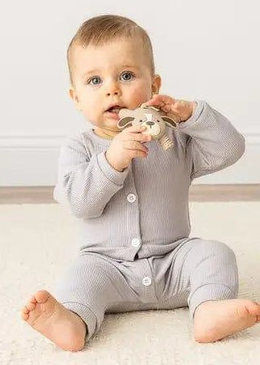

Possibility of Designer Babies

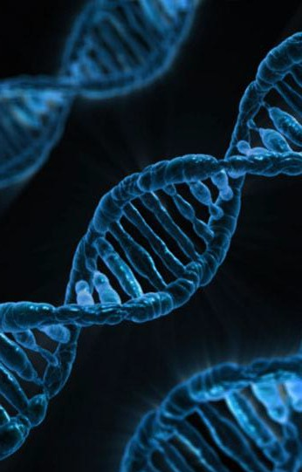
Contents

- Introduction of the Ted Talk
- Reason I chose this topic
- Important Vocabularies
- Question
- My opinion

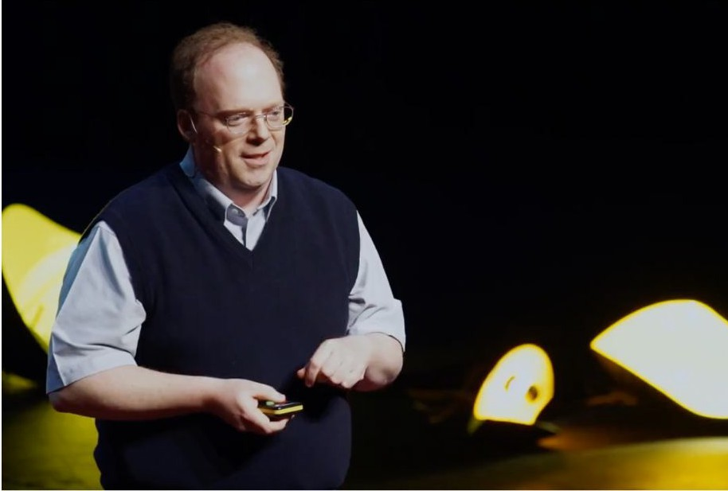
Introduction of the Ted Talk
“The ethical dilemma of designer babies”
— Paul Knoepfler

https://www.ted.com/talks/paul_knoepfler_the_ethical_dilemma_of_designer_babies?language=en

Reason I chose this topic

On week 11, we listened to and talked about the podcast “Could A Human Actually Get A Superpower”. Through this podcast, I got interested in genetic modification and wanted to know about it more.
In addition my interest, the speaker mentions about the reality we face regarding genetic modification and a possible future of designer babies. I think that this topic could affect us in very personal ways so we should be aware of the reality and think carefully about this topic.

Important Vocabularies

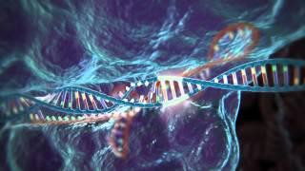
CRISPR: CRISPR stands for Clustered Regularly Interspaced Short Palindromic Repeats. With CRISPR, it’s easy to disrupt a targeted gene, or, if a DNA template is added to the mix, insert a new sequence at the precise spot desired.

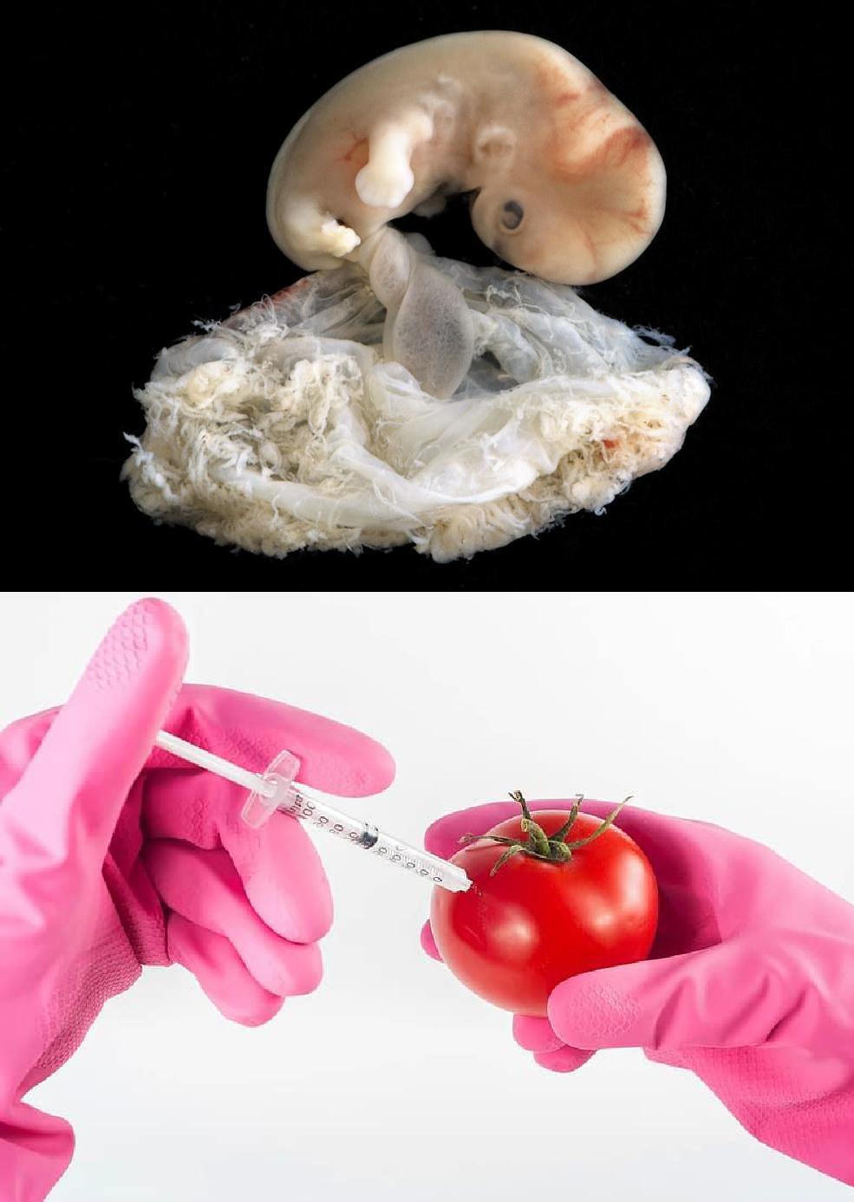

Important Vocabularies

Embryos: a human being or animal in an early stage of development, either in its mother’s uterus or in an egg, or a plant that is developing in a seed
GMO(Genetic Modified Organism): changing the genes of an organism in a laboratory setting
Eugenics: the selection of desired heritable characteristics in order to improve future generations, typically in reference to humans.
IVF (In Vitro fertilization): a treatment for a woman who cannot become pregnant naturally, in which an egg is fertilized outside her body and the resulting embryo is put into her womb to develop into a baby

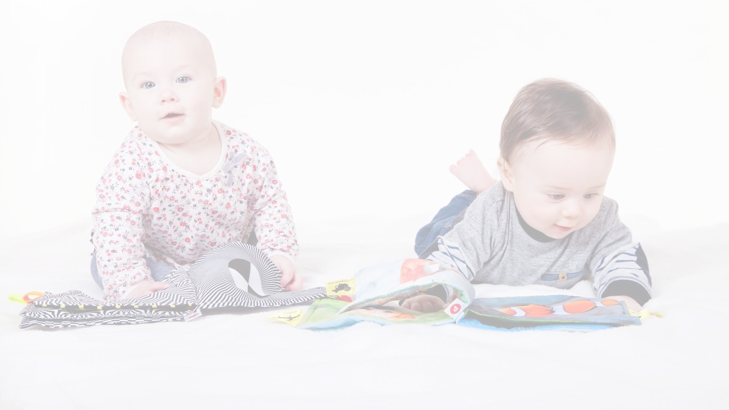
- Question

What choices are you going to make if trending encourage us to have designed babies?
What is the world going to be?

My opinion

I totally agree with the speaker. I don’t think we should accept genetic modification speedily at this moment, because there are many risks to adapt it to our lives and we are not enough ready for dealing with them. However, it is the fact that science is developing and it would be helpful and make the world better if we can use it in correct way. I think we should understand and be aware of where we are in science field and consider about this theme more seriously.
Also we should notice how big the power of trend is. When people consider designed baby normal, the world would be changed completely. That would be very dangerous.

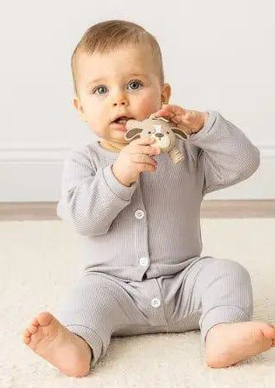

THANK YOU！

