

<The Hidden Power of Smiling>
Speaker : Ron Gutman
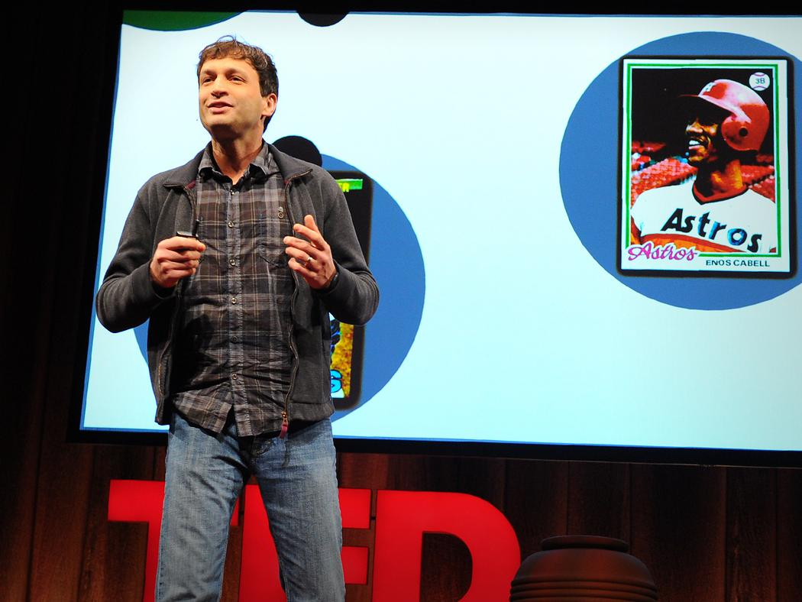
https://www.ted.com/talks/ron_gutman_the_hidden_power_of_smiling?language=en
- Why I chose this topic?
It is well known that smiling has many positive effects, including the ability to make people feel comfortable and brighten up the atmosphere. In addition, I myself naturally feel happy when I am in a space where laughter is constant.
Therefore, I wanted to share with you a Ted Talk that led me to learn more specifically about the benefits of smiling. Here, scientific evidence teaches us about the many powers of the smile. I believe this material will surely be useful in our future lives.
- Before you watch…
Vocabulary Development
Before watching the talk, check the meaning of the words below.
(Vocabulary list)
Embark (v)…start, begin, launch
Yield (v) …generate, provide
Longitudinal (adj)…continuing, long-run
Stumble (v) …fall, fall down
Stumble upon (idiom)…discover coincidentally, find by chance
Womb (n) …the organ in which a baby grows
Renown (n) …the state of being widely honored
Cannibalism (n)… a person who eats human flesh, or an animal that eats the flesh of animals of its own kind
Frown (v) …in an expression of anger, disapproval
Contagious (adj)…easily spread as from one person to another
Mimic (v) …to imitate, copy
Impair (v) …to damage, spoil
Induce(v) …to cause, provoke
Enhance(v) …to improve the quality, amount, or strength of something
Courteous(adj) …polite, hospitable
Competent(adj) …skilled, proficient, expert

- After you watch…
< Activity 1> After you watch the ted talk, please answer the questions below.
- What kind of research was conducted in California and what kind of result did Wayne State University get.

- Please indicate the three benefits of smiling.

<Activity 2> The following is a timeline of Ron Gutman’s speech. Please try to feel the blanks.
When Ron was a child
In California
Start of journey

At Wayne State Univ.

He wants to make everyone happy,
but it is a dream that cannot be fulfilled without superpowers, so he starts looking around for ways to make it really useful.

A study of the length of time professional baseball players smiled revealed that the longer they smiled, the longer their average life expectancy was.

Uppsala Univ. & Univ. in France
Common human characteristics
Charles Darwin’s study

Smiling is not only an expression that appears when you are in a good mood; smiling can improve your mood. A German study found that smiling activates the brain.

Smiling is a basic human expression and is seen when people are happy or content, regardless of age or culture.

Effects of smiling
Research in UK

It was found that a smile has the brain stimulation equivalent to 2,000 chocolate bars and the same stimulation as receiving $25,000.

<Activity 3>
What did you learn from this Ted Talk? Please share what you thought of this video and what you would like to incorporate into your life in the future.

- Answer

Activity 1
- What kind of research was conducted in California and what kind of result did Wayne State University get.
In California, a study was conducted to measure the smiles of subjects in their graduation albums and to find a link between their smiles and their level of success and happiness in life. Also, at Wayne State University, it was found that the longer people smiled, the longer their life expectancy was.
- Please indicate the three benefits of smiling.
・To smile can make you feel better.
・Smiling makes you healthier.
・You can make good impression on others. In addition, you can make yourself look competent.
Activity 2
When Ron was a child
In California
Start of journey

At Wayne State Univ.

He wants to make everyone happy,
but it is a dream that cannot be fulfilled without superpowers, so he starts looking around for ways to make it really useful.
A study was conducted over a 30-year period to determine the success and happiness in the lives of the subjects from their graduation album photos. These were predictable by measuring smiles.
A study of the length of time professional baseball players smiled revealed that the longer they smiled, the longer their average life expectancy was.

Uppsala Univ. & Univ. in France
Common human characteristics
Charles Darwin’s study

It is difficult to look dissatisfied in front of someone who is smiling. In addition, because smiles are contagious, we can understand if someone's smile is genuine by imitating it when our muscles are in their natural state.
Smiling is not only an expression that appears when you are in a good mood; smiling can improve your mood. A German study found that smiling activates the brain.

Smiling is a basic human expression and is seen when people are happy or content, regardless of age or culture.

Effects of smiling
Research in UK

Smiling works by decreasing stress hormones such as cortisol, adrenaline, and dopamine, and by releasing happy hormones such as endorphins. It can also create a positive impression on others and make one appear competent.
It was found that a smile has the brain stimulation equivalent to 2,000 chocolate bars and the same stimulation as receiving $25,000.

Activity 3
What did you learn from this Ted Talk? Please share what you thought of this video and what you would like to incorporate into your life in the future.
I learned smiling has a positive effect on myself and those around me. I was able to understand again, based on scientific evidence, that smiling can improve our feelings by activating the brain, but this was the first time I learned that smiling can also improve our health by acting on the secretion of happy hormones.
Therefore, from now, I would like to have more opportunities to interact and communicate with others and spend more time smiling. Also, I want to share the power of a smile with my friends so that they can help make those around them happy.

