The likability dilemma for women leaders

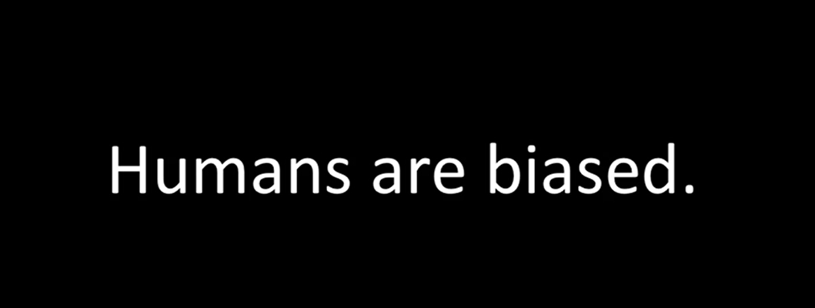
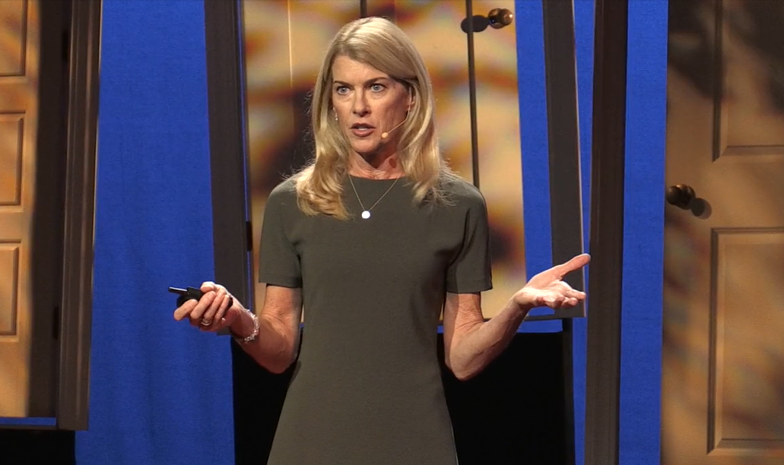
When women lead, bias often follows. Documentarian Robin Hauser dives into the dilemma between competence and likability faced by women in leadership roles, detangling the unconscious beliefs and gendered thinking that distort what it means to be a good leader.

Why I chose this TED talk:
I thought it is important to understand what we should do against gender biases and how to tackle internalized stereotypes.

Questions:
True or False

- Today's sexism is different from what it was in the past, and today’s situation surrounding women is better than that.
- Women are rarely perceived to be both competent and likable.
- In 2003, an experiment conducted by Professor Flynn revealed students’ gendered biases.

- What trait is thought to be inappropriate for a woman?

① Obedience
② Assertiveness
③ Quietness

- Why do most of us regard strong women as not likable?

- What is needed to solve the unconscious bias on female leaders?

- We need to speak up. Speak up when you witness ( a ).
Question comments that are made about a woman's appearance or personality rather than her ( b ) or ( c ).

Discussion Topics
・Have you ever been treated differently because of your gender?
・How do you behave when you witness a comment of sexist nature?

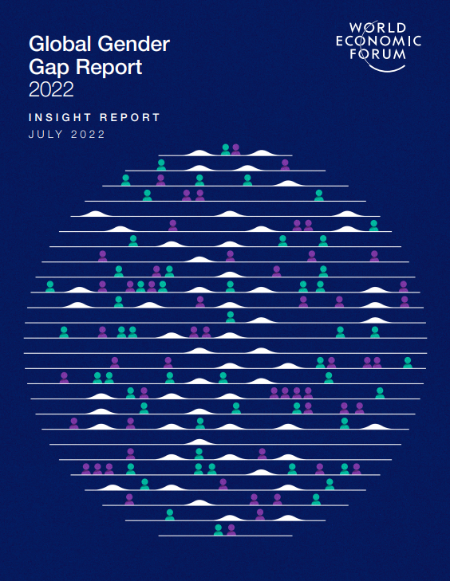

References:
The Global Gender Gap Report 2022 (Japan:116th out of 146 countries)
https://www3.weforum.org/docs/WEF_GGGR_2022.pdf
Gendered biases cause fewer female leaders.

Answers
- False
- True
- True
- ②
- Because we are unconscious about our biases.
- Redefine what it is to be a leader and a woman.
- a. gender bias b. skills c. ability

