


Topic : The power of introverts
Speaker :Susan Cain
Why did I choose this topic?
I often fell that many people believe we should be extrovert compared to introvert. I recently joined a seminar of job hunting and was taught how to write entry sheets. As I listen to the lecture, I felt that we have to express extrovert parts of us such as communication skills to get a job.
Also, many people do something like introvert/extrovert tests to know their personality these days, so I was interested in this topic.




Questions

Q1. Why did the speaker become a lawyer, not a writer that she always longed to be?

Q2. What is the rate of people who are introverts. Q3. What is "introversion"?
Q4. What is the key to maximize our talents? Q5. Why are introverts good leaders?
Q6. What did psychologists find when they looked at the lives of the most creative people?
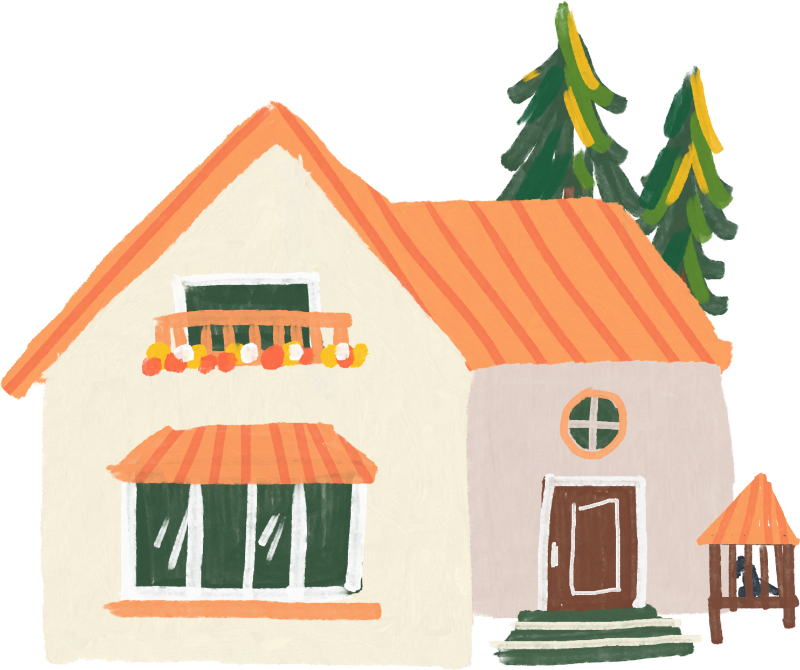
Q7. Why do we think that extroverts are better than introverts? Q8. What are three calls for action that the speaker mentioned?



Vocabulary Development

From LONGMAN


keg [noun]
Definition :a round wooden or metal container with a flat top and bottom, used for storing beer Example Sentence : He was able to life a keg of beer from the floor to the bar.

rowdy [adjective]
Definition : behaving in a noisy rough way that is likely to cause arguments and fighting Example Sentence : A group of three men including, he said, the appellant, were being rowdy.

bunk [noun]
Definition : a narrow bed that is attached to the wall, for example on a train or ship Example Sentence : During the night I wake to dash the two yards from bunk to bathroom.

forsake [verb]
Definition : to leave someone, especially when you should stay because they need you.
Example Sentence : Disappointed customers and forsaken employees pretty much had to tough it out alone.

grandiose [adjective]
Definition : grandiose plan sound very important or impressive, but are not practical
Example Sentence : In the autumn twilight the great building appeared simultaneously shoddy and grandiose.

gregarious [adjective]
Definition : friendly and preferring to be with other people
Example Sentence : Colleagues call the former Democratic deputy whip gregarious and determined; he is a leading figure in the Latino world.

sage[adjective]
Definition : very wise, especially as a result of a lot of experience
Example Sentence : They were sage young people and got on with Christopher.

Sort out
Introvert extrovert

- You are listener in your friend group.
- In a quiet space with no distractions, you are the most productive.
- At parties, you like to talk as many people as possible.
- When you have to speak in public, you really enjoy and want others' attention.
- You are leader in your friend group.
- On the topic of public speaking, you get super nervous.
- Find your energy is depleted when you spend too much time alone.
- You gain energy through inner reflection and solitude.

Let's have a discussion!
  - What do you think is the necessary thing to be a good leader?
  - Do you have any experience that you felt you have to be extrovert during your school days?
  - What can we do to make environment that everyone can maximize talents?



Answers to the Questions

A1. It is partly because she thought that she needed to prove to herself that she could be bold and assertive.

A2. A third to a half of the population are introverts, so that is one out of every two or three people we know.

A3. Introversion is how you respond to stimulation, including social stimulation. It is different from being shy (Shyness is about fear of social judgement).

A4. It is to put ourselves in the zone of stimulation that is right for us. Extroverts really crave large amounts of stimulation, wheres introverts feel at their most alive and their most switched-on and their most capable when they are in quieter, more low-key environments.

A5. Because they tend to be very careful, much less likely to take outsize risks. Also, they are managing proactive employees, they are much more likely to let employees run with their ideas.

A6. They found that creative people are who are very good at exchanging ideas and advancing ideas but who also have a serious streak of introversion in them.



A7. The answer lies deep in our cultural history. Western societies, and in particular the U.S., have always favored the man of action over the man of contemplation . When we hit the 20th century, which was the culture of personality, we had evolved an agricultural economy to a world of big business. People had to prove themselves in a crowd of strangers, qualities like magnetism and charisma suddenly come to seem really important.

A8. They are stopping madness for constant group work, go to the wilderness, and take a good look at what's inside your own suitcase and why you put it there.

