
Daniel Pink
The puzzle of motivation
~ How we run our businesses~
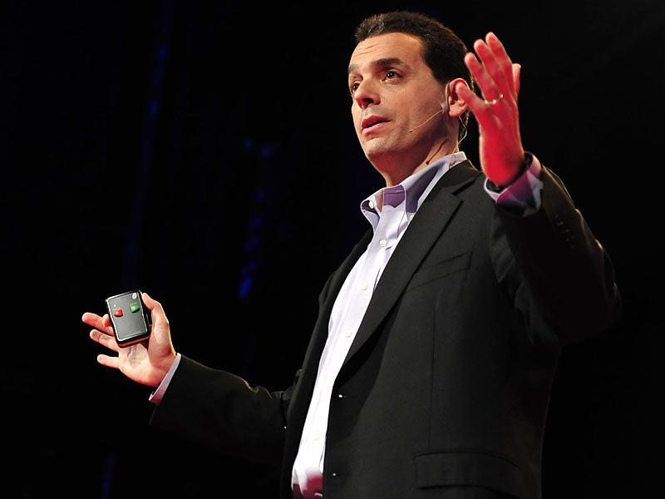
https://www.ted.com/talks/dan_pink_the_puzzle_of_motivation?utm_campaign=tedspread&utm_medium=referral&utm_source=tedcomshare
Why I chose this topic?
I thought that all of us have had experienced many situations where we needed motivation. To give you an example, scoring good marks in an exam is one of the tough events in terms of hard efforts. Likewise, you might be promised rewards such as buying you a new video-game software or to go to short trip to inspire yourself and this method could work.
This kind of incentive is usually monetary when you graduate and start working. However, this content teaches us that rewarding monetarily can activate businessperson only in a limited range in today’s world. I chose this topic because I want you to know the most important principle of motivation and apply what we learned in this Ted Talk to your future decision.
- Vocabulary/Grammar Development
Before watching the talk, check the meaning of the words below.

(Vocabulary list)
Behavioral science (n.) – to look human action in multiple fields of study
Thumbtack (n.) – a short pin with a broad flat top, used for fastening paper to a wall
Adhere (v.) – to stick firmly to a surface
Incentive (n.) – a thing that motivates or encourages someone to do something
Norm (n.) –an average
Accelerate (v.) – begin to move more quickly
Dull (v.) – to decrease, reduce or lessen
Aberration (n.) – a temporary change from the typical way of behaving
Replicate (v.) – to repeat something
Robust (adj.) – strong
Extrinsic (adj.) – external, outside
Intrinsic (adj.) – internal, inside
Kick someone’s butt (idiom) – to attack or defeat someone
Mystify (v.) – ↔︎ clarify, clear up
Marshal (v.) – to bring together, to collect
Rudimentary (adj.) – elementary, primary, basic
Autonomy (n.) – self-determination, independence
Mastery (n.) – ability, skill

- Complete the summary of the speech by filling in underlines with words from the word list (You can change them into an appropriate form)

About the candle problem…
In 1945, psychologist Karl Duncker conducted a experiment. The experiment required the subjects to attach the candle to the wall in a way wax doesn’t drip on to the table. It’s difficult for them and they take five to ten minutes to arrive at an answer. The key is to think out of the box or unconventional solution.

Another experiment done by Sam Glucksberg who is scientist shows us the function of . He gathered the participants and divided them into two teams. He told one group that the goal was to know the average time and told the other group that he would give money to anyone who could solve it quickly. The results showed that the former solved the problems an average of 3.5 minutes faster. The existence of incentives destroys their creativity and their thinking.

However, when Sam Glucksberg brings up the candle problem with same condition in another way, the group kicked the other group’s butt. This is because the subjects could recognize the box not as a ’s case but as a tool to fix the candle.

What is the result of the experiments…?
From these experiments, he declared firmly that reward for success can show a positive effect when the task has simple set of goals and a clear destination. A reward prompts us to concentrate on something deeply so that in the case the task needs mechanical skill, it can work very well. On the other hand, once the task requires skill, it doesn’t work at all. It means that financial incentives can result in a negative impact on overall performance in the field of business in 21st century.

Then what is the solution of that problem? The answer is to approach motivation like (the urge to direct our own lives), (the desire to get better and better at something that matters) and purpose (the yearning to do what we do). This kind of motivation can produce superb performance.
- Questions

- About the candle problem conducted by Karl Duncker, what is the key to find out the way to arrive at an answer?

- What is the difference in the tasks people perform in the 20th and 21st centuries?

- Is it true that to give rewards for success produces enough effect about businessman’s performance?

- What type of work does the if ~then formula reward work best for?

- What do companies need to focus on to achieve high performance in 21st century tasks?

- Activity
You will join an internship at a manufacturer of ◯◯ products. There, you will be assigned to produce sales of the product.

You can use any method you like to promote the sales of the product. The product can be something that exists in the world, something that doesn't exist in the world, or something that you wish existed, that you would like to sell, or that you wish could be sold.

How do you appeal to them? Think about it yourself first and share it with your classmates.

- What item do you choose?

- Why do you like that item?

- What do you think the most effective way to sell the item and why?

Answer of summary
About the candle problem…
In 1945, psychologist Karl Duncker conducted a behavioral science experiment. The experiment required the subjects to attach the candle to the wall in a way wax doesn’t drip on to the table. It’s difficult for them and they take five to ten minutes to arrive at an answer. The key is to think out of the box or unconventional solution.

Another experiment done by Sam Glucksberg who is scientist shows us the function of incentives. He gathered the participants and divided them into two teams. He told one group that the goal was to know the average time and told the other group that he would give money to anyone who could solve it quickly. The results showed that the former solved the problems an average of 3.5 minutes faster. The existence of incentives destroys their creativity and dulls their thinking.

However, when Sam Glucksberg brings up the candle problem with same condition in another way, the incentivized group kicked the other group’s butt. This is because the subjects could recognize the box not as a thumbtack’s case but as a tool to fix the candle.

What is the result of the experiments…?
From these experiments, he declared firmly that reward for success can show a positive effect when the task has simple set of goals and a clear destination. A reward prompts us to concentrate on something deeply so that in the case the task needs mechanical skill, it can work very well. On the other hand, once the task requires rudimentary cognitive skill, it doesn’t work at all. It means that financial incentives can result in a negative impact on overall performance in the field of business in 21st century.

Then what is the solution of that problem? The answer is to approach intrinsic motivation like autonomy (the urge to direct our own lives), mastery (the desire to get better and better at something that matters) and purpose (the yearning to do what we do). This kind of motivation can produce superb performance.

Answer to questions

- About the candle problem conducted by Karl Duncker, what is the key to find out the way to arrive at an answer?
- The key is to think out of the box or unconventional solution
- The key is to overcome functional fixedness.

- What is the difference in the tasks people perform in the 20th and 21st centuries?
The difference is that the tasks of 20th century needed mechanical skills, whereas those of 21st century needs rudimentary cognitive skills.

- Is it true that to give rewards for success produces enough effect about businessman’s performance?
No, it isn’t.

- What type of work does the if ~then formula reward work best for?
It works for a task which has simple set of goals and a clear destination.

- What do companies need to focus on to achieve high performance in 21st century tasks?
Companies need to approach intrinsic motivation such as autonomy, mastery and purpose.

Example answer of activity 4

I want to choose a smaller heater for the item I appeal to others.

This item is very useful in terms of portable (you can use anywhere) so that you can feel comfortable with. Also, here in Japan, winter is very cold season, almost all of us use air heating. It can be work when you stay at a large room or stay with many people there, but if you stay alone in a small room, smaller heater is much better. By reason of a seasonal product and simplicity of use, I think that this product has a high demand. That’s why I chose it.

I think most effective way to appeal the product is show it to customers throughout commercial or cooperate with influencers and ask them to use and review it so that many people can have a chance to know it.

