
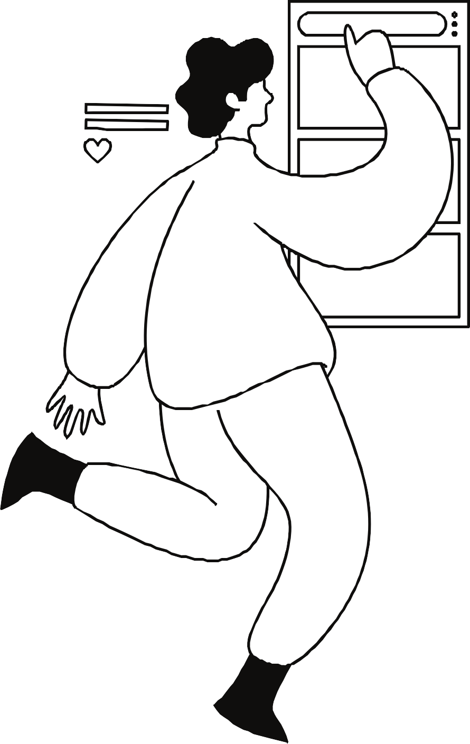
PAGE 01

TED TALK MATERIAL




PAGE 02

TOPIC:
TO THIS DAY ... FOR THE BULLIED AND BEAUTIFUL
SHANE KOYCZAN

HTTPS://WWW.TED.COM/TALKS/SHANE_KOYCZAN_TO_THIS_DAY_FOR_THE_BULLIED_AND_BEAUTIFUL/TRANSCRIPT? REFERRER=PLAYLIST-TALKS_THAT_EXPLAIN_DIFFICULT_TOPICS_TO_KIDS&AUTOPLAY=TRUE

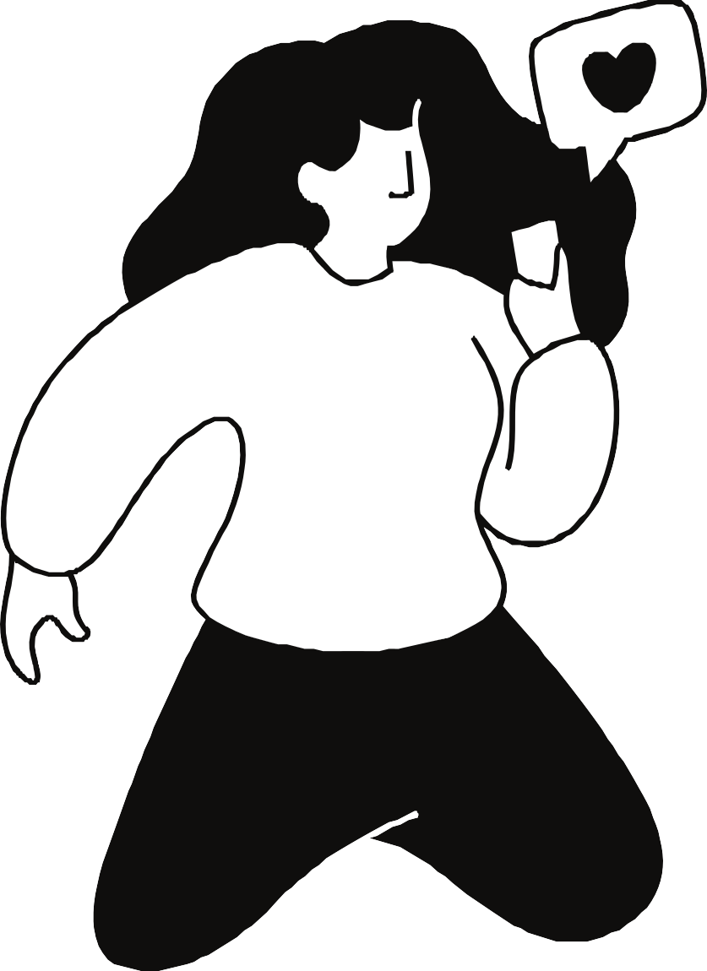
PAGE 03

WHY I CHOSE THIS TOPIC
AS A POET, THE WAY HE TALKS AND THE WORDS HE USES IS INTERESTING. HIS TALK STUCK IN MY MIND AND FELT THERE ARE TALKING SKILLS WE CAN LEARN FROM HIM.
SINCE IT IS A POEM, WE CAN DEVELOP OUR ENGLISH
SKILLS MORE.
THE CONTENT MAKES US THINK ABOUT HOW BULLYING, INCLUDING THE WAY A CHILD IS CALLED, CAN AFFECT OUR LIFE


PAGE 04

VOCABULARY
MATCH THE WORDS AND MEANINGS

From Cambridge Dictionary https://dictionary.cambridge.org/dictionary/english/

PAGE 05

MASQUERADE APOLOGETIC SHTICK
BE LOATH TO DO STH

LATE SLIP
①To be unwilling to do something

②The type of humor typical of a comedian (= person whose job is to make people laugh)

③Behavior that is intended to prevent the truth about something unpleasant or not wanted from becoming known

④ Showing that you feel sorry about having caused someone problems or unhappiness

⑤A piece of paper given to a student who is late to school

PAGE 06

HALL PASS TOOLSHED METASTASIZE AUDACITY ARSENAL
①an official piece of paper, etc. that gives a student permission to leave their classroom during a class
>permission to do whatever you like or to have an easy time

②Spread to other parts of the body and cause tumors to grow there

③A collection of weapons

④Courage or confidence of a kind that other people find shocking or rude

⑤A small building in which tools and garden equipment are kept


PAGE 07

KEY IDIOM TO UNDERSTAND THE TALK
"STICKS AND STONES MAY BREAK MY BONES, (BUT WORDS CAN NEVER HURT ME)"

Said in order to show that people cannot be hurt by unpleasant things that are said to them

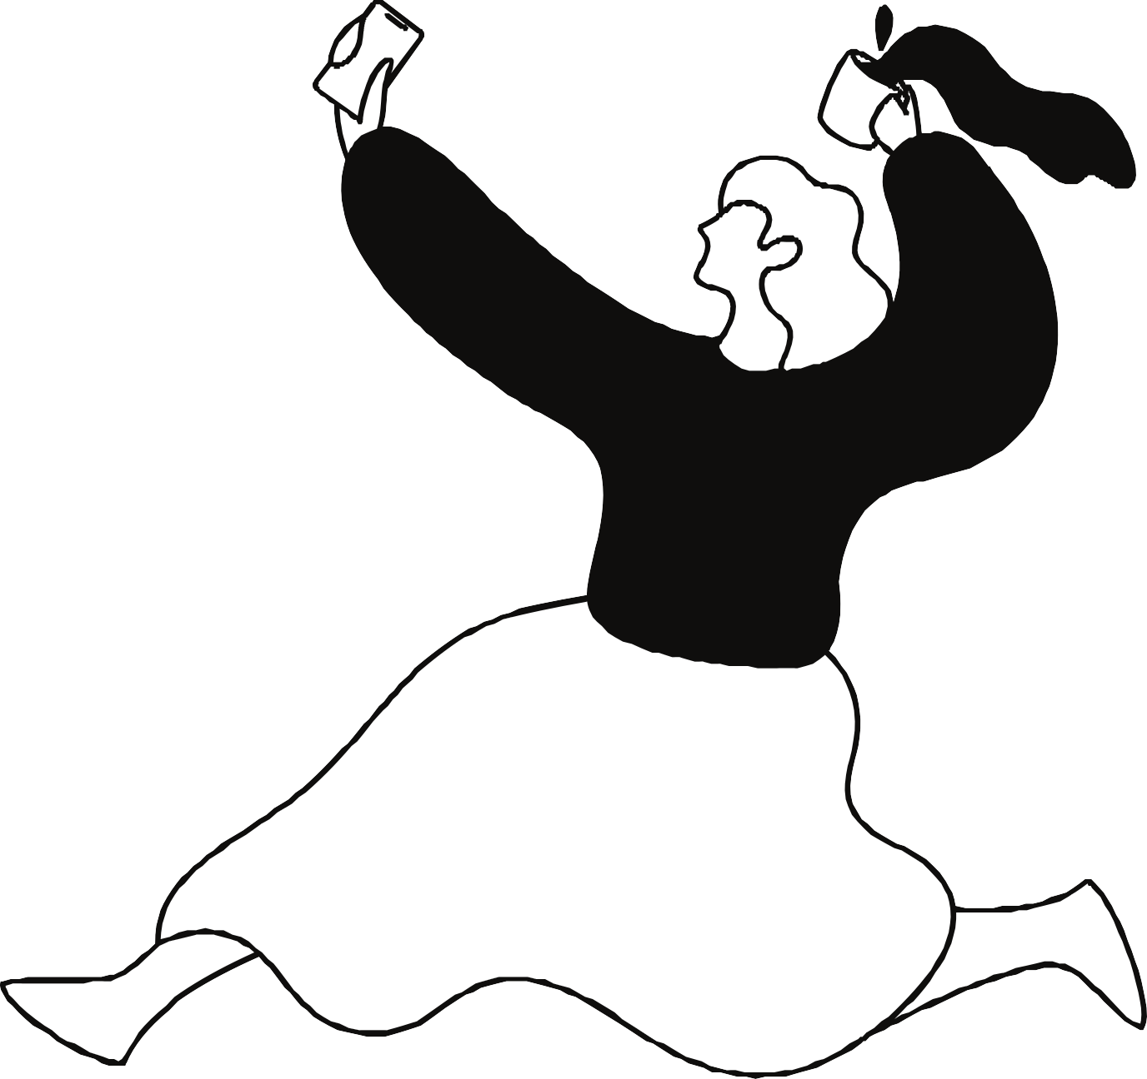
PAGE 08

QUESTIONS

PAGE 09

Questions regarding the content

What nickname did Shawn have?
Why did people not accept Shawn's dream? How did a nickname in youth affect the girl?
What is the problem of a kid saying to the boy "get over it"?

PAGE 10

Open questions for you to think further

Do you find it hard to stand up for yourself? Why do you think Shawn considers it is difficult to stand up for oneself?
In some schools in Japan, nicknames have been prohibited saying that it leads to bullying. However, nicknames can also be used to show how close they are. Are you for or against to such school rule?


PAGE 11

FUN ACTIVITY

PAGE 12

Fact about bullying and suicide
How much bullying did you think in Japan from elementary school to high school was found in 2022?

How many children (elementary school students - high school students) committed suicide in 2022?

The internet created a new form of bullying, which is cyberbullying. How has social media affected bullying?


PAGE 13

THANK YOU FOR JOINING!

Ted Talk Material 2 Answers

Masquerade ③ Apologetic ④ Shtick ②
Be loath to do something ①
Late slip ⑤ Hall pass ① Toolshed ⑤ Metastasize ② Audacity ④
Arsenal ③
Questions regarding the content
- What nickname did Shawn have? “Yogi” and “Porkchop”.
- Why did people not accept Shawn’s dream?
Because they thought Shawn’s dream was self-conscious and overly apologetic. It was a dream that deviates from the “usual” path, making adults think it is stupid.
- How did a nickname in youth affect the girl?
Despite the love from her family, she does not think she is beautiful.
- What is the problem of a kid saying to the boy “Get over it”?
That kid has loving parents and does not and cannot understand the boy’s feelings. However, he told him to get over his tough past and the issues he carries, as if depression is something that can be cured easily.

Open Questions for you to think further

>There can be various answers depending on each person Fact about bullying and suicide
- How much bullying did you think in Japan from elementary school to high school was found in 2022?
More than 610,000 cases.
- How many children (elementary school students - high school students) committed suicide in 2022?
512 students (<biggest number ever)
- The Internet created a new form of bullying, which is cyberbullying. How has social media affected bullying?
Example answer: Communication apps such as Line make it possible for people to create groups online, which leads to strengthening the bond inside that group and excluding others.
Because social media is a closed place where not everyone can see the conversation or event taking place nor can we see each other’s faces, people feel easier to say harsh words to others.

