TED TALKS: Try something new for 30 days

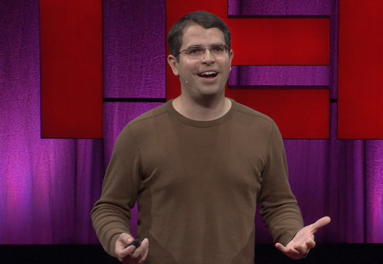
Is there something you've always meant to do, wanted to do, but just ... haven't? Matt Cutts suggests: Try it for 30 days. This short, lighthearted talk offers a neat way to think about setting and achieving goals.
https://www.ted.com/talks/matt_cutts_try_something_new_for_30_days?language=en

1. Why chose it
I first became aware of this video while studying abroad in Canada, when a professor at a local university introduced it to me. In this video, the speaker conveys the message to the audience that no matter how small you feel you want to try something, it is important to first try it for 30 days. Inspired by this message, I started strength training to improve my exercise regimen, and more than 30 days later, I am still doing it. I decided to present this video in the hope that other students, if they have their own interests and goals, will first try the challenge continuously for 30 days and then experience the sense of accomplishment from it.

2. Before watching the video

・(be) stuck in a rut: Being stuck in the same behaviors and formalities and becoming bored.
(Ex. I was stuck in a rut.)
・desk-dwelling: Staying at a desk all the time
・computer nerd: a person who is overly concerned with computers
(Ex. I went from desk-dwelling computer nerd to the kind of guy who bikes to work.)

・from scratch: from the beginning
(Ex. Every November, tens of thousands of people try to write their own 50,000-word novel, from scratch, in 30 days.)

・give it a shot: to try something
(Ex. So why not think about something you have always wanted to try, and give it a shot!)

3. Fill in the blanks while watching the video

A few years ago, I felt like I was in a , so I decided to follow
the of the great American , Morgan Spurlock, and try something new for 30 days.

It out 30 days is just about the of time to a new habit or a habit like watching news from your life.

I also noticed that I started to do more and 30-day challenges, my self- confidence .

4. Think and answer the questions

Q1. Have you ever tried something new in your college life?

Q2. Have you ever been able to sustain a challenge for an extended period of time?

Q3. Imagine that you decided to keep trying for 30 days to achieve a certain goal, and you were able to keep trying for 30 days, but as a result you did not achieve your goal. What do you think about the 30-day challenge that you did?

5. Set goals
Would you like to try something new in the future? Start by writing down as many ideas as you can think of.

・To memorize 10 new Mongolian words each day. (Example)
・
Then, decide on one of the challenges!

I will try !

