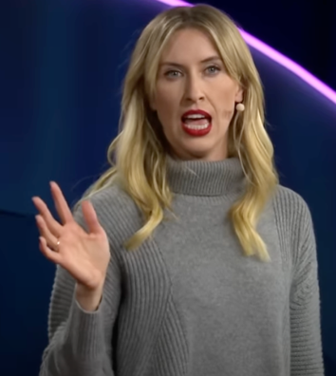
We don’t “move on” from grief. We move forward with it.
Nora Mclnerny, the speaker of this ted talk, experienced really hard time in 2014. Losing our important people is not a special thing. That happens to anyone anytime. We cannot avoid this. In this ted talk, she explains how she thinks about her losses with her funny talking. And her talk remains in my heart. This is why I chose this ted talk.

https://www.youtube.com/watch?v=khkJkR-ipfw


Have you ever lost your important person?

Vocabulary
・indelible: impossible to remove or forget
・in denial: a condition in which you refuse to admit or believe that something bad exists or has happened
・vacuum: a situation in which someone or something is missing or lacking
・unfurl: if a flag, sail etc. unfurls, or if someone unfurls it, it unrolls and opens
・enormity: the great size, seriousness, or difficulty of a situation, problem, event etc.

Questions for understanding more deeply
Q1: What happened to Nora in 2014? Please write three things.

Q2: What do the members of the Hot Young Widows Club do in their activities?

Q3: What did her son say to his father on the last day of his father?

Q4: What phrase does she hate to be said?

To be a good speaker like Nora, what will you do?

Answers for the questions
A1: 1 She lost her second pregnancy
2 She lost her father.
3 She lost her husband.
A2: They gather and share their experiences.
A3: “I love you. All done. Bye, bye”
A4: “moving on”

