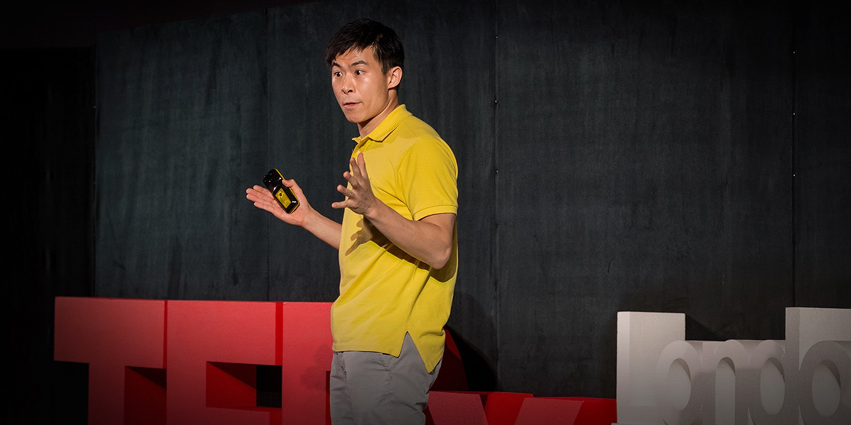

What to trust

in a “post-truth” world
by Alex Edmans

Access to the Talk
https://www.ted.com/talks/alex_edmans_what_to_trust_in_a_post_truth_world/tr anscript?language=ja&subtitle=en

About This TED Talk & Reason to Choose
What do we trust in a “post-truth” world? Alex Edmans let us know how we uncritically accept the story that you’d like to be true in politics, in business, and in health advice. He also offers three tips to find out evidence that we can trust.
I would sincerely like to recommend Alex’s TED talk because we’re facing what resemble truthful facts in particular shapes of a story, data, and evidence in ordinary life. By watching his insightful talk, you we can acquire comprehension to distinguish what can be “true” and what cannot be “true”. That is why I chose his TED talk.

Vocabulary & Grammar Development
These sentences below are from Alex’s TED talk. Fill in the blanks in each sentence. The meaning of the words or phrases in parenthesis.

Belle’s story .

(to spread quickly and widely)

Even if education was good for your income, you'd still see one
who didn't go to university.

(a very rich person who has money or property worth several million dollars)

Well, most people would think, it's successive .

(a number that can be exactly divided by two)

But this detachment gives you years to spend on a study. To really a result.
(to fasten down with or as if with nails / to settle in a definite way)

Engaging Questions
Answer questions below to understand this talk more deeply.
- Alex takes “confirmation bias” as a keyword so often in his talk. What is a definition of the “confirmation bias” according to him?

- Alex argues that data is not evidence. Then how will data be evidence?

- Do you have any experiences of facing confirmation bias? How did you recognize and get through that?

- Three tips are advocated to ensure that we don’t have a story but evidence in the talk. Which tip do you think is the most important of three? Why do you think so?

Fun activity
These words below are from the Oxford world of the year. Combine each word and meaning of it as a pair.


  - Goblin mode (2022)

  - Vax (2021)

  - Toxic (2018)

  - Youthquake (2017)

  - Post-truth (2016)

  - (2015)
  - A vaccine or vaccination.
  - A significant cultural, political, or social change arising from the actions or influence of young people.
  - Relating to or denoting circumstances in which objective facts are less influential in shaping public opinion than appeals to emotion and personal belief.
  - A type of behaviour which is unapologetically self-indulgent, lazy, slovenly, or greedy, typically in a way that rejects social norms or expectations.
  - Face with tears of joy.
  - Poisonous.

Answers
Vocabulary & Grammar Development
- Belle’s story went viral.
- Even if education was good for your income, you'd still see one multimillionaire who didn't go to university.
- Well, most people would think, it's successive even numbers.
- But this detachment gives you years to spend on a study. To really nail down a result.
Engaging Questions
- Confirmation bias can be defined as the tendency to only accept information that supports your personal beliefs and to reject any other information that contradicts it.
- Data will be supportive as evidence if it isn’t consistent not only with the theory but also with rival theory.
- N/A
- N/A

FUN ACTIVITY
From https://languages.oup.com/word-of-the-year/
