What will the dream car of the future be like?
Alex Koster: What will the dream car of the future be like? | TED Talk


Do you use a car in your daily life? Cars are essential in modern society. They are used to transport goods and people. They can also serve as a kind of social status. As the image shows, enjoying a drive with your loved one can be a wonderful time!!!! And now the car is in a time of evolution. Various evolutions are expected, such as solving the fuel problem and automated driving. What will the cars of the future be like?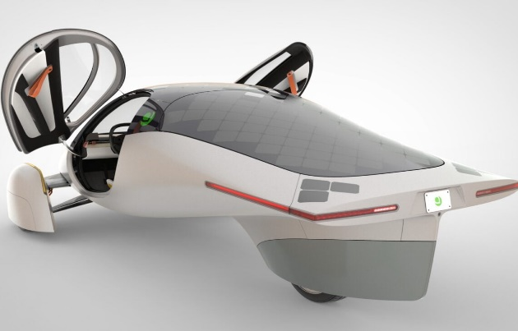
この写真 の作成者 不明な作成者 は CC BY のライセンスを許諾されています

- A-G explain the meaning of the words. Choose the one that matches each of these from 1-7.

A. attractive, exciting, and related to wealth and success
B one of the tubes which carries blood to your heart from other parts of your body
C the quality of being very exact or correct
D believing that good things will happen in the future
E the outside of something, especially a building
F a unit of energy in nuclear physics
G very angry

1 vein 2 optimistic 3 furious 4 glamorous 5 precision
6 exterior 7 quantum

- I - V are video scripts. Choose the words that match the blanks from A to G above.

ⅠYou stand in traffic, you look for parking space, you breathe recycled air, clearly not .
ⅡAre you guys technology or pessimists?
Ⅲ And what you really want is it should feel more like a well-orchestrated dance between the human and the machine on , very fast, immediate.
Ⅳ so I don't have petrol running in my or something.
Ⅴ So again, you are in control of both the interior and the experience of the vehicle.

- Answer the following questions from the video

1 What percentage of people in China say that a car does not increase your status significantly?
2 Does the speaker, Alex Koster, like cars?
3 What are three major technology trends that are hitting the industry massively?
4 How much computing power does the Dream Car software have?
5 Why the tech companies shy away from the liabilities?

- Watch the video and tell me about your thoughts on the question
1 What kind of transport do you use most often?
2 What are the advantages of a car over other modes of transport?
3 How do you think cars will evolve in the future?

Answer
- A 4 B 1 C 5 D 2 E 6 F 7 G 3
- Ⅰ 4 Ⅱ 2 Ⅲ 5 Ⅳ 1 Ⅴ 6
- 1 16%
2 No, he doesn’t.
3 The shift from fossil energy to clean energy, the shift from mechanical to software, and AI
4 Ten times faster than any other device that you have.
5 Because this is a life and death product.

