
Presented by Krishna Sudhir

What yoga does to your body and brain

https://youtu.be/_8kV4FHSdNA?si=bIqpHaoRMPaDWvzC

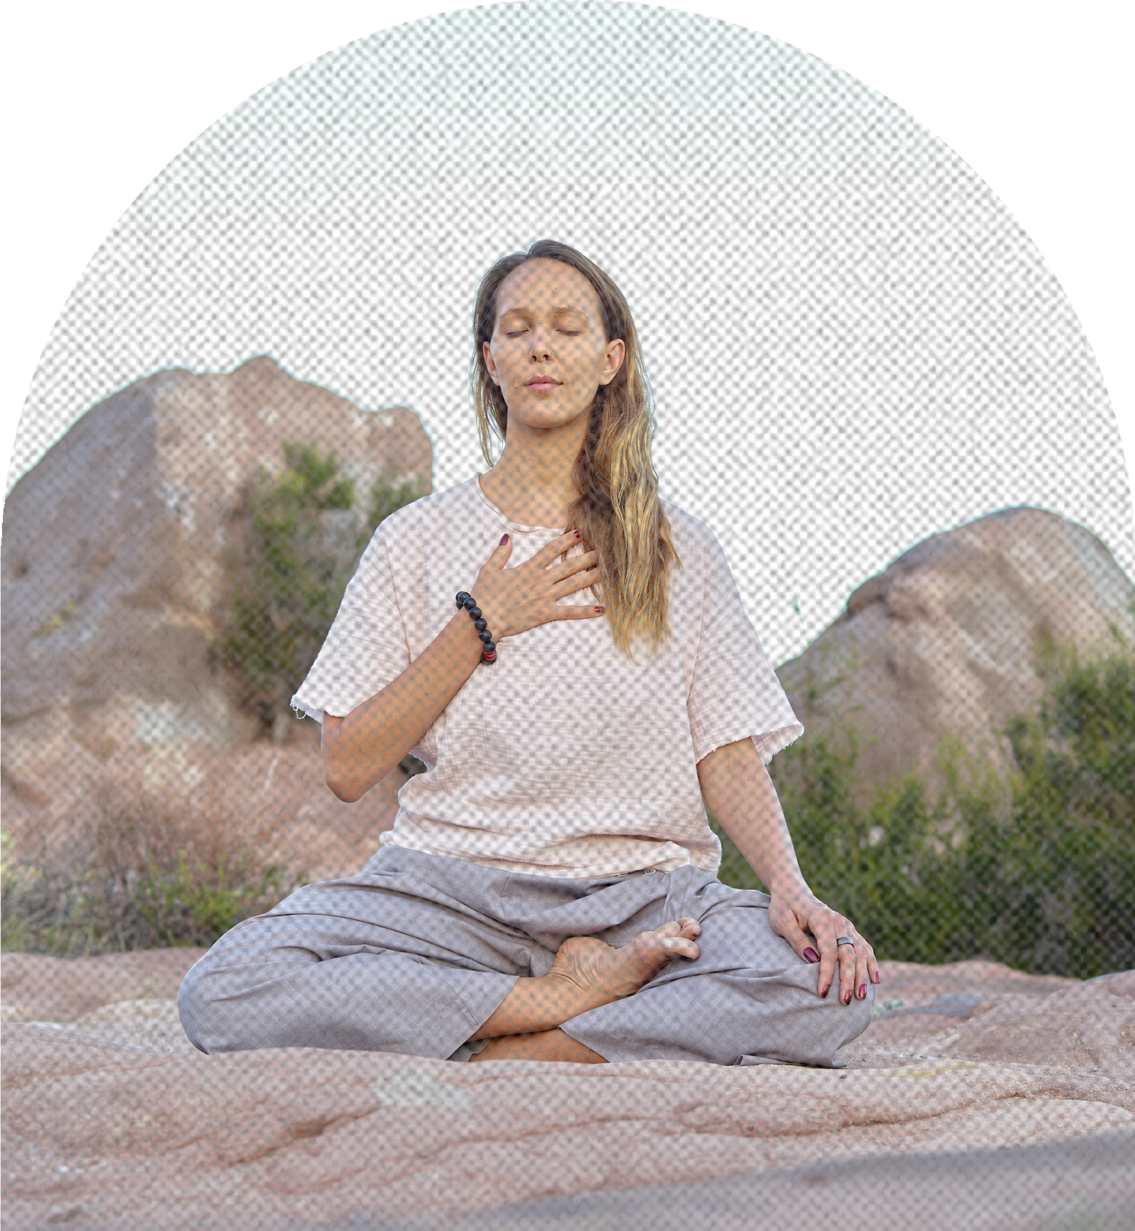
The power of yoga
Have you ever tried yoga? These days, yoga is growing in popularity as one of the ways to stay healthy. But still, it’s not as major as other sports like running, swimming, weight training, and so on. In this video, you can learn more deeply about yoga and it will make you want to try yoga!

Why I chose this video?
I like exercising and got interested in yoga too, but I always suspected the effects of yoga because it is too easy as an exercise. It’s not tough, doesn’t make us out of breath and sweat so much. Therefore, I sympathized with the sentence of the thumbnail of this video; “Is yoga actually good for you?”.
Then, I was curious about what kind of merits are there and whether it’s truly effective or not.

Before watching the video

・yoke a long piece of wood that is fastened across the neck of two animals, especially oxen
・contemplation the action of looking thoughtfully at something for a long time
・robust strong and healthy
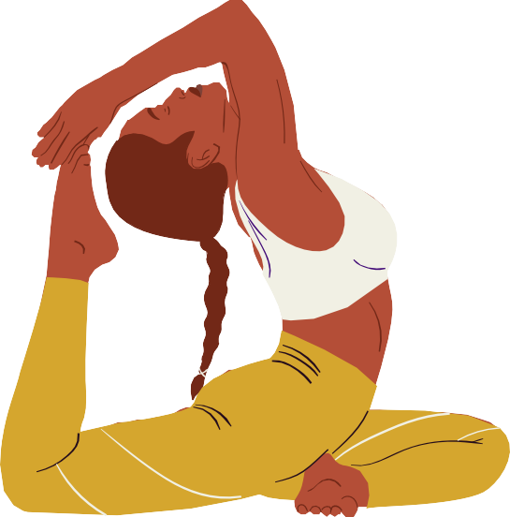
・ligament a short band of tough, flexible fibrous connective tissue which connects two bones and holds together a joint
・regimented very strictly organized or controlled
・cardiovascular relating to the heart and blood vessels
・severity the fact or condition of being severe
・cognitive connected with mental processes of understanding

True or False Questions
If the sentence is correct, write down “ T “

If the sentence is incorrect, write down “ F ” and correct the wrong part.

01
The techniques Patañjali recorded are much older than Indian
civilization.

02
Many of yoga‘s advantages have been supported specifically
by the results of experiments.

03
It‘s unclear which form of yoga is the best to improve flexibility.

04
Yoga is efficient not only to improve strength but also to carry
oxygen throughout the body.

05
The most supported benefits of yoga are the psychological
effects and they are the most difficult benefits to prove.

Participants‘ age and nationality vary widely, so it‘s difficult to quantify yoga‘s impact on symptoms of depression and anxiety disorders.
06

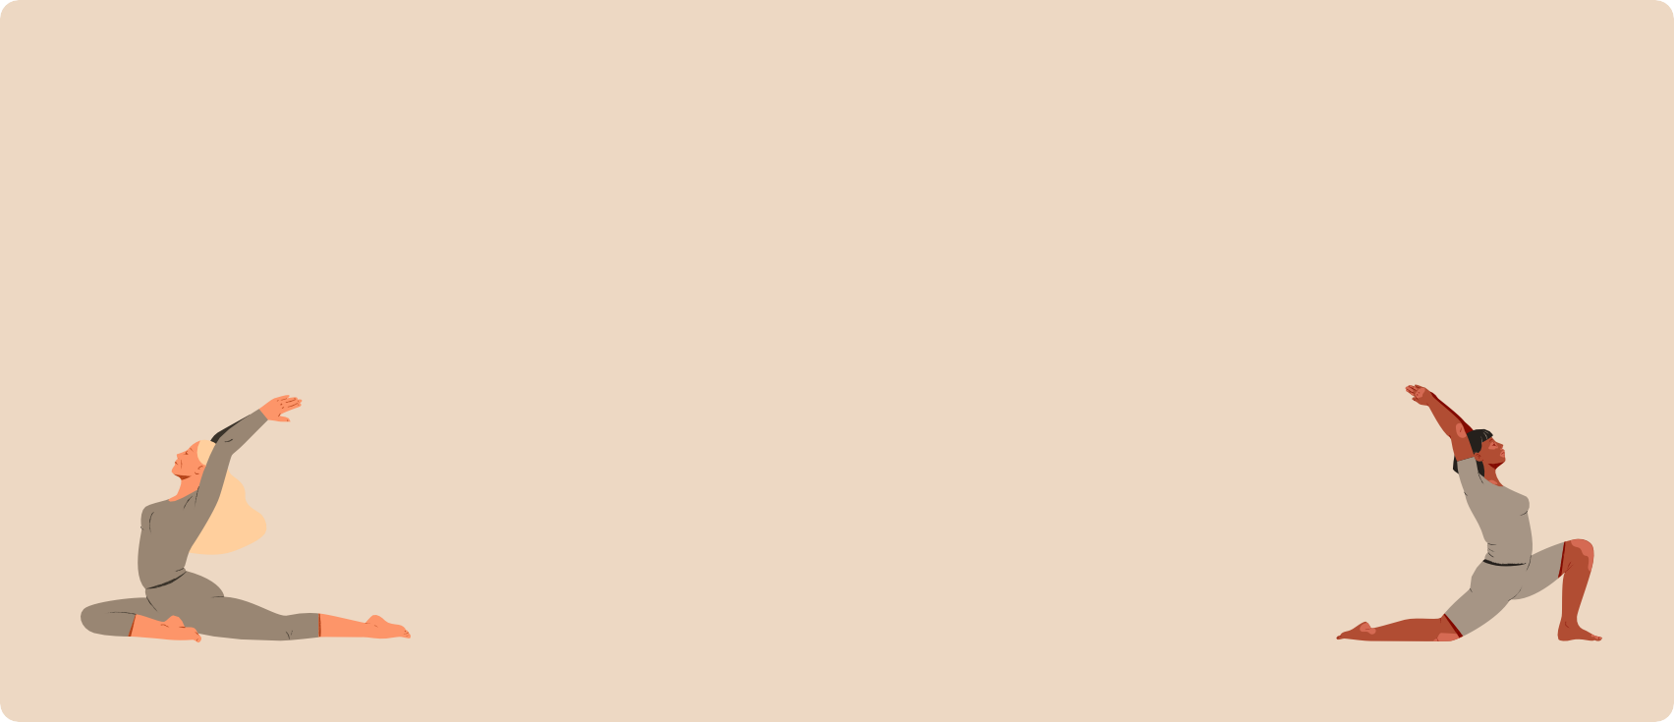
Deeper Questions

Answer freely in sentences.

01


Did this video make you want to try yoga?
Why?/Why not?

02


Which element of yoga do you think is the most effective?
Physical postures/Breathing exercises/Spiritual contemplation

03

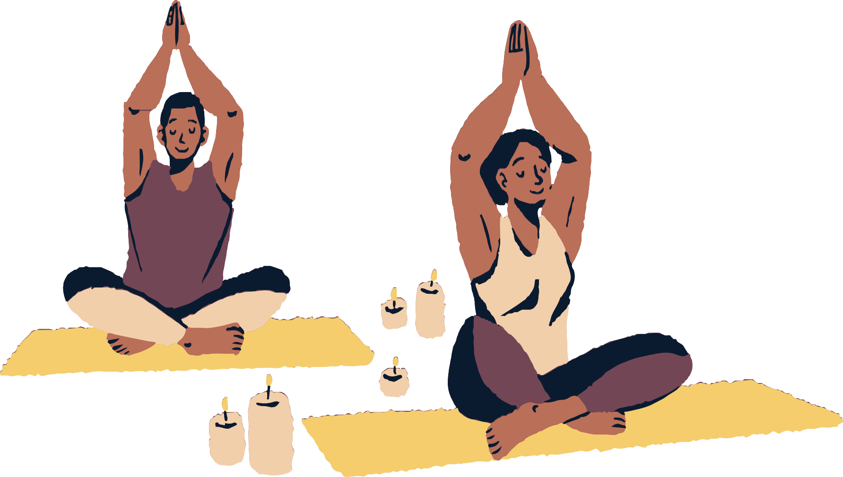
The number of people who do yoga will increase in the future?

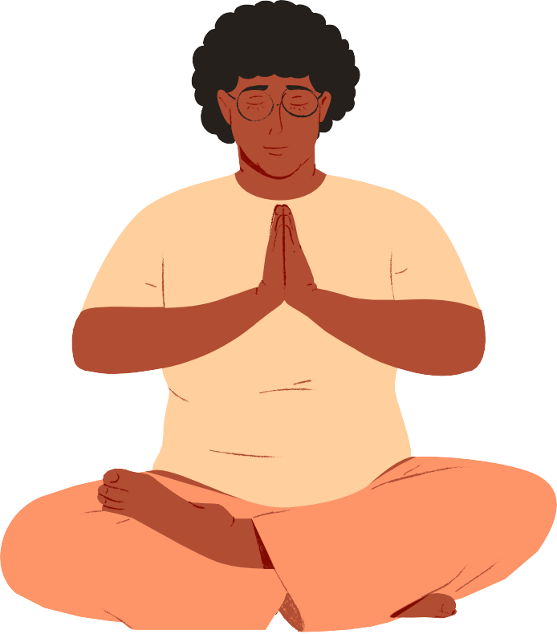
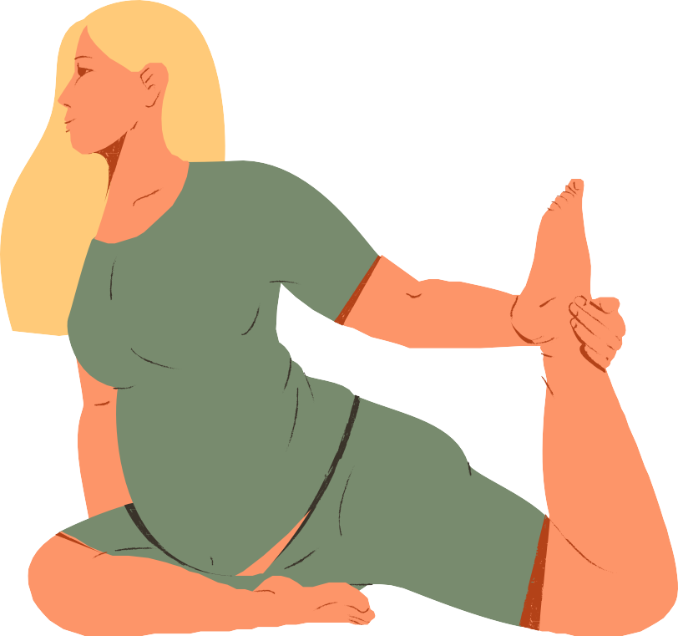
Fun quizzes
Let’s try some yoga poses and answer the questions!

CAUTION!
Don’t over do it. Be careful not to get hurt.

①
01
shoulders

Which parts are stretched?
02
hamstrings

Select the number.

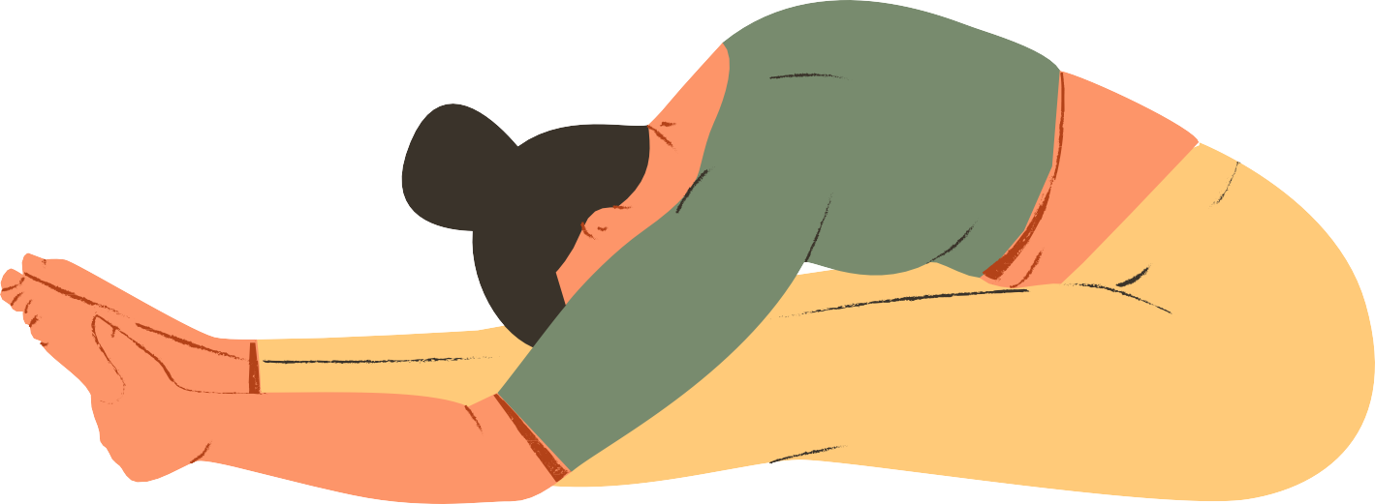
03
shoulders and
hamstrings

②
01
thighs, neck, shoulders

Which parts are stretched?
02
thighs, knees, ankles

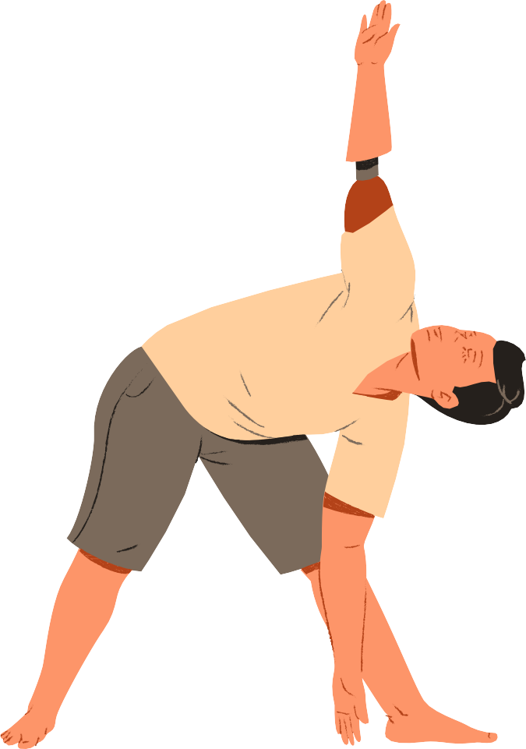
Select the number.
03
thighs, stomach, shoulders

③
01
ankles, hips

Which parts are strengthened?
02
legs, back

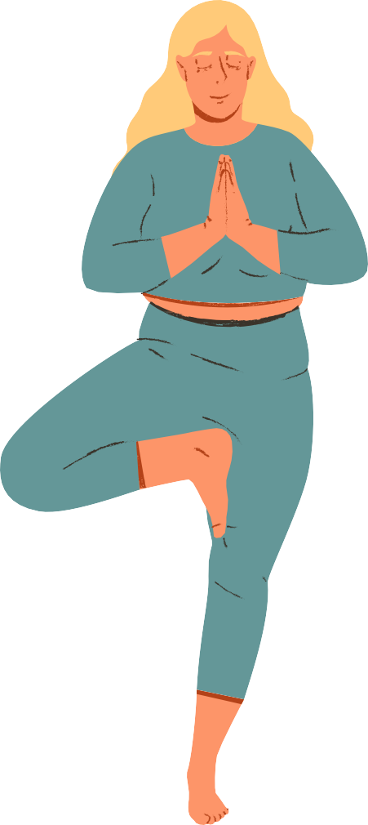
Select the number.

03
legs, ankles, feet

④
01 shoulders, chest

Which parts are stretched?
02
shoulders, hips

Select the number.
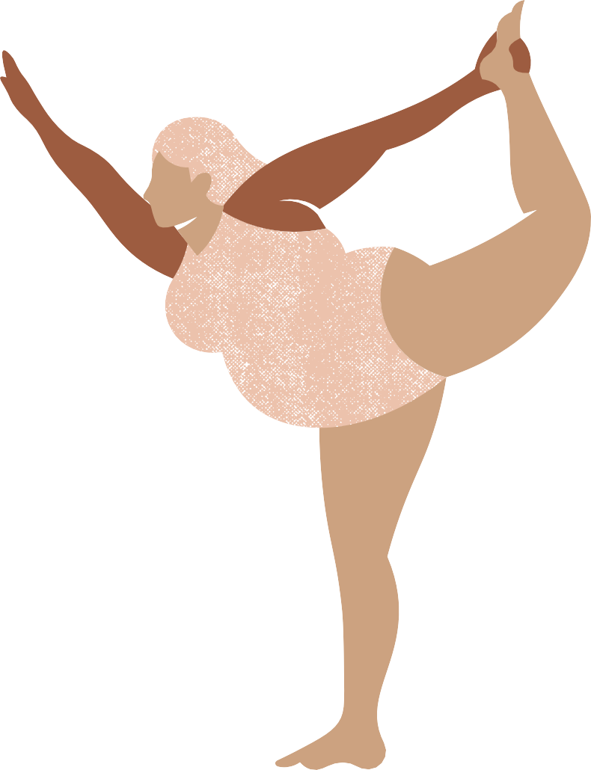
03
thighgs, ankles

⑤
01
stomach, legs

Which parts are strengthened?
02
stomach, spine
Select the number.
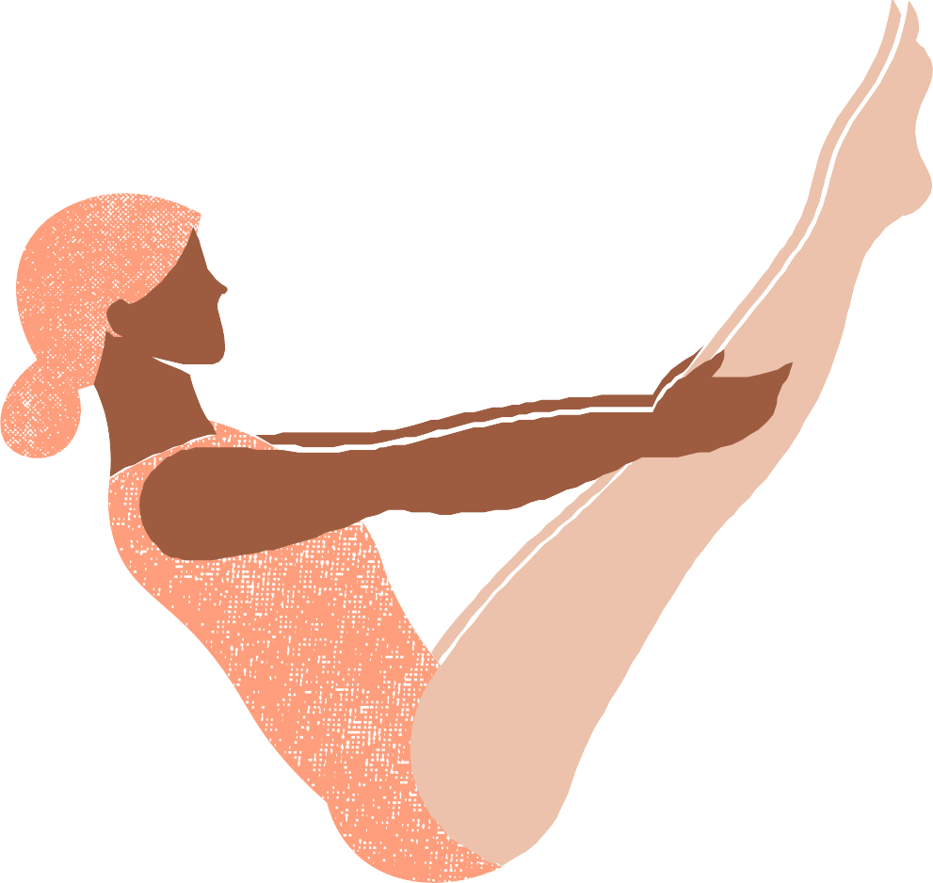
03 stomach, shoulders

Answers

True or False Questions
- F The techniques Patañjali recorded are nearly as old as Indian civilization.

- F Many of yoga‘s advantages have not been supported specifically by the results of experiments (because it’s tough to make specific claims about yoga’s advantages).

T
- T
- F The most supported benefits of yoga are the psychological effects and they are maybe the most difficult benefits to prove.
- F Diagnosis and conditions varies widely, so it‘s difficult to quantify yoga‘s impact on symptoms of depression and anxiety disorders.

Answers

Fun quizzes


① 3
② 2
③ 3
④ 1
⑤ 2

References

・What yoga does to your body and brain - Krishna Sudhir
https://youtu.be/_8kV4FHSdNA?si=X0AfGI5pUdG-bvRK

・POCKETYOGA.
https://pocketyoga.com/pose/?sort=category

