
Why we love, why we cheat

Helen Fisher


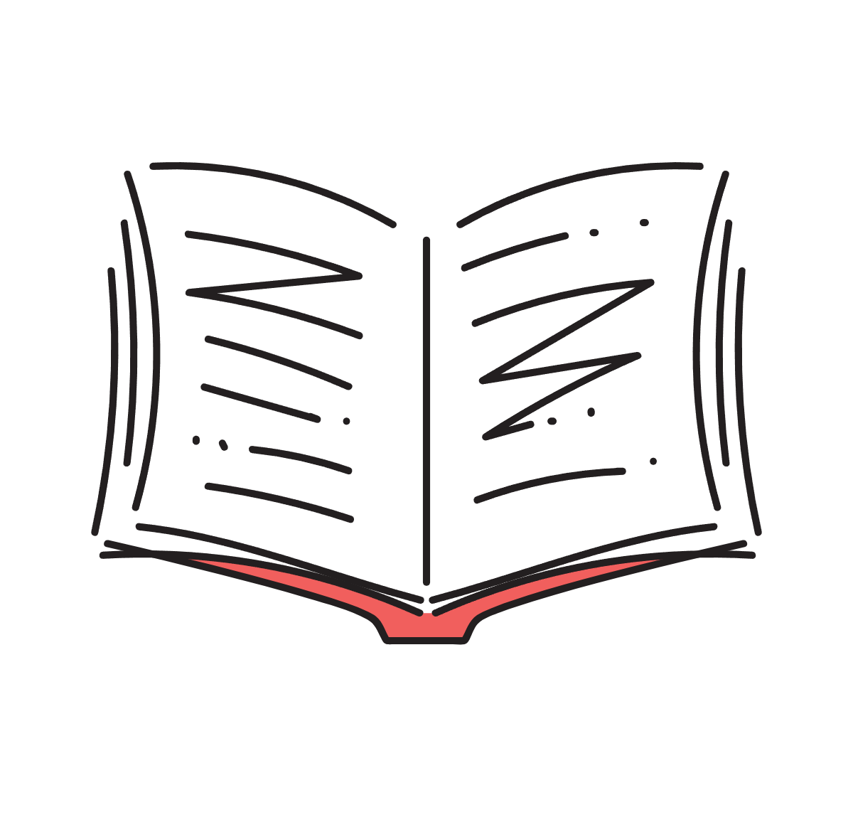
Table of contents

- Why I chose this topic

- Warm Up

- Grammar Development

- Talking Point

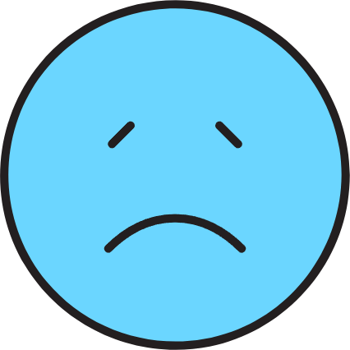


  - Why I chose this topic

Because my partner recently cheated on me.


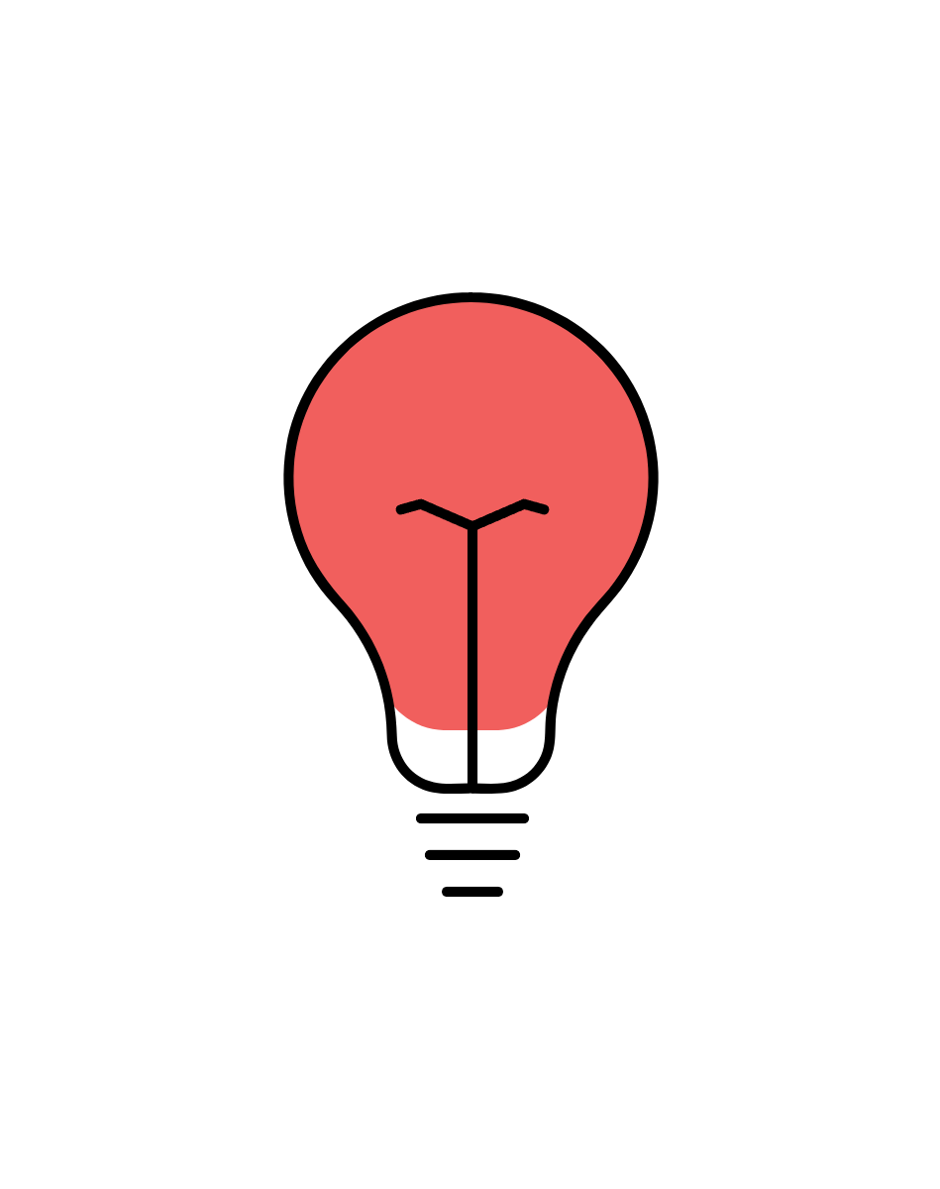
  - Warm Up

    - What do you think is happening in the human brain when we fall in love?
What do you think causes people to cheat?


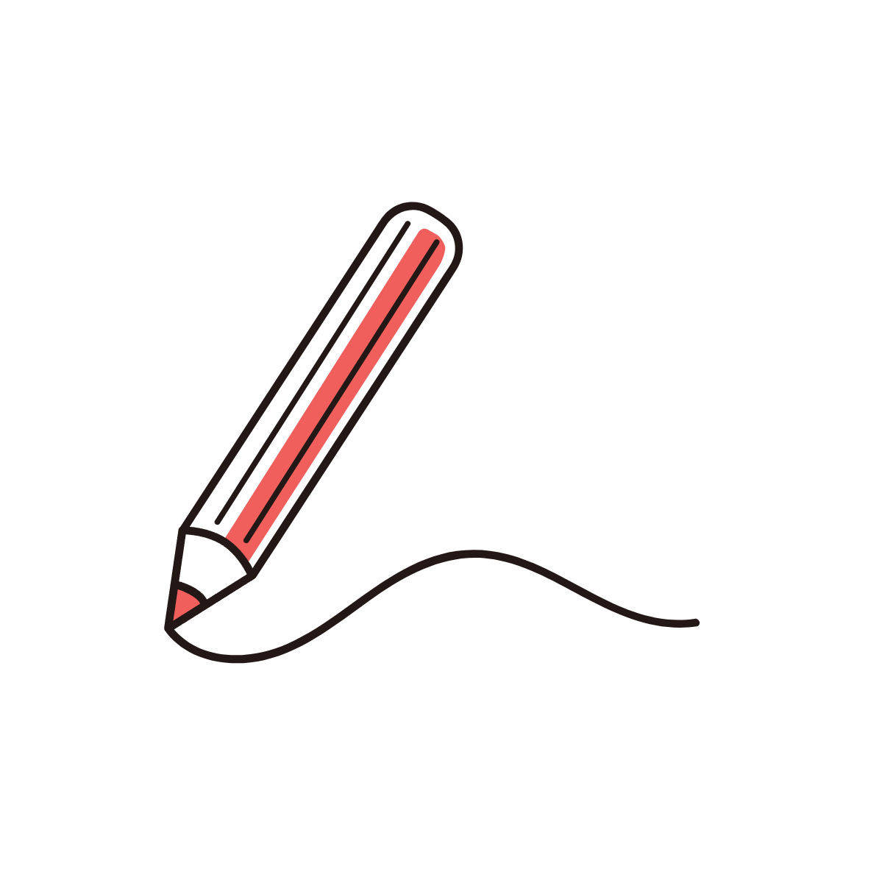

  - Grammar Development

Connect it with
the correct meaning.

- aggrandiz
- elation
- craving
- traumatic
- drive (verb.)
- obsession
- dopamine
- neutral

  - a state of extreme happiness or excitement
  - something or someone that you
think about all the time
  - causing severe and lasting
emotional shock and pain
  - to make someone more powerful or important
  - a state of no activity or development
  - a hormone that is made naturally in the body and may also be given as a drug
  - to force someone or something to go somewhere or do something
  - a strong feeling of wanting something


Fill in the words from 1 to 8 above.
    - ’s associated with romantic love, and you can just fall in love with somebody who you’re just having casual sex with.
    - You feel intense when things are going well; mood swings into horrible despair when things are going poorly.
    - I began to realize that romantic love is not an emotion. In fact, I had always thought it was a
series of emotions, from very high to very low. But actually, it’s a .
    - The main characteristics of romantic love are : an intense to be with
a particular person, not just sexually, but emotionally.
    - People are blinded when they fall in love, and not only do they turn away from the unpleasant aspects of their partner, they them.
    - I don’t work with people in any kind of situation.
    - The motor in the brain begins to crank, and you want this person. And last but not least, it
is an .
    - We scanned their brains, looking at a photograph of their sweetheart and looking at
a photograph, with a distraction task in between.

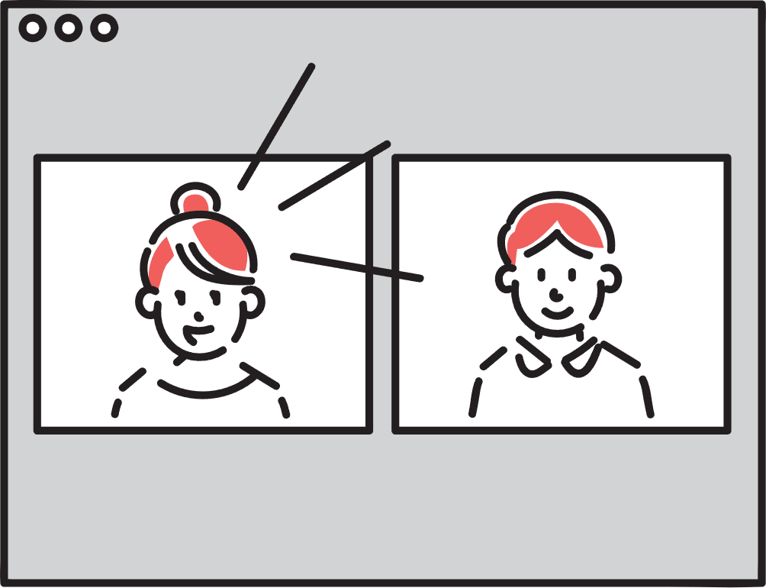
Talking Point

Discuss any of the questions below.
    - Did anything in Fisher's story apply to your own previous relationships?
    - What do you think can be done to prevent your partner from cheating on you?
    - What do you think is necessary to have a good relationship with your partner?

Let's look at some data on cheating.

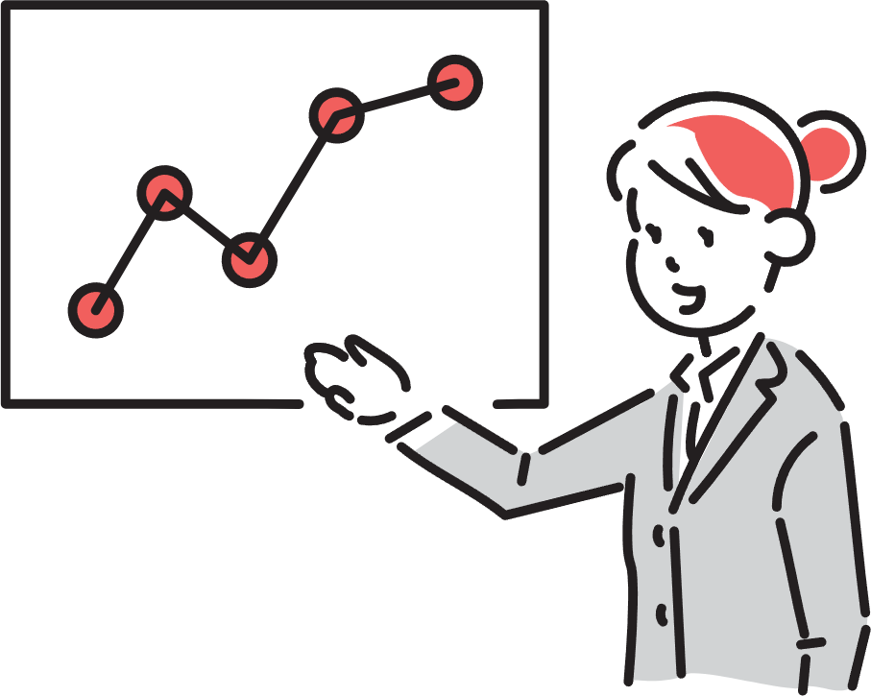

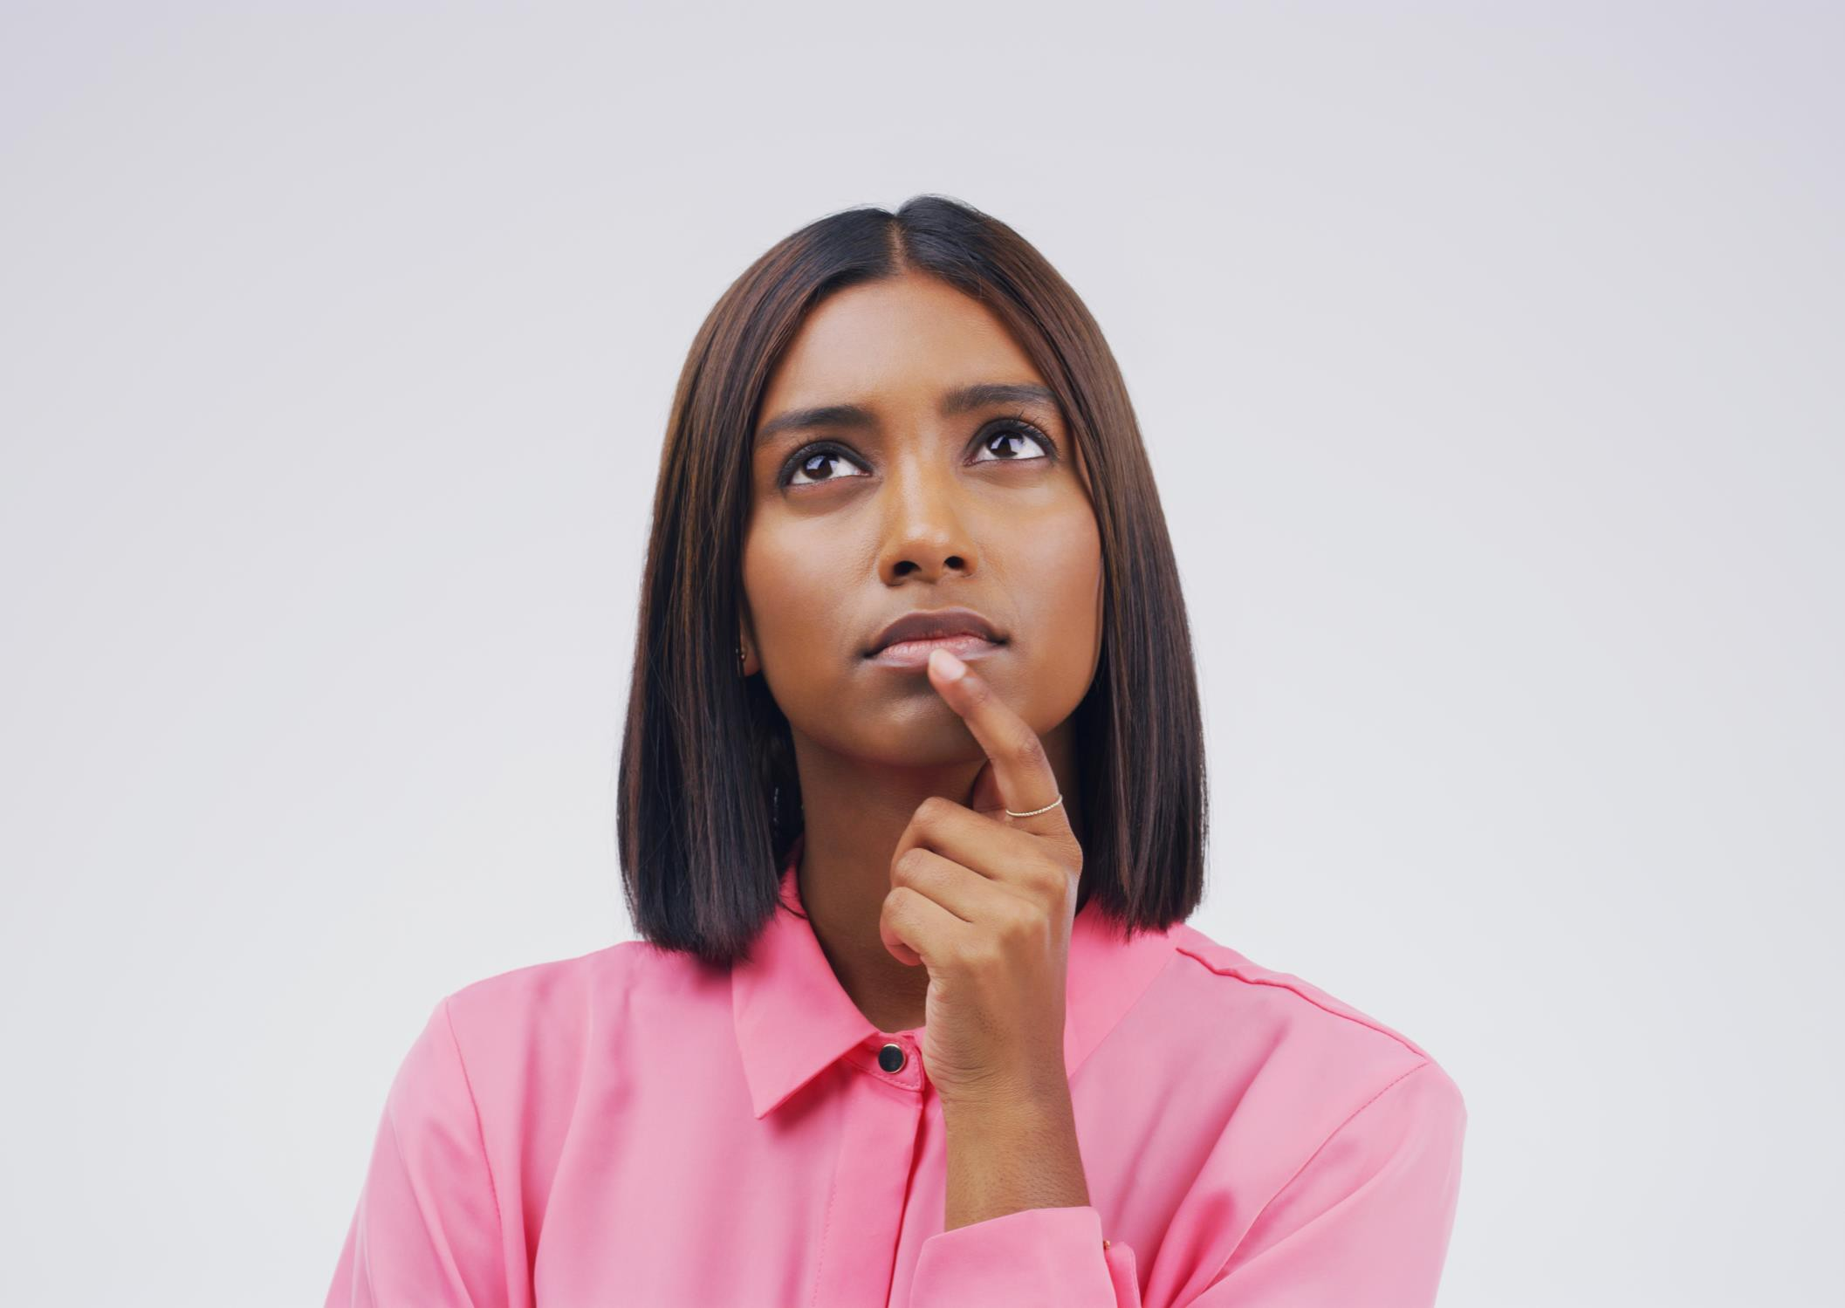
In general, what percentage of people do you think have had cheated?


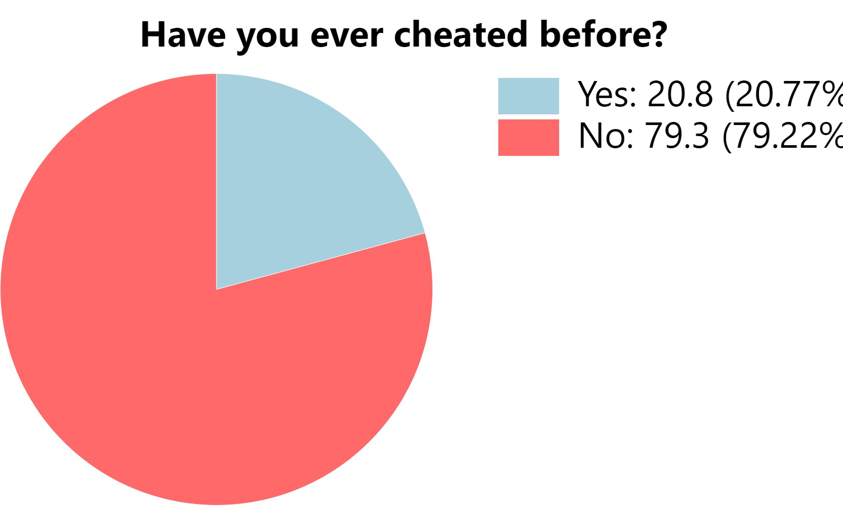

by gender, 22.3% of men
and 18.86% of women having done so

How did the affair start when it was discovered?


1st
2nd 3rd
Coming out from a partner
Checking a lover's smartphone, PC, or social media

Finding physical evidence such as hotel receipts, presents, or letters from an affair partner.

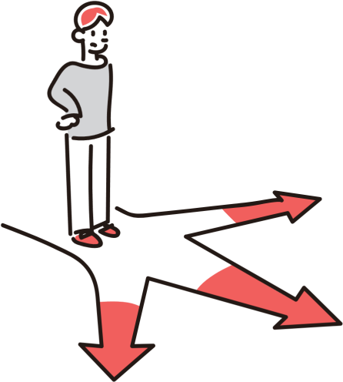

Having knowledge allows one to become more tolerant and make informed decisions.

Have a happy romantic love life.

