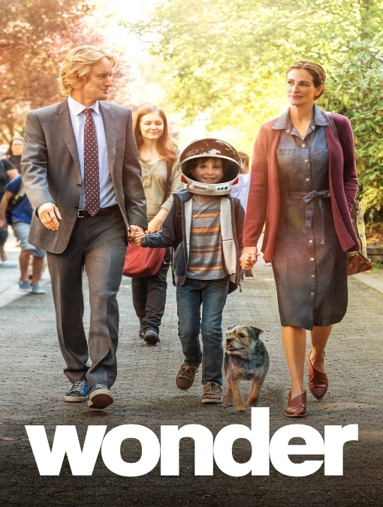
Scene: Auggie and Via talk after an argument
Auggie: (enters Via’s room hesitantly) Can I come in?
Via: (sighs, closing her book) What do you want, Auggie?
Auggie: (nervous) I… I just wanted to say I’m sorry.
Via: (looks surprised) Sorry for what?
Auggie: For… I don’t know. For being me. For taking all of Mom and Dad’s attention.
Via: (sits up) Auggie, don’t say that. It’s not your fault.
Auggie: But it is. You were happy before I was born.
Via: (pauses, softens her tone) That’s not true. You know what I was thinking when Mom and Dad told me you were coming home for the first time?
Auggie: What?
Via: (smiles) I couldn’t wait to meet you. I told all my friends I was getting a baby brother. I didn’t know what you’d look like, and I didn’t care.
Auggie: (tearing up) Really?
Via: (nods) Really. You’re not a burden, Auggie. Yeah, sometimes it’s hard. But you make us better—our whole family.
Auggie: (smiles faintly) Thanks, Via.
Via: (playfully) Just don’t touch my stuff, okay?
Auggie: Deal.

